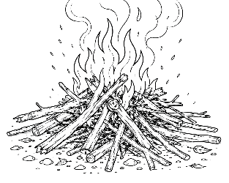
7-12 Year-Olds
8/30/2026
KINDLING
for KIDS!

TOO MUCH! TOO FAST! TOO MANY!
When Everything Feels Like A LOT!
MY BRAIN HAS 47 TABS OPEN! 🤯

“Come to Me, all you who labor and are heavy laden, and I will give you rest” (Matthew 11:28).

Have you ever tried to do your homework while watching TV, answering somebody, looking for your missing shoe, thinking about and maybe studying for tomorrow's test, and wondering what's for supper?

Sometimes life feels like your brain has 47 tabs open at the same time!

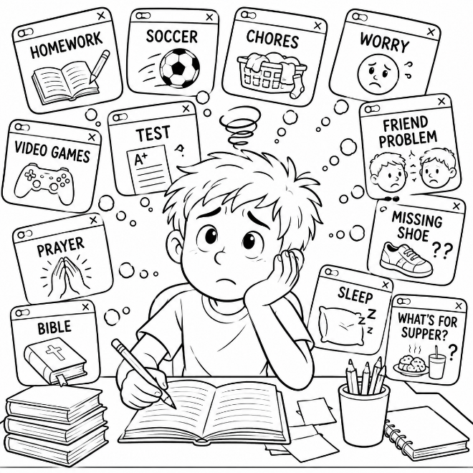
Jesus knows that we get tired. He knows when we're worried. And He knows when everything starts feeling like TOO MUCH. But He doesn't say, “Hurry
up! Try harder!” He says: “Come to Me.”

God doesn't expect you to have unlimited energy. When you're tired, worried, frustrated, or overwhelmed, you can stop and talk to Him.

CLOSE SOME TABS!

Which tabs to the left do you think could wait? Which are important? Which could you ask God to help with?

THE OVERLOADED BACKPACK 🎒

“Casting all your care upon Him, for He cares for you” (1 Peter 5:7).

Imagine putting your schoolbooks into your backpack… Then add your lunch… Then your water bottle…Then three rocks… Then a bowling ball… Then a toaster… Then a hippopotamus… What? Wait! STOP! 😂

Eventually you're carrying something you were never meant to carry.

We sometimes do that inside ourselves. We carry: 🪨 I'm worried about tomorrow 🪨 What if I mess up? 🪨 Someone is mad at me 🪨 I have too much homework 🪨 What if nobody likes me? God says we can give those worries to Him. Why? Because He cares about us.

WHAT BELONGS IN THE BACKPACK? Circle or color what should belong.
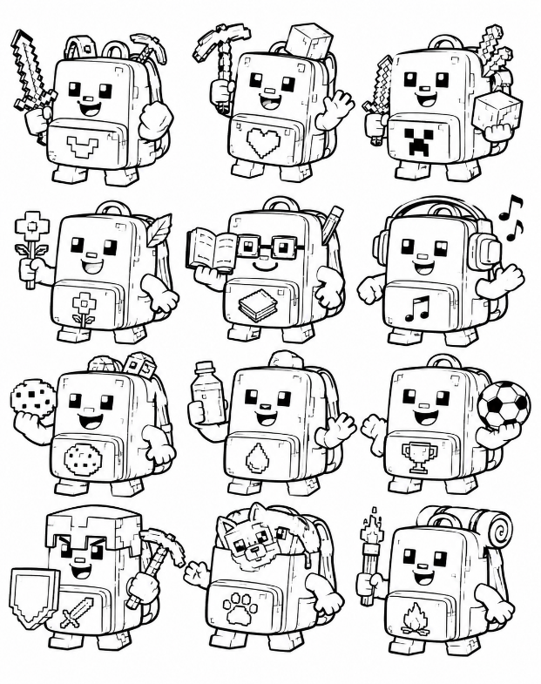
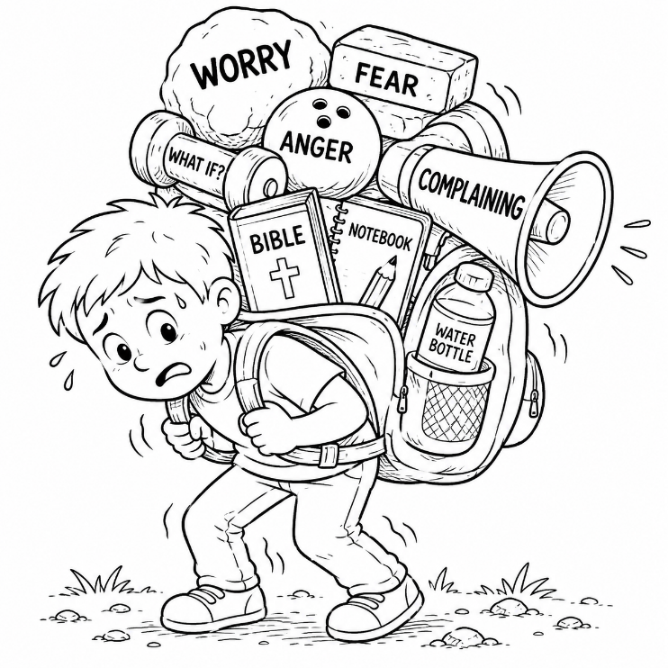

Some things are too heavy to carry. When they are – GIVE THEM TO GOD!

YOU DON'T HAVE A SUPERPOWER BATTERY! 🔋

“He gives power to the weak, and to those who have no might He increases strength” (Isaiah 40:29).

Your tablet needs charging • Your game controller needs charging • Your family's car needs fuel or electricity • And you need strength too!

Sometimes we act as though we have an imaginary battery:

100% → 75% → 50% → 25% → 5% 😵

Maybe you've stayed up too late. Maybe you've been running from school to practice to homework to chores. Maybe something is worrying you.

God doesn't expect you to manufacture endless strength.

The Bible says: “He gives power to the weak.” Prayer, God's Word, rest, worship, and time with God remind us where our real strength comes from.

RECHARGE!

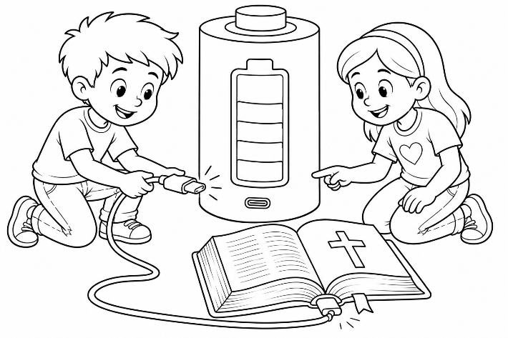
Solve each of the below quick puzzles. For each solved mini-clue, color in a section of the battery, starting at the lowest section and going upward until it’s fully charged.

🙏 Talk to God = P________
📖 Read God's W________
😴 Get proper R________
⛪ Worship G________
❤️ Trust J________

When all five are completed:

🔋 FULLY CHARGED!
PRAY • WORD • REST • GOD • JESUS

Answers:
STOP. BE STILL. REMEMBER. ✋

“Be still, and know that I am God” (Psalm 46:10).

Sometimes when we're overwhelmed, we think the answer is: GO FASTER!

But imagine getting lost and then running as fast as possible without knowing which direction you're going. Well, running faster wouldn't help!

Sometimes the smartest thing you can do is STOP.

Jesus once told His disciples:

“Come aside by yourselves to a deserted place and rest a while” (Mark 6:31).

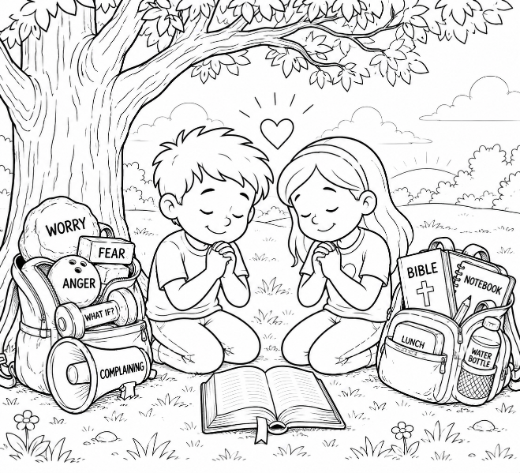
They had been busy doing GOOD things! But even doing good things can wear
us out. But God doesn't need you to be the fastest kid, the busiest kid, the kid who does everything perfectly, or the kid who never needs help. He wants you to trust Him.

So when everything feels like: TOO MUCH! TOO FAST! TOO MANY!

Remember four things: STOP ✋ • PRAY 🙏 • TRUST ❤️ • GO WITH GOD 👣

FINAL CHALLENGE — THE 60-SECOND RESET

Sometime this week, when you're frustrated, rushed, or worried:

1. STOP what you're doing.
2. Take a quiet moment.
3. Tell God what's bothering you.
4. Ask Him for help.
5. Remember: YOU DON'T HAVE
TO DO EVERYTHING AT ONCE

