KIDS ZONE! 7-12 Years 7/5/2026

Faith, Freedom & America at 250!
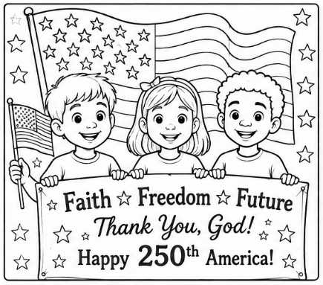
God Bless America!

This year, America celeb-rates 250 years as a nation! That is a very long time. Our country began in 1776 when brave leaders signed
the Declaration of Independence.

Many of America’s early leaders believed that freedom was a gift from God. They prayed for wisdom and asked God to guide the nation. The Bible teaches us that true freedom comes from Jesus.

Bible Verse – “If the Son therefore shall make you free, ye shall be free indeed” (John 8:36).

Did You Know?

- The words “In God We Trust” appear on American money.
- George Washington prayed often and asked God for wisdom.
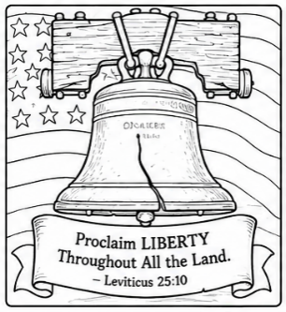
- The Liberty Bell rang to announce important events in American history.

Color & Think – Draw a picture of:
An American flag • Your church
Or something that reminds you of freedom!

Word Search –

FAITH • FREEDOM • AMERICA • PRAYER • GOD
BIBLE • CHURCH • LIBERTY • TRUTH • FLAG

W T W B Z C C L F A P H R H E R Y G D P
L T B C F X X T R U T H T P R L B O Z T
S T L I B E R T Y N R V K I R R B D F U
T F Z D V D V N S S F K F M A A M I I J
U L G C T P A T Z Z D I P G G F Y G B D
C A H C R U H C F R E E D O M H Z E U B
F G O H A C I R E M A Z D W T L O Y R Y
A Y U T I U U E C D Z B Q M P U I J H O
J G D Q R W T E U O M B V C L K Y Y A B
Heroes of Faith and Courage –

Long ago, brave men and women helped build our country. Some were soldiers, pastors, teachers, and families who trusted God during difficult times. Today, God wants us to be brave too!

Bible Verse – “Be strong and courageous… for the Lord your God will be with you wherever you go” (Joshua 1:9).

Unscramble the Words –

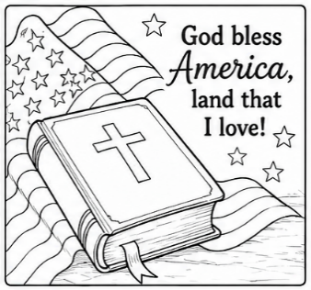
EFRMDEO → _____________
RYAPRE → _____________
HCRUCH → _____________
AFTIH → _____________
MIREACA → _____________

True or False –

The Bible teaches us to pray for our leaders.
TRUE / FALSE
Freedom means we should be unkind to others.
TRUE / FALSE
God wants us to love our neighbors.
TRUE / FALSE
America is celebrating 250 years in 2026.
TRUE / FALSE
Jesus gives us true freedom.
TRUE / FALSE

Be A Light For Jesus!

America needs boys and girls who love God, tell the truth, help others, and shine for Jesus every day.

Bible Verse – “Let your light shine before others” (Matthew 5:16).

How Can I Help My Country?

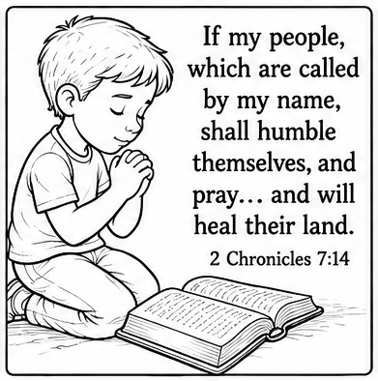
Check the boxes!

☐ Pray for others
☐ Obey my parents
☐ Tell the truth
☐ Be kind at school
☐ Read my Bible
☐ Help someone in need
☐ Thank God for freedom
