TEEN ZONE [13-16+] 7/5/2026

Faith, Freedom & America at 250
America at 250: Why Faith Still Matters – In 2026, the United States celebrates 250 years as a nation. For generations, Americans have fought for freedom, defended truth, and hoped for a better future. But as Christians, we know that freedom is more than politics or history – true freedom begins with God.
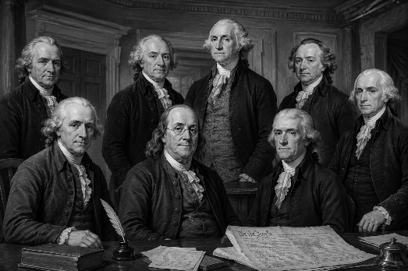
Many of America’s founders believed that faith and morality were essential for a strong nation. While they were imperfect people, they understood that liberty without truth eventually falls apart.

Today, our culture faces serious chalenges: Division • Anxiety Confusion about Truth • Violence • Hopelessness • Pressure to Compromise Faith.

As a teenager today you are growing up in a world full of noise and distraction. Social media, peer pressure, and cultural trends constantly compete for attention. Yet God still calls young believers to stand strong and shine brightly.

Memory Verse – “Do not let anyone look down on you because you are young, but set an example for the believers…” (1 Timothy 4:12).

God does not expect teens to wait until adulthood to make a difference. You can influence your school, team, family, and friends right now.

Faith Question –

If people watched your life for one full week, what would they learn about Jesus?

Write your thoughts below:
_______________________________________________________________________________________________________________________________________________________________________________________

Quick Poll – Circle the biggest challenge facing teens today then find the Capitalized words in the Word Search below:

Stress • Loneliness • Temptation • Social Media Pressure
Bullying • Fear of the Future • Lack of Faith • Identity Confusion

Y T I T N E D I C M A K V K T S A V B P S O L H K N
R E I H X X Y D W Q K X F U T U R E U M E D I A E S
N S V I G S G P R E S S U R E R L F L A I C O S K M
X S X Y T T G J P A N B B Q R P A L T X W L O E P G
U H T R G N I Y L L U B J I V Y C I C M Q S N E R X
W P E O L M L E T F A I T H C G K W J Y A F E A R X
W S A D D N F H G N O P V R T F L O N E L I N E S S
S N O I S U F N O C O U T E M P T A T I O N D P S X
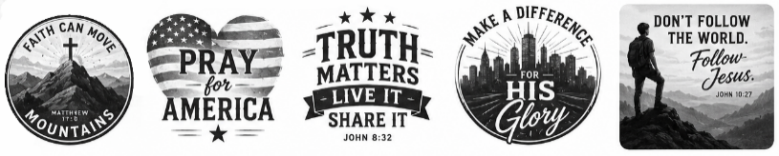
Freedom – More Than a Word – America cele-brates freedom, but the
Bible teaches that freedom is not simply doing whatever we want. Real freedom means living the way God created us to live.

Memory Verse – “It is for freedom that Christ has set us free” (Galatians 5:1).
Sin promises freedom but often leads to addiction • brokenness • regret. Jesus offers something better: Purpose • Forgiveness • Truth • Peace • Eternal Life

The world says: “Follow your heart.” • God says: “Follow Me.”

Did You Know?

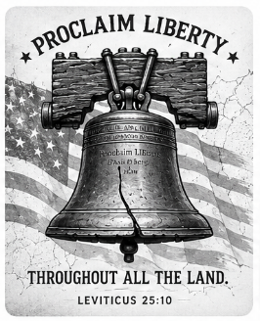
- George Washington frequently called the nation to prayer.

- The Liberty Bell includes a Bible verse: “Proclaim liberty throughout all the land…” (Leviticus 25:10).

- Early American leaders believed faith helped shape good character.

This or That

Which influences teens more today? Circle the one you think it is in each pairing.

Social Media or Scripture? | Friends or Faith?
Culture or Christ? | Entertainment or Truth?

Challenge of the Week – Choose ONE:

☐ Pray 10 minutes every day ☐ Invite a friend to church
☐ Read 1 chapter of Proverbs daily ☐ Memorize a Bible verse
☐ Encourage someone struggling ☐ Don’t get on social media
for 1 whole evening

Standing Strong in a Confused Culture

Being a Christian teen today is not always easy. Sometimes standing for truth feels uncomfortable. You may feel different from others around you. But remember – God has always used young people to change the world.

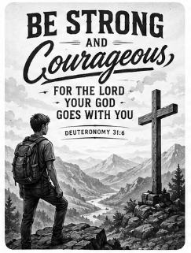
David was a teenager when he faced Goliath • Josiah became king at only eight years old and later led spiritual revival • Mary was likely a teenager when God chose her to carry Jesus • Timothy was young when Paul encouraged him to lead boldly.

Memory Verse – “Be strong and courageous… for the Lord your God goes with you” (Deuteronomy 31:6).

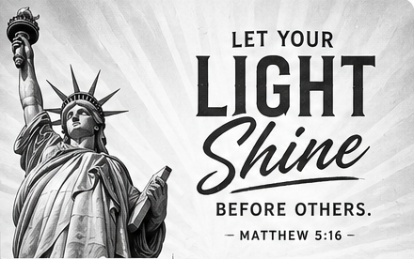
Lighting the Way Forward – America’s future will not only be shaped by leaders in Washington – it will also be shaped by young Christians willing to live boldly for Christ. Teenagers today are tomorrow’s: Parents • Teachers • Soldiers • Preachers
Missionaries • Business Leaders • Church Leaders. Your generation has the opportunity to make a huge difference. Jesus said: “You are the light of the world” (Matthew 5:14). Remember, a small light shines brightest in a dark place.

Prayer for Our Nation – Lord, help our nation turn back to You. Give our leaders wisdom. Help churches stay faithful. Strengthen families. Help teenagers live courageously for Christ. Teach us to love truth, honor others, and walk closely with You. Amen.

Final Thoughts – America at 250 reminds us that freedom is precious – but faith is eternal. Our nation needs young people who: Love God • Stand for Truth • Serve Others • Pray Faithfully • Live courageously. You do not have to be famous to make a difference. You simply need to be faithful.

