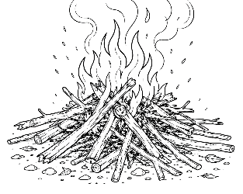
7-12 Year-Olds
7/26/2026
KINDLING
for KIDS!

NOAH THEN… US TODAY
God’s Grace • Our Obedience • Our Hope

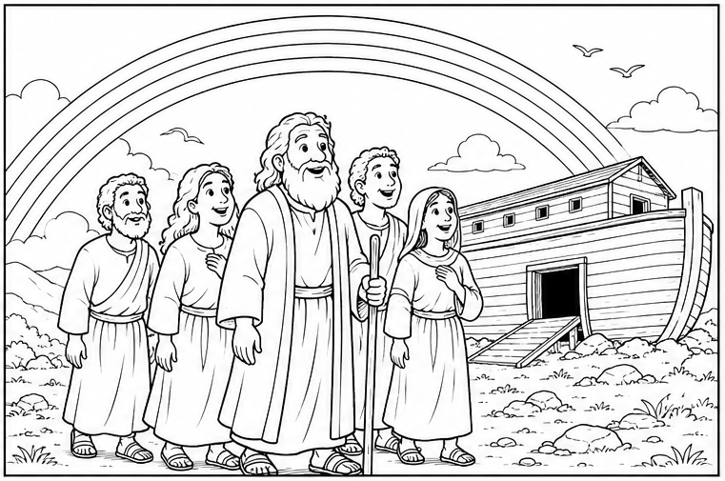
God Keeps His Promises – Have you ever wondered why God put a rainbow in the sky? Long ago, Noah lived in a world where most people had forgotten about God. Even though everyone else chose the wrong path, Noah trusted God and obeyed Him. God saved Noah and his family
through the flood.

The story of Noah isn’t just about a big boat. It’s about God’s grace, obedience, and hope – things that still matter today!

Memory Verse – “But Noah found grace in the eyes of the Lord” (Genesis 6:8)
Covenant

Did You Know? – A covenant is a special promise. God promised He would never again destroy the whole earth with a flood.

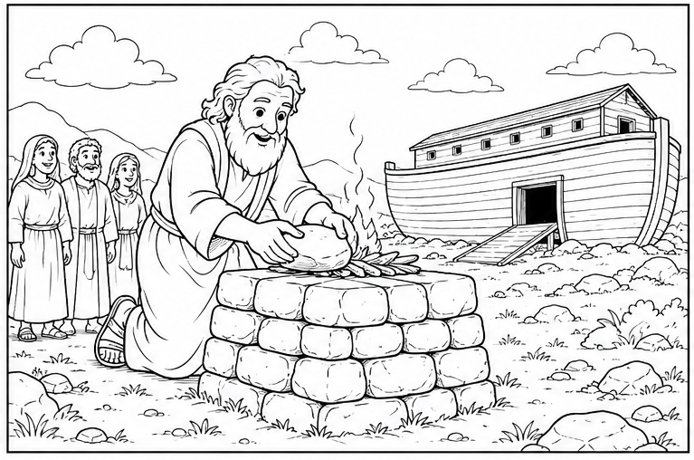
God’s Grace – After Noah left the ark, the very first thing he did was worship God. Noah knew that God had protected his family during the flood. God showed Noah grace. Grace means God gives us blessings we don't de-serve.

God still gives us grace today through Jesus.

Think About It – Can you name three blessings God has given you?
• _____________________________________________________
• _____________________________________________________
• _____________________________________________________

Word Search

NOAH • ARK • GRACE • LOVE • FAMILY • SAFE • GOD • RAINBOW • HOPE • TRUST

E V R F R R Y R U H A C D I D J P M A R M S A G H P E U Z
P V I R N A L S J S J N C K O U X B T C C O W H S P B D E
O D E D M S I B R H Y R E Y R K N H D C E J W V Y E Y V I
H P U F T A M N K E D T I X B A Y L W O N N F X E S M B C
Z G L R Q F A W B K H Z P R Q N O A L S Z W Y W C L K V C
T T D C C E F L N O M H H D G T H B S D P K X Z A D V T V
H A O N B W B D S D W N P O W S Z X I C N P I K R X J V F
A U B Y L I S W Y F J X R G Q U L J B Z C A R M G L H E J
N C P T Y X M F N C G U Z K N R O Y C C N Y B X R C V T A
X M Y R D Q Z X V P T K Y G J T V B E R P G U F J F W K L
R R E X Z V Y W X G G V U X N Y E X L C W E T A A D T V L
Obedience Matters – Noah obeyed God even when people laughed at him. Obeying isn't always easy. Sometimes we obey by: Telling The Truth • Helping Others • Listening To Parents • Being Kind • Reading God's Word. When we obey God, we show that we trust Him.

Crossword –
Across
2. The big boat God told Noah to build.
7. The Bible is God's ___.
9. Do what God says is right.
10. God's free gift of love.
12. The man who built the ark.
13. God always shows this to us.
14. ______ the truth is always right.
16. Believing God and obeying Him.
17. God's rules for living.
18. The Creator of heaven and earth.
Down
1. Noah saved his whole ____.
3. God kept Noah and his
family ____.
4. Trusting God's promises for
tomorrow.
5. God tells children to obey
their _____.
6. God's colorful promise in the sky.
8. _____ your Bible helps you grow.
11. Always tell the _____.
13. Paying careful attention and
obeying.
15. Being kind by serving others.

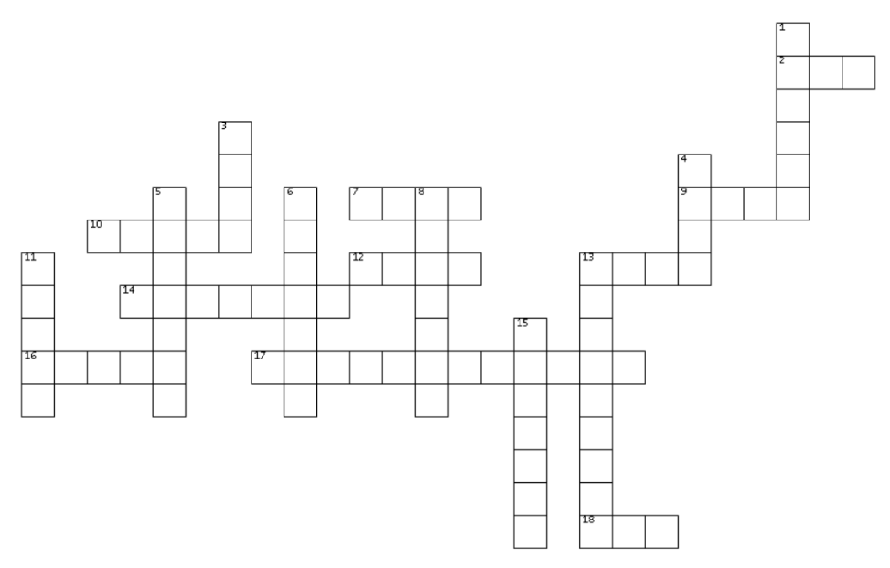

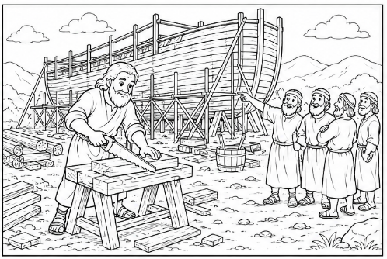

Memory Verse – “If you love Me, keep My command-ments” (John 14:15)
Hope For Tomorrow – The flood didn't last forever. When the rain stopped, God gave Noah a new beginning. Sometimes we have hard days too.
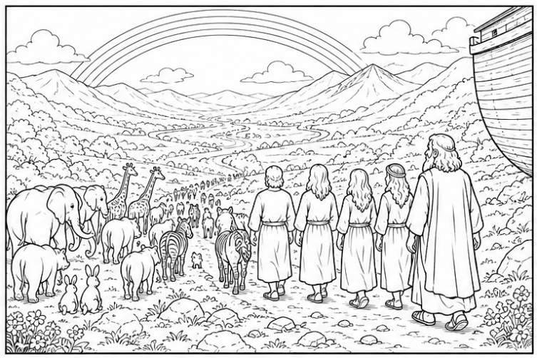
We may feel afraid. We may feel lonely. We may feel sad. But God never forgets His children. Just as God remembered Noah, He remembers you. Because of Jesus, we can always have hope!

Memory Verse – “Now may the God of hope fill you with all joy

and peace in believing...” (Romans 15:13).

Maze –

Help Noah and his family find the path to the new valley.

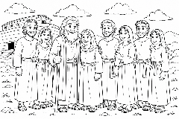
Prayer – Dear Father, Thank You for loving me
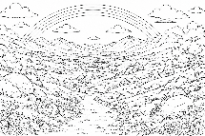
and caring for me every day. Thank You for
Noah's example of trusting and obeying You. Help me to choose what is right, even when it is difficult. Thank You for Your grace,
Your promises, and the hope I have because of Jesus. Please help my life shine for You. In Jesus' name, Amen.

