
TORCHLIGHT for TEENS
13-16+Year-Olds 10/04/2026


THE “WHAT IF?” MACHINE
Your 🧠 brain is surprisingly good at making movies. Not good movies, necessarily. Sometimes it's more like: 🎬 Worst-Case Scenario: The Ex-tended Edition –
You have a test tomorrow. Your brain: “What if I fail?” Then: “What if I fail the CLASS?” Then: “What if I never
graduate?” Then somehow, 45 seconds later: “I will probably be living in a cardboard box!” 😐

Wow. That escalated quickly. Or maybe somebody hasn't answered your text. What if they're mad at me? What if I said something wrong? What if everybody knows except me? What if – 🚨 WHOA.

Something important just happened. Your brain took one thing you know and filled everything you don’t know with worry. Jesus said: “Therefore do not worry about tomorrow, for tomorrow will worry about its own things” (Matthew 6:34).

Jesus isn't saying tomorrow doesn't matter. He's saying: You don’t have to live tomorrow today.

🎬 What Actually Happened? Write something you've worried about recently:

What I Know: ___________________________________________________________

What My Brain Added: ___________________________________________________

What I Actually Know About Tomorrow: Probably less than your brain would like to admit.
THE WHAT-IF SPIRAL🔁

It usually starts small.

What If...? What if something goes wrong? What if I can't fix it? What if everybody notices? What if it's TERRIBLE? 😵 WE'RE DOOMED.

Meanwhile... Nothing has actually happened yet.

🛑 Break The Spiral – When your brain starts racing ahead, try three questions:
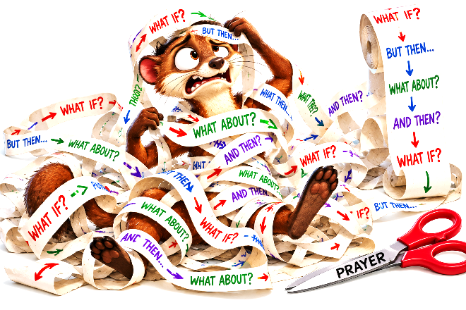
1️⃣ Is It Happening Right Now? Or am I imagining
what might happen?

2️⃣ Is There Something I Can Do Today?
Study • Apologize • Ask • Prepare •
Pray • Get Help

3️⃣ What Part Isn’t Mine Yet? Tom-
orrow? Next week? What some-
body else decides? What I can't
control? Leave That Part With God.

Peter wrote: “Casting all your care upon Him, for He cares for you” (1 Peter 5:7).

Notice that Peter doesn't say: “Pretend you don’t care.” He tells us where to put the care.

🎮 Control Freak Mode: Activated – Sometimes worry isn't really asking: “What’s going to happen?” It's asking: “How can I control what’s going to happen?”

So we try to control: What people think • Whether somebody likes us • What someone says about us • Whether plans change • Whether we win • Whether somebody stays our friend • What happens next month • Other people's choices • The future.

That's an awfully big job description for a teenager. Actually... That’s an awfully big job description for any human.

🎮 Can I Control It?

Mark each Me or Not Me:

_____ Whether I study.
_____ What grade the teacher gives
me.
_____ Whether I tell the truth.
_____ Whether somebody believes
me.
_____ How I treat someone.

_____ Whether they like me after-
ward.
_____ Whether I apologize.
_____ Whether they forgive me im-
mediately.
_____ What I do today.
_____ Everything that happens to-
morrow.

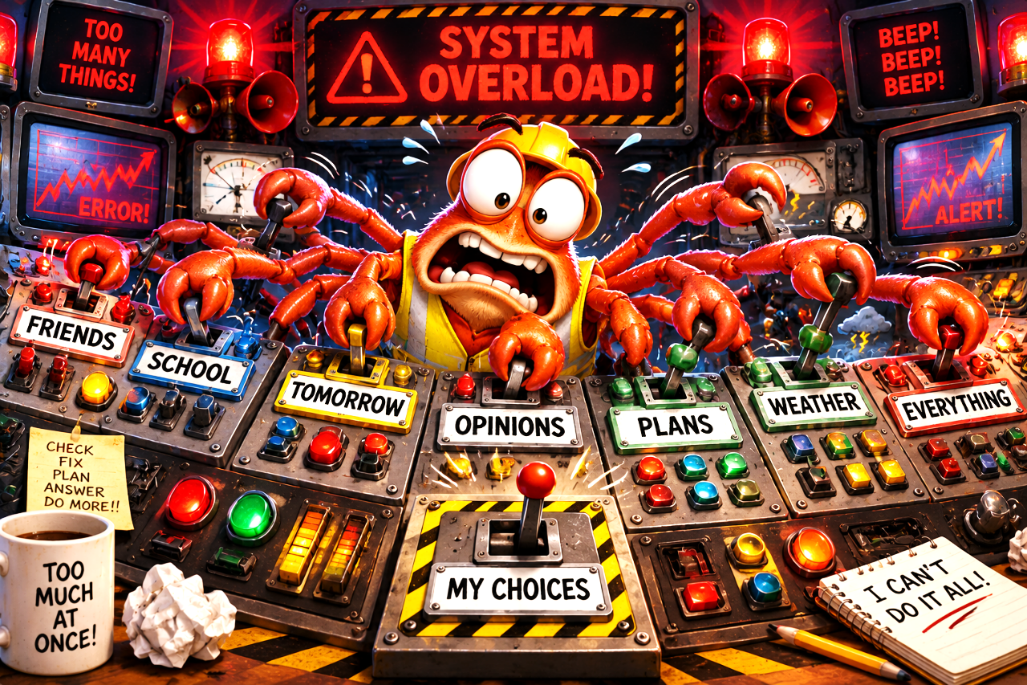

There's freedom in learning the difference between: My Responsibility and God's Territory.

“Trust in the LORD with all your heart, and lean not on your own understanding” (Proverbs 3:5).
📅 Tomorrow Called...

Nah. It didn't. Because tomorrow isn't here yet. 😂

But worry has a strange habit of borrowing trouble from a day that hasn't arrived. Jesus brings us back to: Today.

Today you can pray • Today you can tell the truth • Today you can study • Today you can apologize • Today you can be kind • Today you can obey God • Today you can take the next step.

Tomorrow? We'll deal with tomorrow... When It Becomes Today!

📋 TODAY'S ASSIGNMENT

One Thing I Need To Do:
________________________________________________________________________

One Thing I Need To Stop Rehearsing In My Head:
________________________________________________________________________

One Thing I’m Giving To God:
________________________________________________________________________

Let’s look once more at Matthew 6:34: “Therefore do not worry about tomorrow, for tomorrow will worry about its own things. Sufficient for the day is its own trouble.”
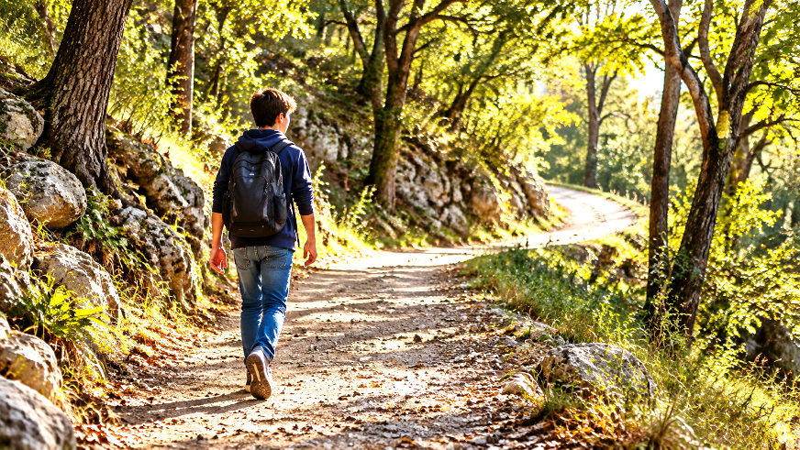
You Don’t Have To See The Whole Road Or Trail.

You Just Have To Walk With The One Who Does.

