
KIDS ZONE! 7-12 Years 6/14/2026

God’s Word In A Digital World

Memory Verse:
“Your word is a lamp to my feet and a light to my path” (Psalm 119:105).

Today you use tablets,
phones, computers, and smart watches and speakers every day. But did you know these tools can help you learn the Bible, remember Scripture, and grow closer to God?

Let’s discover how to use technology in wise, fun, and God‑honoring ways!

Today’s Big Ideas:

- Technology can help you study the Bible
- Technology can help you meditate on God’s Word
- Technology should be used wisely

God’s Word is powerful – no matter the device!

1
DEVOTIONAL: Tech That Helps You Grow

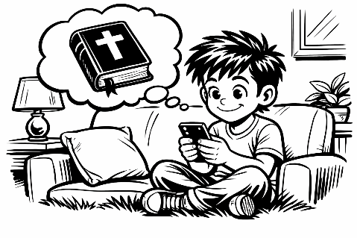
The Bible tells us to think about God’s Word all the time:

“Keep this Book of the Law always on your lips;
meditate on it day and night” (Joshua 1:8).

Technology can help you do that! Here are some ways:

- Bible Apps: You can read the Bible anywhere – in the car, at home, or waiting for practice to start. Some apps even read the Bible out loud to you!
- Audio Bibles & Podcasts: Listening to Scripture helps you think about God’s Word even when your hands are busy.
- Digital Notes & Highlights: You can highlight verses, write prayers, or save your favorite Scriptures.
- Bible Games & Quizzes: These help you learn memory verses and stories in a fun way.

BUT REMEMBER… Technology is a tool – not a boss. We use it to help us follow God, not distract us from Him.
“Pay attention to what I say; turn your ear to my words.” — Proverbs 4:20–21

2
Bible Verse Word Search

¹⁶ Let the message of Christ dwell among you richly as you teach and admonish one another with all wisdom through psalms, hymns, and songs from the Spirit, singing to God with gratitude in your hearts (Colossians 3:16).

O G M A D M O N I S H T G H Y L R Q E N
S F P M K D W E L L A N E W Z J S J D V
G N O M A E M O D S I W K M H T I Y U X
N H W P T N M T H R O U G H R M D S T N
O U C T S I R H C Z V H Y A E W I P I T
S B G O D L D G V L C M E S W N L I T Z
A N O T H E R Y S A N H S T G K V R A W
W Y L H C I R R E S L A Q I R W G I R P
A P S A L M S T E Z G B N Q D V R T G Q
H I M G X T H U D E P G X A T M Z A F C


Design Your Own Bible App!
Draw or imagine an app that helps kids learn the Bible. What features would it have?

- Daily verses?
- Prayer reminders?
- Bible games?
- A place to write prayers?
- A “quiet time” timer?

3
- Something else?
Reflection, Prayer, and Challenge

THINK ABOUT IT

How do you use technology each day?
________________________________________________________________________
Does it help you get closer to God — or distract you?
________________________________________________________________________
What is one way you can use tech to learn the Bible this week?
________________________________________________________________________

PRAYER

“Lord, thank You for giving us tools that help us learn Your Word. Help me use technology wisely and choose things that bring me closer to You. Teach me to love Your Word more every day. Amen.”

WEEKLY CHALLENGE:
Pick ONE of these to do this week:
- Listen to one chapter of the Bible on audio
- Set a reminder to pray & then pray at that time.
- Play a Bible memory game
- Watch a kid‑friendly Bible story video
- Highlight one verse in your Bible app

4

