
TORCHLIGHT for TEENS
13-16+Year-Olds 9/27/2026


UNDER CONSTRUCTION
Please Excuse The Mess –

You've seen the signs:
🚧 Road Work Ahead
🚧 Expect Delays
🚧 Detour
🚧 Lane Closed
And perhaps the most terrifying:
🚧 Construction – Next 11 Miles

Nobody likes the construction part. We like the finished part. Smooth pavement. New bridges. No potholes. No orange barrels. No guy holding a SLOW sign when you're already late. But here's the problem: You can’t get the finished road without going through the messy part!

And right now? 🚧 You’re in the MESSY part. You're learning. You're changing. You're figuring things out. Sometimes you get it right. Sometimes you absolutely do not. 😬

Maybe you've wondered: “Shouldn't I be better at this by now?” or “Why do I keep struggling with the same thing?” or “Why don't I have everything figured out?”

Good news, believe it or not: You’re not SUPPOSED to have everything figured out yet! Paul wrote: “He who has begun a good work in you will complete it until the day of Jesus Christ” (Philippians 1:6). That means that God is doing something in you.

He's teaching you. Correcting you. Strengthening you. Helping you become more like Christ.

And sometimes... Construction is messy. That doesn't mean mistakes don't matter. It doesn't mean: “Whatever. That's just how I am.” It means a mistake doesn't have to become the FINAL version of you.
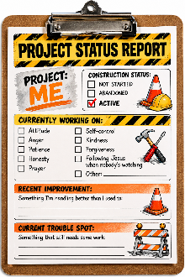
🦺 Project Status Report –

Project: Me

Construction Status:
☐ Not Started ☐ Abandoned ☑ ACTIVE 🚧

Currently Working On:

☐ Attitude
☐ Anger
☐ Patience
☐ Honesty
☐ Prayer
☐ Self-control
☐ Kindness
☐ Forgiveness
☐ Following Jesus when nobody's watching ☐ Other: _____________________

Recent Improvement (Something I'm handling better than I used to):
________________________________________________________________________

🚧 Current Trouble Spot (Something that still needs some work):
________________________________________________________________________

Please Excuse The Mess. GOD Is Still Working.

🕳️ Potholes – Some Things Actually Need Fixing –

Imagine driving down the road and seeing this: 🕳️WHAM! Your teeth rattle. Your backpack launches into the air. Your water bottle achieves low-Earth orbit. And somewhere at the highway department somebody says: “Yeah...we know that's there.” 😐 “Well, are you going to fix it?” “Nah.” Probably not the answer you wanted.

Yet sometimes we discover a pothole in ourselves and do basically the same thing. “Yeah, I have a terrible temper.” “Yeah, I gossip sometimes.” “Yeah, I lie when I think I'll get in trouble.” “Yeah, I'm rude to my family.” And then comes the classic: “That’s just how I am.” WHAT??? Wait. 🚨 That’s a BIG nope!!!

Being able to identify the pothole isn't the same thing as repairing it. David prayed: “Create in me a clean heart, O God, and renew a steadfast spirit within me” (Psalm 51:10). David wasn't pretending everything was fine. He was willing to say: “Yes, there’s something here that needs fixing.”

🔧 Pothole Inspection Which ones sometimes appear on your road?

☐ 🕳️ Anger
☐ 🕳️ Gossip
☐ 🕳️ Lying
☐ 🕳️ Jealousy
☐ 🕳️ Selfishness
☐ 🕳️ Complaining
☐ 🕳️ Giving Up
☐ 🕳️ Disrespect
☐ 🕳️ Procrastination
☐ 🕳️ “Me First!”
☐ 🚧 Biggest Repair Needed: ____________________________________________________________

But here's the important part. Don't stop at: “Yep. Found it.” Instead ask: What’s One Actual Repair I Can Make?

- If it's anger: Maybe pause before answering.
- If it's gossip: Don't pass the story along.
- If it's lying: Tell the truth even when the truth costs you something.
- If it's procrastination: Do the first five minutes now.
- If it's disrespect: Change the way you answer.
- What’s A Repair I Can Or Need To Make To Fix One Of My Potholes:
________________________________________________________________________

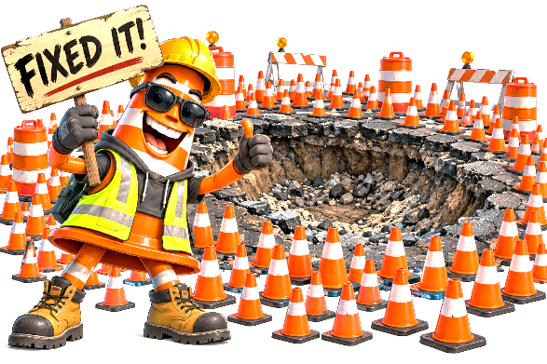
Inspection Complete.
Pothole Identified.
Repair Crew Needed.

🚧 Detour Ahead – When God’s Route Isn’t Your Route –

You had a plan. And not just A plan. A VERY good plan. You knew what was supposed to happen. And then... 🚧 DETOUR

You didn't make the team • Your friend suddenly started hanging out with somebody else • The thing you were looking forward to got canceled • Your family plans changed • You worked hard for something – and didn't get it • Something you thought would be easy... wasn't.

Then… 📱 Life Is Recalculating... Detours are frustrating because you know where you wanted to go. The Bible says: “A man's heart plans his way, but the LORD directs his steps” (Proverbs 16:9). That doesn't mean every disappointment is a secret message from God. It does mean your plans changing doesn't put your life beyond God's reach.

🗺️ Detour Or Disaster? – What would your FIRST reaction probably be?

You don't get something you really wanted.
☐ 😡 NOT FAIR!
☐ 😐 Okay...now what?
☐ 🙏 God, help me handle this.
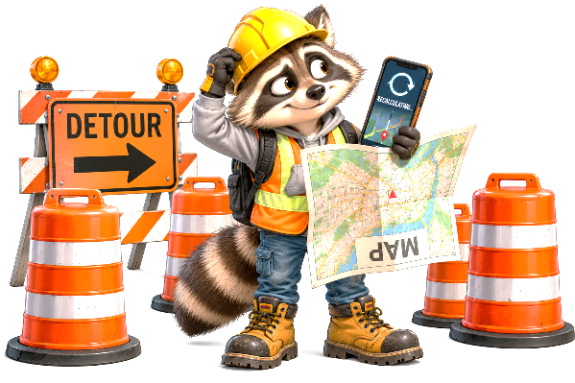
Something takes WAY longer than expected.
☐ 😡 I'M DONE.
☐ 😐 Keep going.
☐ 🙏 God, teach me patience.

Your plans suddenly change.
☐ 😡 THIS RUINS EVERYTHING.
☐ 😐 Time for Plan B.
☐ 🙏 God, help me choose what to do next.

Your friend chooses something you weren't invited to.
☐ 😡 Fine. I don't need them anyway.
☐ 😐 This hurts—but don't make it worse.
☐ 🙏 God, help me respond well.

🚧 Sometimes A Detour Isn’t The End Of The Road.
It’s Just Not The Road You Expected.

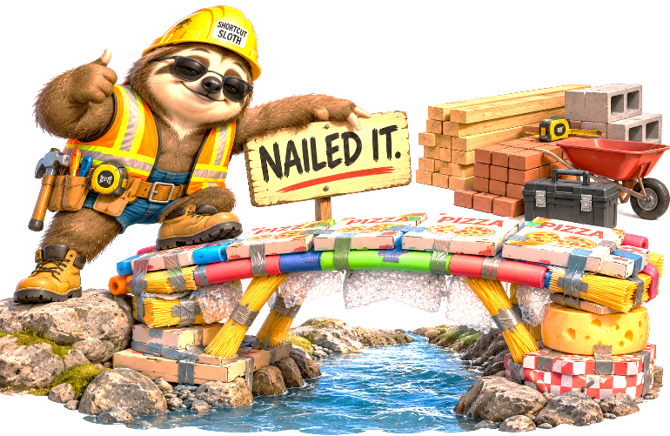
🏗️ Building Materials – What Are You Actually Building With? –

You probably wouldn't want somebody building your bridge out of:

🍕 Pizza Boxes
🧦 Old Socks
🫧 Bubble Packaging
🍜 Ramen Noodles
And definitely not: 🧀 Cheese. Yet imagine the construction foreman proudly announcing: “Relax. We used TWO layers of cheese.” 😐

Building materials matter. And every day you're putting things into the construction project called: YOU.

What you watch • What you listen to • What you read • Who influences you • How you talk • What you practice • What you spend your time thinking about.

All those things become... 🧱 Building Materials.

Jesus said: “Whoever hears these sayings of Mine, and does them, I will liken him to a wise man who built his house on the rock” (Matthew 7:24).
Did you notice: two of those verbs: Hears + Does. That means that knowing what Jesus said isn't the same as building your life on it.

🚚 Keep It Or Dump It? The truck just arrived – Write a “K” for Keep or a “D” for DUMP beside each load:

___ 📖 God's Word
___ 🗣️ Gossip
___ 🙏 Prayer
___ ❤️ Kindness
___ 👀 Constant comparison
___ 🤝 Forgiveness
___ 😡 Anger I refuse to let go
___ 👥 Friends who encourage me to do right
___ ✓ Honesty
___ 🤷 “Everybody else is doing it.”
___ 🧠 Self-control
___ 💬 Encouragement
Add Your Own Next…
Something I need MORE of:
________________________________________________________________________

Something I need LESS of:
________________________________________________________________________

You’re Building Something.
The Question Is: What Are You Building With?

🚜 Construction Crew Wanted – Most Of The Work Isn’t Very Dramatic.

Sometimes we imagine growing as a Christian should feel like:

⚡ Massive Life-Changing Moment ⚡
🎺 Angels 🎺
🔥 Instantly Different 🔥

And sometimes there really are big moments. But a lot of Christian growth happens in ridiculously ordinary ones. You were about to say something cruel...
but didn't.

🔧 Work Completed 🔧
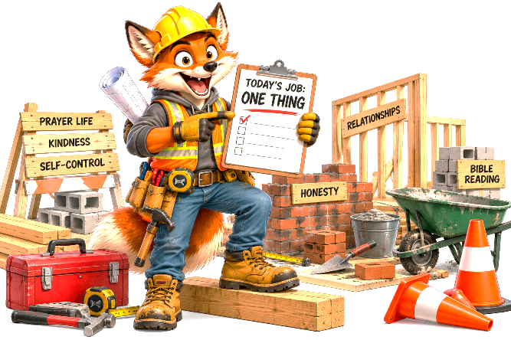
You messed up and apologized instead of making excuses.
🔧 Work Completed🔧
You prayed because you were worried.
🔧 Work Completed🔧
You opened your Bible when nobody
told you to.
🔧 Work Completed🔧
Someone was being ignored and you
included them.
🔧 Work Completed🔧
The gossip reached you... and stopped there.
🔧 Work Completed🔧
You're trying to forgive someone even though it still hurts.

🚧 Work In Progress

Paul wrote: “For it is God who works in you both to will and to do for His good pleasure.” — Philippians 2:13 (NKJV)
📋 This Week’s Work Order – Don't try to repair everything by Tuesday – Choose ONE project:

☐ Repair a relationship.
☐ Remove a bad influence.
☐ Build a better prayer habit.
☐ Encourage somebody who needs it.
☐ Work on controlling my temper.
☐ Spend more time in God's Word.
☐ Stop participating in gossip.
☐ Ask someone to forgive me.
☐ Work toward forgiving someone.
☐ ______________________________

🦺 My Project:

🔧 My First Actual Step:
________________________________________________________________________
📅 When Will I Do It? (Pick An Actual Date To Start)
________________________________________________________________________

Why? Because: “I should work on that sometime” is not actually a construction schedule. 😂

🚧 Final Inspection – You’re Not Finished –

Sometimes you look at yourself and mostly notice... The orange barrels • The dirt • The unfinished pieces • The places where you still struggle • The thing you thought you'd have conquered by now • The mistake you wish you hadn't made • The part of following Jesus you're still learning.

But here's something important: Construction zones aren’t supposed to look finished. They're supposed to show that something is being built. That doesn't give us an excuse to stay the same because “God isn't finished with me!” doesn't mean: “So I don't need to change.” It's exactly the opposite.

And because God isn't finished... Keep growing.
Because God isn't finished... Keep learning.
Because God isn't finished... Keep praying.
Because God isn't finished... Keep getting back up.
Because God isn't finished... Keep letting His word change you.

And when you mess up? Don't put 47 orange cones around the problem and call it: “Fixed!” 😂 Go back to work. Paul's words from the beginning of our bulletin are worth reading again: “He who has begun a good work in you will complete it until the day of Jesus Christ” (Philippians 1:6).

🦺 Final Project Report –

Project: Me

Status: 🚧 Under Construction

Builder: God

Today: Not finished.

Tomorrow: Still growing.

Goal: Becoming more like Christ.

And maybe that's the most important thing to remember:
There’s a BIG difference between
🚧 UNFINISHED and ⛔ ABANDONED.
So Remember, God HASN’T abandoned the project!
