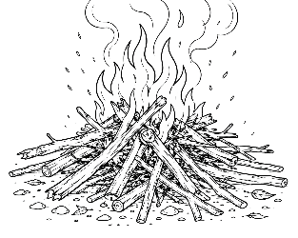
7-12 Year-Olds
8/16/2026
KINDLING
for KIDS!

WHICH WOULD YOU CHOOSE?
Sometimes following Jesus means making a choice. At school, at home, at church, and with friends, you may have only a few seconds to decide what you’re going to do. Meet these goofy characters and decide: Which one would YOU choose to be like?

The Lonely Lunch The Pencil Problem
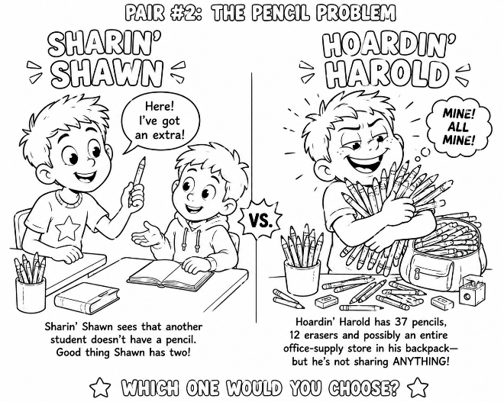
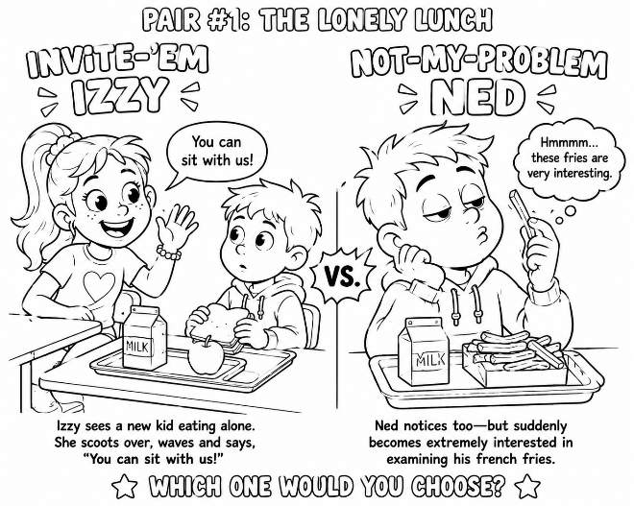

Be kindly affectionate to one another...” — Romans 12:10
“But do not forget to do good and to share...” — Hebrews 13:16







The Really Juicy Rumor The “That’s Not Fair” Moment
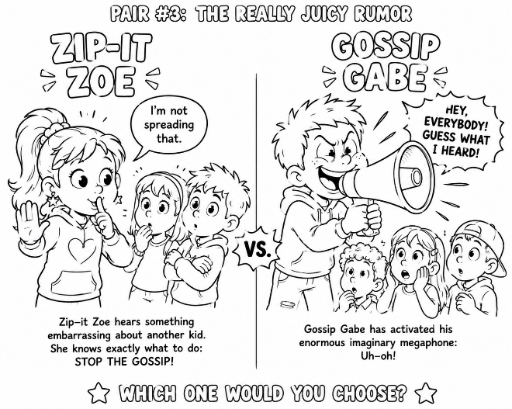
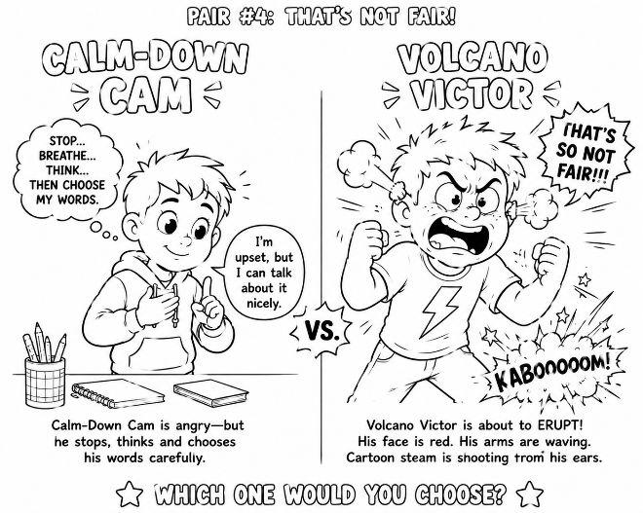
“A talebearer reveals secrets, but he who is of a faithful spirit conceals a matter.” — Proverbs 11:13
“A soft answer turns away wrath...” — Proverbs 15:1

The Homework Emergency The Hurt Feelings Challenge
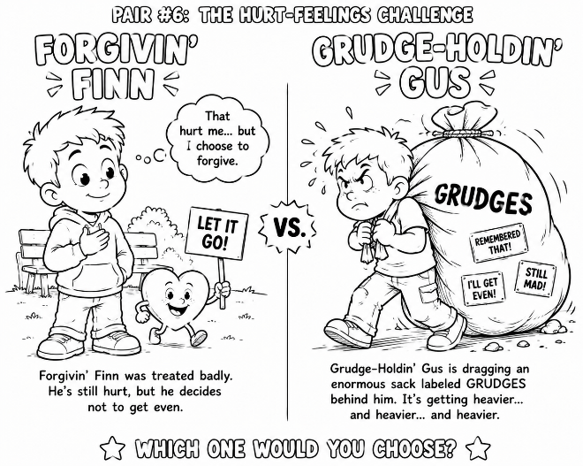
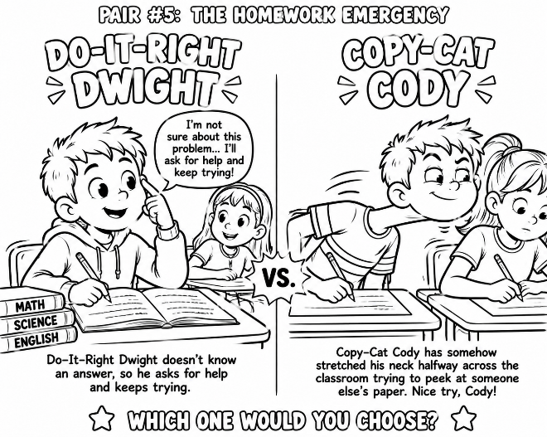

“Providing honorable things, not only in the sight of the Lord, but also in the sight of men.” — 2 Corinthians 8:21
“Forgiving one another, even as God in Christ forgave you.” — Ephesians 4:32

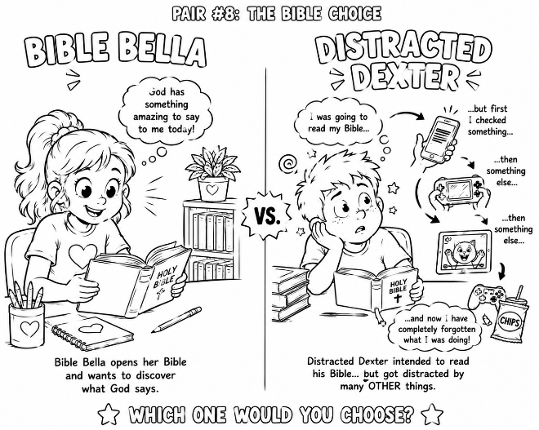
The “Nobody Asked Me” Test The Bible Choice
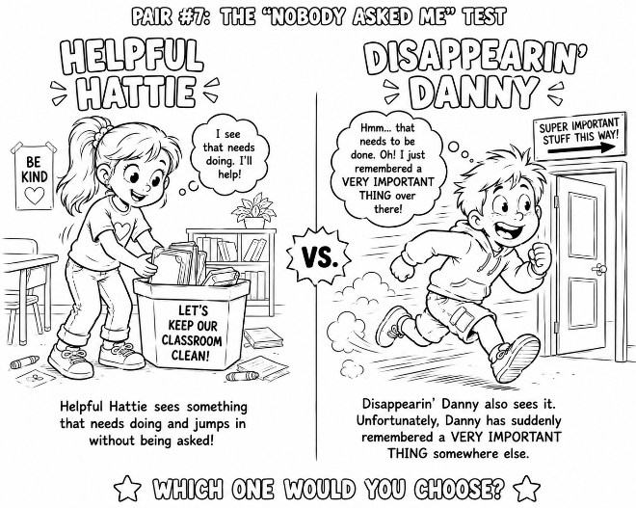

“Through love serve one another.” — Galatians 5:13
“Your word I have hidden in my heart, that I might not sin against You.” — Psalm 119:11

So, Izzy or Ned? Shawn or Harold? Zoe or Gabe? Cam or Victor? Dwight or Cody? Finn or Gus? Hattie or Danny? Bella or Dexter? They’re funny characters – but their choices aren’t imaginary. You make choices like these every day.

Memory Verse – “Choose for yourselves this day whom you will serve” (Joshua 24:15).

Challenge - Choose ONE of the good characters above. During the coming week, find a real opportunity to make the same choice that character made. Then see if you can do it!


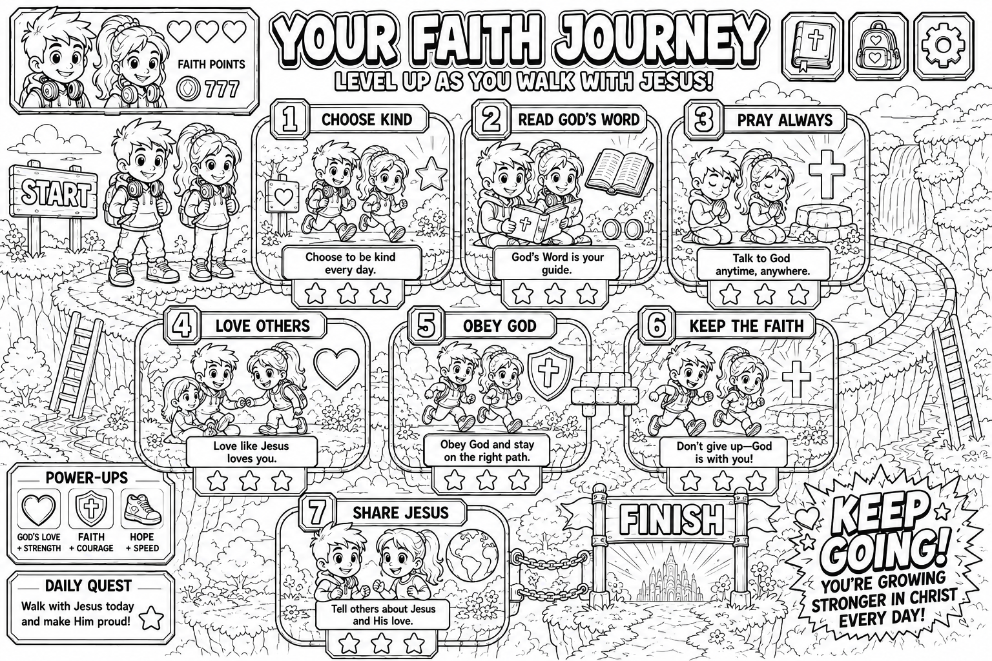

Pick & Color The Charms You’d Like To Hang On Your Backpack.



