
KIDS ZONE! 7-12 Years 6/7/2026

Learning To Pray Like Jesus
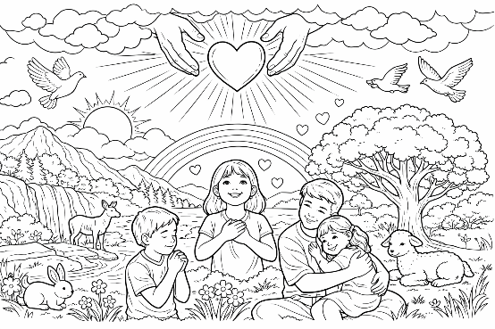
Jesus Teaches Us To Pray:

Memory Verse
“Lord, teach us to pray.” – Luke 11:1

Quick Devotional:

Jesus’ disciples watched Him pray all the time. He prayed early in the morning, late at night, before big decisions, and when He needed strength.

They saw something special – Jesus talked to God like a child talks to a loving Father.

So they asked Him, “Lord, teach us to pray.”

And Jesus started by saying, “When you pray, say… Father.”

Prayer starts with knowing God loves you.

1
Try This: One‑Minute Starter Prayer

Close your eyes and take a slow breath.

Say: “Father, I’m here. I love You. Help me today. In Jesus name. Amen.”

That’s praying like Jesus!
Jesus Prayed Every-where:

Jesus didn’t only pray in church.

He prayed:

- On mountains

- In gardens

- In lonely places

- With friends

- Before meals

- Before miracles

- Before choosing His disciples

Jesus prayed because He loved His Father and trusted Him com-pletely.
Activity Box: Draw It!


Draw a picture of Jesus praying. Where do you imagine He is: a moun-tain, a quiet place, a garden?
-


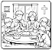
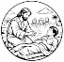
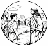
The Lord’s Prayer With Short Explanation:

2
Jesus gave us a model prayer – not to memorize only, but to understand.

Lord’s Prayer

“Our Father in heaven”
God loves you like a perfect parent.

“Your kingdom come”
We want God’s ways to guide our lives.

“Give us today our daily
bread”
God provides what we need.

“Forgive us”
We ask God to clean our hearts.

“Help us forgive others”
We show the same kindness God shows us.

“Deliver us from evil”
God protects us.

Fill‑In‑the‑Prayer - Complete the missing words:

Our ______ in heaven.

Give us today our daily ______.

_________ us our sins.

Deliver us from _______.

3
Prayer Challenge:

Write your own short prayer using three of the ideas Jesus taught.
________________________________________________________________________.

Word Search – Find The Following Lord’s Prayer Words:

FATHER • HEAVEN • HALLOWED • KINGDOM • NAME • EARTH • HEAVEN • DAILY • BREAD
FORGIVE • TRESSPASSES • TEMPTATION
DELIVER • EVIL • POWER • GLORY • FOREVER

B I O P K R V E I I W Y L I A D O E N
Z H K V E G E O J F Z R T B D H C V B
Y H B W V P A N A M E M S U M K Y G Q
Y X O U O U R N N O I T A T P M E T N
D P X O T N T N E E X X M B Y F N R Q
H D S B W R H Z V V W S H I I F E Q W
G U T P L E E E Y L A E N T E V F A Z
Q A C O Z I I S R R D E T Z E H M L E
E C W D E H V J S A O F H R F J L Y N
D T F K M V G E B P H L O O U A P L Q
M I Q Y P E I Y R M A F G K Z I Q N X
M E E I S B F G G T W S A H Y R R I Z
G J U V Q E G S R F Y X S F I T J D I
N X D E L I V E R O F F W E H J Q G O
O Q E V L S Q Y F S F P E X S H R U Q
K M O B R E A D B J R H W H L D R M H
Q Y L Y A C B T K I G K V Z B R X M U

4

