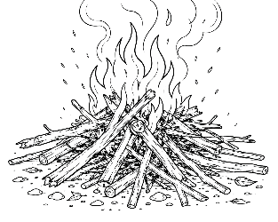
7-12 Year-Olds
9/06/2026
KINDLING
for KIDS!

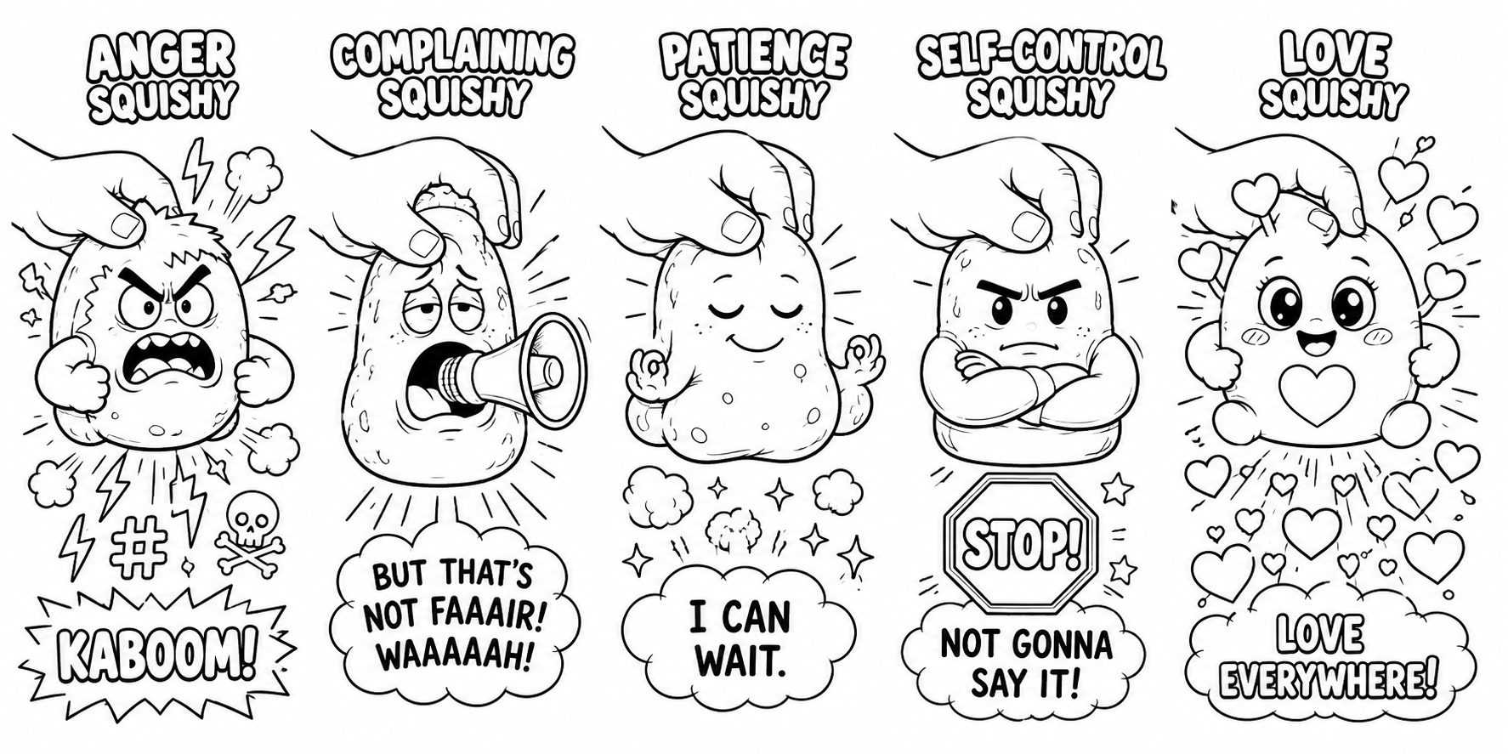SQUISH! WHEN LIFE SQUEEZES YOU…

Have you ever squeezed a squishy toy? You squish it, smash it, stretch it – and somehow it pops back into shape. Sometimes life squishes us too! Your brother takes something without asking. Someone says something mean. Mom tells you to clean your room. You get blamed for something you didn't do. Your homework seems impossible. Then… SQUISH!

What happens next? Well, Jesus said: “For out of the abundance of the heart the mouth speaks” (Matthew 12:34).

In other words, when we're squeezed, what's inside often comes outside! If our hearts are filled with anger, anger may pop out. If they're filled with complaining – LOOK OUT! 📣

But when we let God fill our hearts, something very different can come out: Love • Joy • Peace • Kindness • Patience • Self-control.

🎮 THE SQUISHY CHALLENGE

Draw a line from each situation to the better thing to let out:

WHEN I'M SQUISHED BY... LET OUT...
Someone annoys me KINDNESS
I'm worried FORGIVENESS
Someone hurts my feelings PEACE
I have to wait SELF-CONTROL
I'm really angry PATIENCE

What did you think of the Squishies on the front page?

😡 ANGER SQUISHY – One tiny squeeze and... KABOOOOOM! Steam. Lightning. Stomping feet. Total meltdown.

📣 COMPLAINING SQUISHY – Squeeze her and a gigantic megaphone pops out: “BUT THAT'S NOT FAAAAAIR!”

😌 PATIENCE SQUISHY – Squish... squish... squish... He calmly returns to shape. “I CAN WAIT.”

🛑 SELF-CONTROL SQUISHY – He's angry. He really wants to say it. But...
“NOPE. NOT GONNA SAY IT.”

❤️ LOVE SQUISHY – ‘NUFF SAID. “I’M ALLLLL ABOUT THE LUVVVV.”

Draw your own private Squishy in the box to the right? What’s its name?

_________________________________
When it gets squeezed, what comes out?
_________________________________
🍓 FRUIT UNLOCKED!

GOD HAS SOMETHING BETTER TO PUT INSIDE YOU! “But the fruit of the Spirit is love, joy, peace, longsuffering, kindness, goodness, faithfulness, gentleness, self-control” (Galatians 5:22–23).

When we follow Jesus and allow God's Spirit to work in us, He changes what's growing inside us.

And when life gives us a... SQUISH! ...more and more of His fruit can come out.
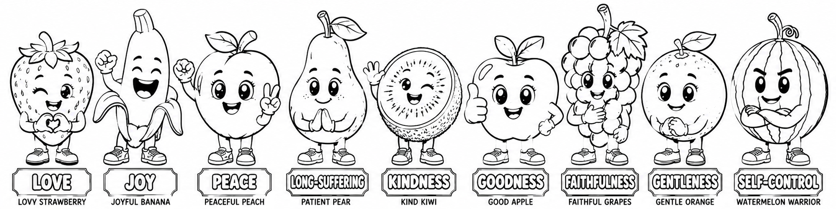🎮 FRUIT UNLOCKED!

❤️ LOVE – Lovey Strawberry – Special ability: Loves even when somebody is difficult.

😂 JOY – Joyful Banana – Special ability: Finds reasons to thank God.

😌 PEACE – Peaceful Peach – Special ability: Doesn't panic when things go wrong.

⏳ LONGSUFFERING – Patient Pear – Special ability: Waits without exploding.

🥝 KINDNESS – Kind Kiwi – Special ability: Notices people who need encouragement.

🍎 GOODNESS – Good Apple – Special ability: Chooses what's right.

🍇 FAITHFULNESS – Faithful Grapes – Special ability: Keeps promises and can be counted on.

🍊 GENTLENESS – Gentle Orange – Special ability: Uses strength without hurting others.

🍉 SELF-CONTROL — Watermelon Warrior
Special ability: Can actually stop himself before doing something foolish!

⭐ COLLECT THEM ALL?

You don't collect the Fruit of the Spirit like toys. Instead, ask God to grow them in you!

🏆 FINAL BOSS CHALLENGE

1. Your brother or sister breaks something of yours.
Which fruit do you need? __________________

2. Your teacher tells you to wait when you really don't want to.
Which fruit do you need? __________________

3. Someone at school is being left out.
Which fruit do you need? __________________

🙏 THIS WEEK'S PRAYER

Dear God,

Sometimes life squeezes me and things come out that shouldn't. Please forgive me. Fill my heart with Your Spirit and help Your fruit grow in me. Help me show love, joy, peace, patience, kindness, goodness, faithfulness, gentleness and self-control – even when I'm being squeezed!

In Jesus' name,

Amen.

