KIDS ZONE! 7-12 Years 6/21/2026

8 Blessings To Studying Your Bible
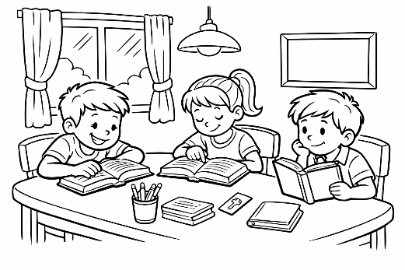
Studying the Bible isn’t just something grown‑ ups do. God gave you His Word so you can know Him, grow strong, and live with joy. Every
Part 1
time you open your Bible, God is ready to teach you something amazing.

Blessing #1 – You Get to Know God Better – When you read the Bible, you learn what God is like – loving, powerful, patient, and always with you.
Memory Verse: “Draw near to God, and He will draw near to you.” – James 4:8

Mini Word Search:
KNOW • GOD • BETTER • READ • BIBLE • LEARN
LOVING • POWERFUL • PATIENT • NEAR

G U K R E T T E B P W O G O D A C Q Z S
N Z U A N R V V D I P O W E R F U L W V
I K B E G Q R P X A K U A B N R A E L K
V P A R S E H C M U E Q L I B W G Z L N
O R T N E I T A P Z U R E Z E L B I B O
L Z E E J F Z H T Y X U S Y G X U J Z W

1
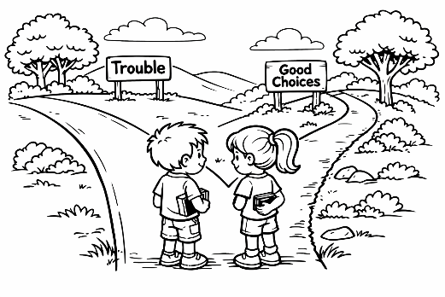
Blessing #2 – God Shows You the Right Path – The Bible helps you make good choices and avoid trouble.
Memory Verse: “Your word is a lamp to my feet
and a light to my path.” – Psalm 119:105

Mini Word Search
GOD • SHOWS • RIGHT • PATH • BIBLE • HELPS
MAKE • GOOD • CHOICES • AVOID • TROUBLE

S E C I O H C J W A B F Q G O D P A Q U
B G H E L P S F S H V K Q D Y C A W A C
N L U H T D I O V A E K A M F Q T N Q Z
C B M V I M R I G H T J Q R X P H W X E
J B I B L E F P A S H E L B U O R T V N
F V I S W O H S E G O O D N H Q W O U P

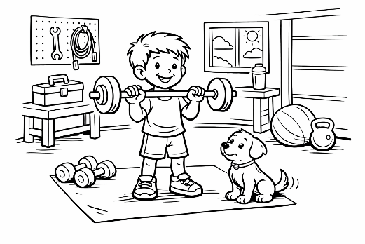
Blessing #3 – God Gives You Strength When Life Is Hard – Bible verses remind you that God is with you, even on tough days.
Memory Verse: “God is our refuge and strength.” – Psalm 46:1
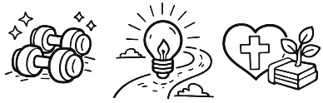


2
Mini Word Search:
GOD • TOUGH • STRENGTH • LIFE • HARD
GIVES • REFUGE • EVER • PRESENT • HELP

R N Q D U P L L E K Z W Y D W O A X I I
E D O O W J H U V G S T R E N G T H G J
F R S G E H R G P H E L P G M J J A L F
U A I E G E E K U L A E W Q Y X D Y H M
G H X O V Q B X V O V A R T N E S E R P
E P C E E W L I F E T L F K C S E V I G

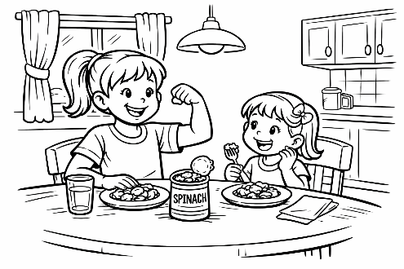
Blessing #4 – You Grow Stronger on the Inside – Just like food helps your body grow, the Bible helps your heart and mind grow.
Memory Verse: “Like newborn babies, crave pure spiritual milk.” — 1 Peter 2:2

Mini Word Search
GROW • STRONGER • INSIDE • HEART • MIND
NEWBORN • BABIES • CRAVE • PURE • MILK

M L D N R O B W E N B W C G E V A R C P
I D N E W R E G N O R T S J B A B I E S
L L I S U V T V Q Y J Y I E R U P P E J
K G M Y U U M L R S Q H E A R T C O M Y
C I R V Z E J P Q C G O M T E L W L A X
P I N S I D E W O R G O Z H P X V G I G

3
Crossword Of All The Mini Word Search Words:

Across
2. Way to walk or follow
3. Create or build
6. Correct or
good
8. Deeply want or
desire
10. Look at words
and understand
11. Full of
strength

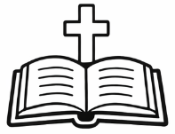
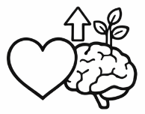
Down
1. Close by
2. Clean and without sin
4. Stay away from
5. Here right now
6. Safe place to rest
7. Not easy
9. More powerful than before
13. Decision we make
14. Part that thinks and learns
16. Hard or bad situation
17. Makes things easier
18. Not outside
21. Hard to break or defeat
24. Give support or aid
25. Improved or more good
28. Get bigger or stronger
29. Creator of all things
Across [cont.]
12. Just born
15. Power to keep going
19. Gain knowledge
20. Calm and willing to wait
22. God's word
23. Makes something clear
25. Very young children
26. Always, without end
27. Where love and faith live
28. Offers freely
29. Pleasing to God

4

