
7-12 Year-Olds
8/2/2026
KINDLING
for KIDS!

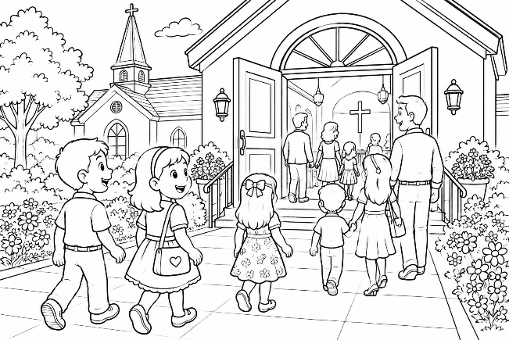
FROM JOY TO SERVICE
The Journey Of Every Lord’s Day

Welcome! We Come With Joy!
Every Sunday is a special day! It's the Lord's Day, when God's family comes together to worship Him. We sing songs, pray together, read the Bible, and encourage one another.

God wants us to come with joyful hearts because He loves us so much. We don't worship because we have to – we worship because we are thankful for everything Jesus has done for us.
Word Search

JOYFUL • WORSHIP • LORD
REJOICE • GLAD • THANKFUL
ENCOURAGE • TOGETHER
SPECIAL • FAMILY • SING

O Q Y E C I O J E R M U Q
W O R S H I P N H W V R Y
H K A U J X R K W J F Q F
P U W B O D R O L G U K Z
L U F K N A H T H Y Q G N
G M E G E G A R U O C N E
B N X R O F S T G L A D P
T M I M X Y H J O Y F U L
M M X S P E C I A L G Q S
I L G N Y L I M A F C H X
W R E H T E G O T F H N N

Before we even walk through the church doors, we can ask ourselves, "How can I make someone smile today?" A happy greeting, a kind word, or a friendly smile can help someone have a wonderful morning.

Memory Verse – “This is the day the Lord has made; We will rejoice and be glad in it” (Psalm 118:24)

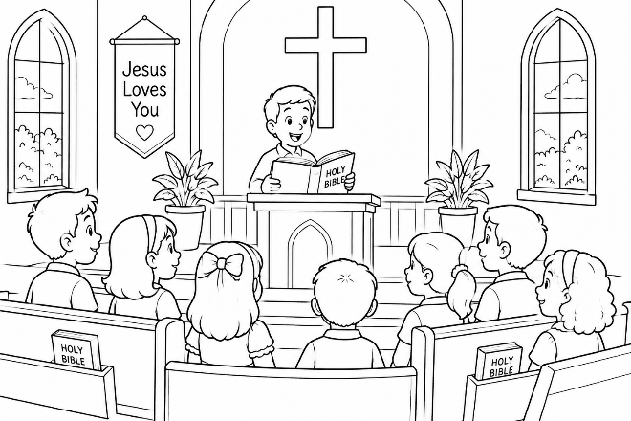
Jesus Is The Center!

Why do we come to church? The answer is Jesus! We sing about Him. We learn about Him. We pray through Him We remember His love for us.

Everything we do helps us keep our eyes on Jesus. When we listen care-
fully during worship, we learn how to become more like Him every day.

Jesus loves every child, and He wants us to love Him with all our hearts.


Memory Verse – “Looking unto Jesus, the author and finisher of our faith” (Hebrews 12:2).


Word Scramble – Unscramble
the following words:

SESJU ____________
OVEL ____________
HCUHRC ____________
YAPR ____________
BELIB ____________
NIGS ____________
RIASEP ____________

Maze – Help the children find
>>>>>>>>>

their Bibles to take to church!

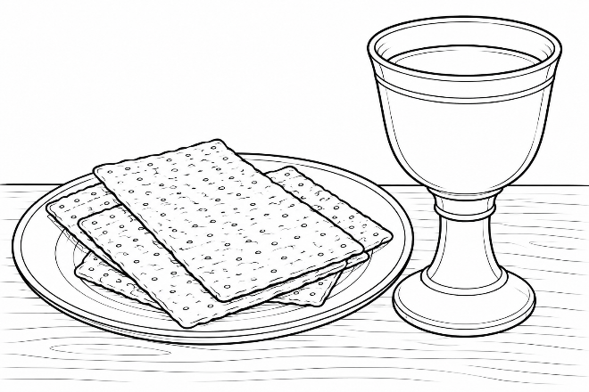
Remembering Jesus

Every Lord's Day, Christians remember Jesus when they share the Lord's Supper. The bread reminds us of His body, and the fruit of the vine reminds us of His blood.

Jesus loved us so much that He gave His life so we could be forgiven.

When we remember Jesus, we also remember how much He loves us – and that should make us want to love Him even more.

Memory Verse – “This do in remembrance of Me” (Luke 22:19).


Crossword
Across
2. Be happy in the Lord.
6. God's Son and our Savior.
8. Helping someone feel stronger.
10. Jesus showed this on the
cross.
11. Holds the
fruit of
the vine.
12. Another
name
for God.

Down
1. Think about what Jesus
did.
3. Happy because of
God.
4. Reminds us of
Jesus' body.
5. Grateful for God's
blessings.

7. We praise God together.
9. Another word for happy.
11. Where Jesus died for us.

Go And Shine!

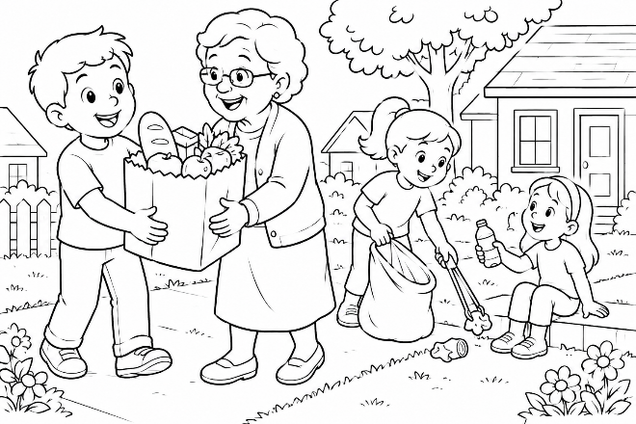
Church doesn't end when we walk outside! Now it's time to show others the love of Jesus. You can help someone at home. You can obey your par-
ents. You can tell the truth. You can be kind to a classmate. You can pray for a friend.

When we do these things, we are shining the light of Jesus wherever we go. Then next Lord's Day, we gather together again to worship Him!

Memory Verse – “Let your light so shine before men...” (Matthew 5:16).

So, each week we come with JOY we WORSHIP Jesus We REMEMBER His LOVE We GO into the world to SERVE Him!

Word Search
K V N Z G M Y X G Y P Z H T Y O H
N E Q T Z W A L R W C B G H Z D V
Y O B A V P R K X Y E B O G Q L N
T P P C S Q P Y G G R X E I P K E
J C F O S S E N D N I K N L Y J M
T M D Z N T K A T T E U I U W E D
E K D D T T V P N O V W H E L P A
T R U T H G U D F V M W S I K A B
LIGHT • SHINE • MEN
HELP • OBEY • TRUTH
>>>>>>>>
KINDNESS • PRAY

This Week’s Challenge

☐ I smiled at someone. ☐ I read my Bible.
☐ I helped at home. ☐ I obeyed my parents.
☐ I prayed every day. ☐ I invited a friend to church.

