
7-12 Year-Olds
8/9/2026
KINDLING
for KIDS!

THE FARE HAS BEEN PAID!

Memory Verse – “The gift of God is eternal life in Christ Jesus our Lord” (Romans 6:23).
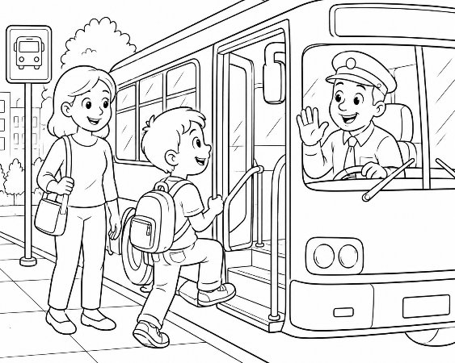
Devotional – Have you ever gone somewhere because someone else paid for your ticket? That is a wonderful gift!

The Bible tells us that Jesus gave us an even greater gift. We could never earn forgiveness by ourselves, but Jesus loved us so much that He paid the price for our sins when He died on the cross.

When we love Him and obey Him, we can look forward to being with Him forever. What a wonderful gift!
W Y E E R F E N X O O R Q A Y T G
S O F X P K D X P Q D Y P L S R E
K P A D K V R S L O V E I C A G W
Q F I J D Z W M E S L F P C X B D
M Q T E E R I P S T E Y E C K T P
H F H S V I A E E J I X L S P F C
L H Y U A N T C P S V R G W J I S
N O T S C O I R X S J T O N H G D
M X R Z N R S T B O X X M O V O N
U I V D P L Y A E R K L P I I F U
D P A I D L P R L C J E K B K M I
Word Search –
JESUS • GIFT • LOVE • FREE
CROSS • PAID • LIFE • HOPE GRACE • LORD • FAITH PRICE

WHO PAID?

Verse – “For even the Son of Man did not come to be served, but to serve, and to give His life a ransom for many” (Mark 10:45).

Devotional – Jesus said He came "to give His life a ransom for many."
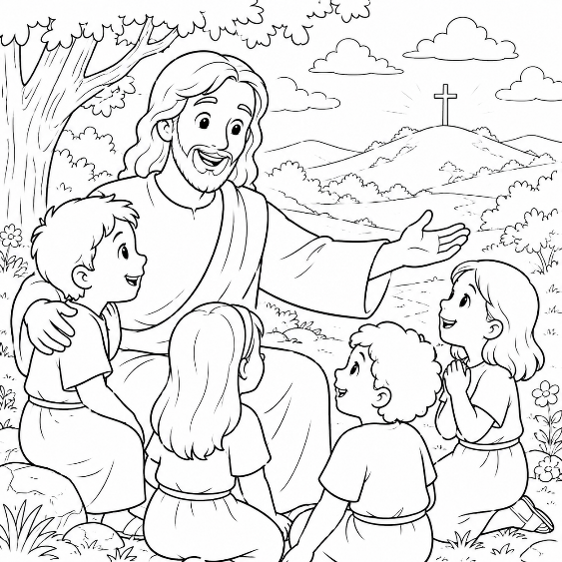
A ransom is a price paid to set someone free.

Jesus willingly gave His life because He loves us so much. No one forced Him. He chose to obey His Father so that we could have forgiveness and hope.

Every time we remember Jesus, we remember His great love for us.

Word Scramble – Unscramble the following words:
Bonus Word Scramble (Harder)

MRYCE _______________

ITVOONDE _______________

RYUJENO _______________

DEREEMDE _______________

RTUTS _______________

ISNLGSEB _______________

EJSSU _______________

SSCOR _______________

RGCAE _______________

ELVO _______________

EILF _______________

IDPA _______________

HTAFI _______________

FIGT _______________

GOD’S GIFT

Verse – “For by grace you have been saved through faith, and that not of yourselves; it is the gift of God” (Ephesians 2:8).

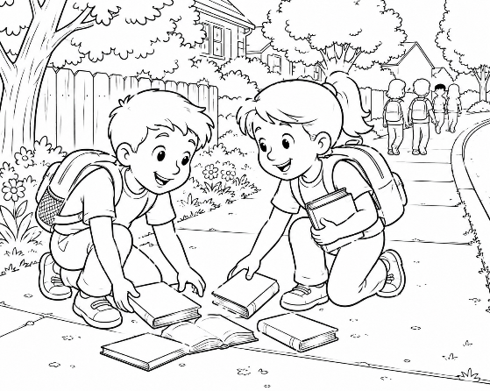
Devotional – The greatest gifts are not earned—they are given because someone loves us.

God's gift is eternal life through Jesus Christ.

That doesn't mean we ignore God. Instead, because Jesus loves us so much, we want to obey Him, pray to Him, read our Bible, and show His love to others every day.


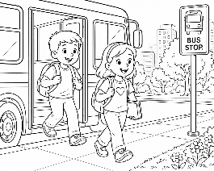
Maze – Help Peter & Jill Get Home








RIDE WITH JESUS EVERY DAY!

Verse – “And whatever you do in word or deed, do all in the name of the Lord Jesus, giving thanks to God the Father through Him” (Colossians 3:17)

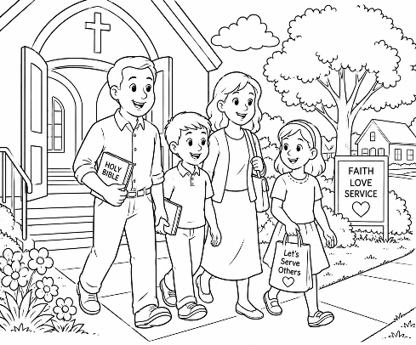
Devotional – When you get off a bus, your trip is finished. But being a Christian is different!

Every day is another chance to follow Jesus by being kind, telling the truth, helping others, praying, and reading God's Word.

Thank Jesus every day for paying the price for you – and then let your life show how thankful you are!

Put A Check Next To Each Picture That Shows Someone Following Jesus.
