
TORCHLIGHT for TEENS
13-16+Year-Olds 7/12/2026

Noah Then . . . Us Now
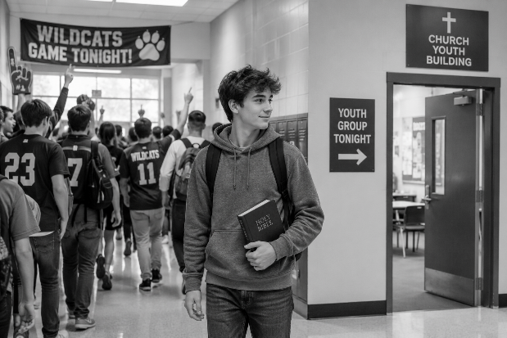
Built To Stand

Key Word – Obedience

Memory Verse – “Thus Noah did; according to all that God commanded him, so he did” (Genesis 6:22)

Faith Isn't Just Believing – Most
people believe certain things. They believe the sun will rise tomorrow. They believe a chair will hold them when they sit down. They believe their coach knows the game.

But belief becomes real when we act on it. That's exactly what Noah did. God told him to build an ark. Noah had never seen a worldwide flood. He didn't know exactly how everything would happen. But he trusted God enough to obey.

That's what biblical faith looks like. It doesn't wait until everything makes sense. It trusts God first. Then it obeys.

What About Us?

You probably won't be asked to build an ark. But every day you'll have opportunities to obey God. Will you tell the truth when it's easier to lie? Will you show kindness when others are cruel? Will you forgive someone who hurt you? Will you choose honesty over popularity?

Every act of obedience is another board added to the “ark” God is building in your life. It’s all the hundreds of little choices we make each day that builds lifelong character.

Word Search –

HURT • HONESTY • POPULARITY • ACT • OBEDIENCE • ARK
OPPORTUNITIES • KINDNESS • TRUTH • CRUEL • FORGIVE BOARD • GOD • BUILDING • LIFE • LITTLE • HUNDREDS CHOICES • BUILDS • LIFELONG • CHARACTER

F T H L Y A A A A N S S E N D N I K C G T A P U I B
H A C T B R E T C A R A H C I Z Y H Q N G I C N Q B
U E O O P P O R T U N I T I E S B B R O R Z N O W H
W Q A X T Y S D E R D N U H T E B P V L L R W D O G
H R I E G T M I H C Z F S W Y C F C H E B U I L D S
D Z F Q M I H W H D D E G T Q N O A D F K D L Z B Z
M I I Q H R O L I X C H S J L E R L N I R G M E U S
L V X B F A U G U I U E R H Q I G Y C L W W K U I L
O L H X I L R O O R N C F W T D I L N W I S G I L I
X E L Z K U M H T O J G T Q I E V S E E F L V E D T
T U O A K P C B H D I J Z P R B E W D H O J B D I T
B R F R B O D J H T U R T G Z O H C E Z E W R I N L
F C R K R P F M R U U H T M R T K J F O H O F X G E

Think About It – What is one area where obeying God is difficult for teenagers today?

Builder’s Toolbox – Obedience isn't about earning God's love. God already loves us. Obedience is how we show that we trust Him.

When Noah obeyed, he demonstrated that God's Word mattered more than the opinions of the crowd.

15-Second Challenge – Ask yourself this question before making a difficult decision this week: “Which choice honors God the most?” Then choose that one!

Crossword

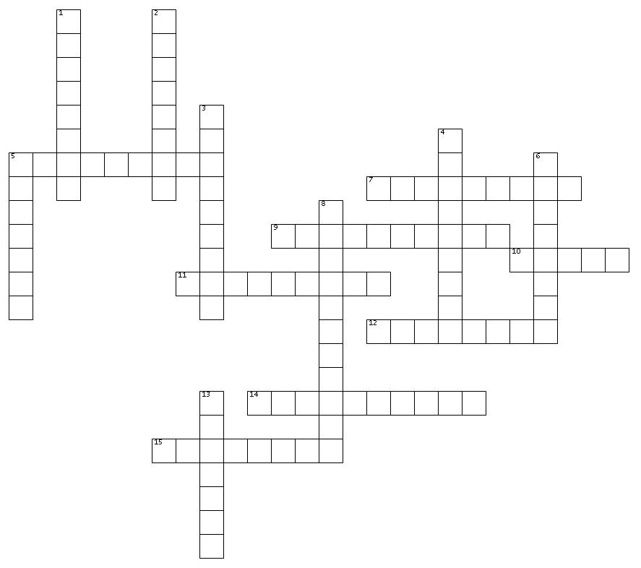
Across
2. The praise or acceptance people often seek from others.
3. Who you really are on the inside.
6. Being well-liked by a lot of people.
9. Being welcomed or included by others.
10. The decisions you
make every day.
13. The courage and
determination to
stand for what is
right.
14. Lasting for your entire life.
15. Telling the truth even when it's difficult.
Down
1. Meant to last and not easily changed.
4. What is real, honest, and faithful to God's Word.
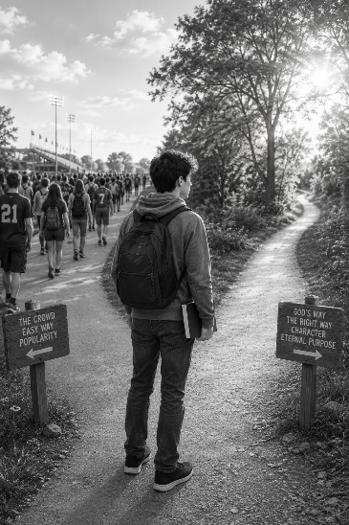
5. Living in a way that honors God and follows what is right.
7. Choosing to follow God's instructions.
8. Doing what's right even when no one is watching.
9. When two people share the same decision or opinion.
11. Continuing through difficult times without giving up.
12. Showing care and compassion through your actions.

One Board at a Time – Building the ark wasn't a one-day project. Noah didn't wake up one morning and suddenly have a finished ark. He built it one board... one beam... one day at a time.

Our faith grows the same way. Every time we choose honesty over cheating... Every time we choose kindness over cruelty... Every time we choose truth over popularity... We're building a life that can stand when the storms come.

Strong faith isn't built in one big moment. It's built through thousands of faithful little choices.

Imagine This – It's Friday afternoon. Some friends invite you to do something you know isn't right. Nobody would ever find out. No teacher. No parent. No minister. Just you. What would you do?

Character isn't revealed when everyone is watching. Character is revealed when no one is. Noah obeyed God because he knew God was always with him. We can do the same.

Did You Know? The ark was built to survive a storm Noah had never seen. God knew exactly what was coming. When God gives us commands, He also knows what lies ahead in our lives. His instructions are always for our good.


Perseverance – This four-syllable word simply means refusing to
quit even when doing the right thing becomes difficult. Noah kept building even when the work was long and people may have mocked him. Don't give up on doing what's right. Faith grows stronger every time you keep going.

Prayer – Heavenly Father, Thank You for loving me enough to guide my life. Help me make choices that honor You, even when they're difficult. Build strong character in me, one decision at a time, so that my life will reflect Your love and truth. In Jesus' name, Amen.

