
TORCHLIGHT for TEENS
13-16+Year-Olds 9/20/2026

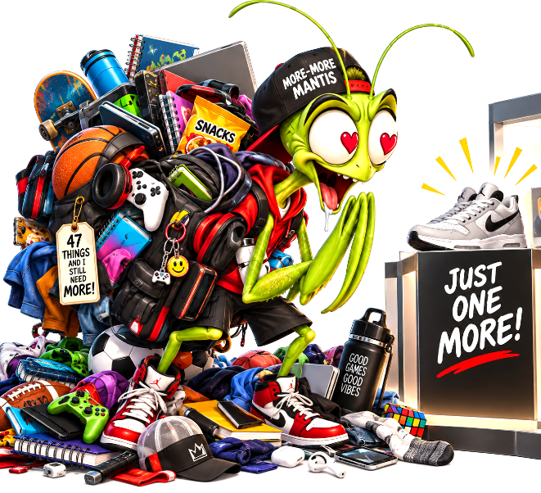
WHEN ENOUGH DOESN'T FEEL LIKE ENOUGH!

📱 YOU HAVE 47 THINGS. WHY DO YOU NEED #48? Maybe you already have a new phone • new shoes • new game • new hoodie • new headphones • n • new whatever-everybody-is-sud-denly-talking-about. You weren't think-ing about it yesterday.

Then you saw it. And now somehow...

YOU NEED IT. 😳 At least, that's what your brain says.

Social media is incredibly good at showing us what we don't have. Somebody always has something newer, better, cooler, more expensive or more exciting. And pretty soon, enough stops feeling like enough.

Jesus talked about this long before phones, influencers or online shopping: “Your heavenly Father knows that you need all these things. But seek first the kingdom of God and His righteousness, and all these things shall be added to you” (Matthew 6:32–33).

Notice Jesus doesn't say that we don't need things. Food matters. Clothes matter. A place to live matters.

God knows that. The problem begins when having more becomes the thing we think will finally make us satisfied.

📊 THE “JUST ONE MORE” TEST

Put a ✔ beside any you've experienced:

☐ My stuff was perfectly fine until I saw somebody else's.
☐ Everybody else has one.
☐ I really wanted something—and barely used it after I got it.
☐ Something I HAD to have last year doesn't matter to me now.
☐ I've compared what I have with what somebody online has.
☐ Getting something new made me happy...but not for very long.

🤔 THINK ABOUT IT

What is something you once desperately wanted but hardly care about now?

________________________________________________________________________

Maybe the problem isn't that you have too little. Maybe your brain has simply learned to keep saying: “OKAY...BUT WHAT'S NEXT?”

📉 THE GIMME METER – WARNING: THIS METER REFILLS ITSELF.
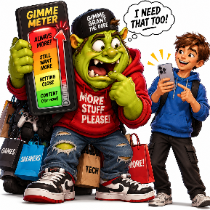
Imagine a meter inside your brain: EMPTY ░░░░████ FULL

You see the thing you've been wanting – I NEED THAT!

You finally get it. 🎉🎉🎉

GIMME METER: FULL ██████████

Three weeks later... Then… Then somebody shows up with
something newer.

██████░░░░ ███░░░░░░░ ░░░░░░░░░░

🚨 “I NEED THAT! GIMMIE! GIMMIE! GIMMIE! YAY! IT’S MINE! 🎉🎉🎉

Congratulations! Your Gimme Meter has reset. ██████████ 😂

That's one reason the Bible teaches contentment. Paul wrote: “I have learned in whatever state I am, to be content” (Philippians 4:11).

Notice one important word: LEARNED. Contentment doesn’t always happen
automatically. It is something we learn.

🎮 WANT OR NEED? Write W for WANT or N for NEED.

___ Food
___ The newest phone
___ Safe clothing
___ Another pair of sneakers
because they're trending
___ Water
___ A place to sleep
___ The game everybody else has
___ People who care about you
___ The newest version of
something you already own
___ Now add something YOU really
want/need:___________________

Is wanting it wrong? Not necessarily! Enjoying something isn't the problem. The question is whether you can say: “I'D LIKE TO HAVE IT... ...BUT I DON'T NEED IT TO BE OKAY.” That's contentment.

👀 THE COMPARISON TRAP – ALL WAS FINE FIVE MINUTES AGO.

You like your shoes. Then you see somebody else's. 😐

You like your phone. Then your friend gets the newer one. 😐

You thought your weekend was fun. Then you see someone
else's photos. 😐

Nothing about your life changed. But suddenly it feels like it did.

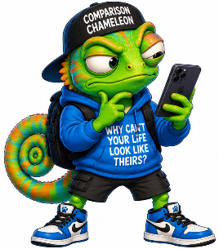
WELCOME TO THE COMPARISON TRAP.

Comparison can take something you were thankful for five minutes ago and make it suddenly seem disappointing. The Bible says: “Godliness with contentment is great gain” (1 Timothy 6:6).

🔄 FLIP THE FEED

Instead of noticing what you're missing, notice what's already there.

Complete the following:

Something useful I already own:__________________________________________

Something I ate today:___________________________________________________

Someone I'm glad is in my life:____________________________________________

Something ordinary I usually take for granted:______________________________

Something God has provided that I didn't earn:_____________________________

⚠️ PLOT TWIST

Gratitude doesn't mean pretending everything in life is perfect. You can be thankful and still have problems. You can be content and still have goals. You can appreciate what you have and still work toward something better. Contentment simply refuses to say: “I can’t be happy until I have more.” Be like Contentment Capybara: “Bro, look at what you already have.”


🙏 ENOUGH FOR TODAY – TOMOR-ROW HASN’T EVEN HAPPENED YET.

Sometimes “not enough” isn't about stuff. It’s about: What if something goes wrong? • What if I don’t have what I need? • What if I fail? • What if things change? • What if… What if… What if…

Jesus said: “Therefore do not worry about tomorrow, for tomorrow will worry about its own things. Sufficient for the day is its own trouble.” (Matthew 6:34).

In other words: YOU DON’T HAVE TO LIVE TOMORROW TODAY.

God hasn't promised you'll get everything you want. But Jesus reminds us that our Father already knows what we need.

So instead of spending today worried about tomorrow – or wishing you had somebody else's life – Jesus gives us something better to chase: “SEEK FIRST THE KINGDOM OF GOD.”

You don't have to own everything. You don't have to experience everything. You don't have to keep up with everybody. You don't even have to know what tomorrow holds. GOD KNOWS WHAT YOU NEED. AND TODAY CAN BE ENOUGH.

