

Confusion In The Age Of Information – A Call For Discernment In Digital Bible Study
We live in a remarkable moment in human history. Never before has the average person carried, in their pocket, access to more information than entire libraries once held. Which means we have moved from searching volumes of paper books in libraries to having most of human knowledge in a hand-held device.” The speed, convenience, and reach of modern technology are astonishing. With a few taps, we can explore ancient manuscripts, compare translations, read commentaries, and listen to sermons from around the world.
But... with this blessing comes a burden – the burden of discernment – because the internet is not a curated library – one where the items have been carefully chosen, thoughtfully organized, and expertly presented. It is a vast, unfiltered ocean where truth and error float side by side. Anyone can publish a “Bible lesson.” Anyone can claim authority. Anyone can speak as though they represent God. And in this environment, the sincere believer faces a new challenge: how do we know what is true?
Technology has not created confusion, but it has multiplied the voices we hear. It has amplified opinions, pre-
[continued on page 3]
[continued from front]
ferences, and interpretations. It has made it easier than ever to mistake human ideas for divine truth and so we end up with two questions: (1) how do we use technology without being used by it and (2) how do we study the Bible in a digital age without losing the simplicity of God’s voice? As the internet is filled with thousands of commentaries, opinions, and beliefs concerning the Bible, the reality of confusion has only intensified. Today, believers can scroll past bite‑sized “devotionals,” feel‑good memes, algo-rithm‑driven videos, AI‑generated sum-maries, influencers offering “new reve-lations,” podcasts that contradict each other, and endless debates disguised as spiritual guidance.
The problem is not that these tools exist. The problem is that we all too often consume them uncritically. So, we wind up with the fact that technology encourages speed, not depth; it rewards novelty, not accuracy; and it promotes what is popular, not what is true. Because digital platforms are designed to keep our attention, not strengthen our faith, they often feed us what we want to hear rather than what we need to hear.
This is why Jesus’ words remain so relevant: “Heaven and earth will pass away, but My words will by no means pass away” (Matthew 24:35). His words are stable. His words are unchanging. His
words are not shaped by trends, algorithms, or popularity. Unfortunately, in this digital age, His words can easily be drowned out by the noise.
Some then would suggest that we back up, log off, and just shut down. Not necessarily because technology is evil, but because the Bible itself is still the clearest, purest, and most reliable source of truth. There is something powerful about opening a physical Bible – a book that does not buzz, notify, distract, or tempt you to click away. A book that invites you to slow down, breathe, and listen. I believe technology can assist Bible study, but it cannot replace meditation, prayer, quiet reflection, personal wrestling with Scripture, and the humility of seeking God’s will. Digital tools can help us find verses, but they cannot help us obey them. They can show us commentaries, but they cannot teach us conviction. They can display translations, but they cannot produce transformation.
Paul reminds us that “All Scripture is given by inspiration of God… that the man of God may be complete, thorough-ly equipped for every good work” (2 Timothy 3:16–17). It is Scripture – not search engines, that equips us. It is Scripture – not social media, that completes us. And it is Scripture – not trending videos, that forms us into the image of Christ. Technology may be a tool [continued on page 6]

[continued from page 3]
tool, but the Bible is still the foundation.
So, what does it look like to use technology without being misled by it? If you’ll allow, here are some guiding principles for believers in the information age: First, we should allow Scripture to interpret Scripture. Before consulting a commentary, podcast, or online article, read the passage yourself. Read it again. Read it in context. And let God speak before anyone else does. Second, test every teaching. John wrote, “test the spirits” (1 John 4:1). In today’s world, that means testing the source, the doctrine, the motives, and the fruit. If a teaching contradicts Scripture, it must be rejected – no matter how polished or popular it is. Third, we must beware of convenience because convenience is not always spiritual – the easiest interp-retation is not always the truest – the shortest video is not always the most faithful. Fourth, we should prioritize depth over speed because technology encourages skimming. Yet God calls us to study, not simply to skim. Fifth, use electronic tools, but trust God. Bible apps, study websites, and digital libraries are blessings – when used wisely. But they must never replace personal study, congregational teaching, prayer, obedi-ence, and the guidance of mature Christians. Sixth, stay rooted in the physical Word because a printed Bible cannot be edited by strangers. It cannot be altered by updates. It cannot be shaped by computer algorithms. It simply speaks.
John 20:30-31 tells us the purpose of the gospel and His words, “³⁰ Jesus performed many other signs in the presence of his disciples, which are not recorded in this book. ³¹ But these are written that you may believe that Jesus is the Messiah, the Son of God, and that by believing you may have life in his name” (emphasis mine). That purpose has not changed. Technology may change, platforms may change, trends may change, but the Word of God remains.
The challenge for today’s believer is not to reject technology, but to use it with wisdom, caution, and spiritual maturity. To recognize that not every voice deserves our attention. To remember that truth is not determined by popularity. And to return, again-and-again, to the un-changing words of the Lord. In an age of confusion, the Bible is still clear. In an age of noise, the Bible still speaks clearly. In an age of information, the Bible still transforms. And for the sincere truth-seeker, that is enough. IENDI

Bulletin of the CHURCH of CHRIST in Lytle, Texas
Sunday Schedule: 9:45AM – Bible Study | 10:45AM – Worship
12:00PM Fellowship Meal (4th or 5th Sundays)
Wednesday Schedule: 4PM – Bible Study
June 14, 2026
Volume MMXXVI Number 24

1948 2026
Lytle Light
You Are The Light Of The World.
– Matthew 5:14a
15340 Main Street,
Lytle, TX 78052
PO Box 668,
Lytle, TX 78058
(726) 241-5234
Tom Woodard
(210) 562-0136
Mitch Watkins
(210) 213-8392

lytlechurchofchrist.org
lytlechurchofchrist@yahoo.com
facebook.com/Lytle-Church-Of-Christ-101136328215158
Searching for faith rather than simply religion; virtue rather than simply values; relationship rather than rule-keeping; divine help rather than self-help? We may be the place for you.



Sermon
Series: “The Parables Of Jesus” – The Sower Went Forth to Sow [continued from last week]
Sermon Scriptures – Matthew 13:3-9,18-23; Acts 8:12; 28:30-31; 2 Corin-thians 4:3-4; Luke 12:29-32; Acts 17:11; Galatians 5:22-23; John 15:1-6; Romans 10:17

INTRODUCTION – (1) Jesus Not Always Received Well • (2) The audiences Were Often “Hard Of Hearing” • (3) Jesus Spoke In Parables • (4) The Parable Of The Sower Well Known
I. Explanation Of The Parable
A. “The Sower” • B. “The Seed” • C. “The Wayside” • D. “The Stony Places” • E. “Am-ong The Thorns” • F. “The Good Ground”
II. Application Of The Parable
- Are You Like “The Wayside”? • B. Are You Like “The Stony Places”? • C. Are You Like “The Thorny Soil”? • D. Are You Like “The Good Soil”?
CONCLUSION – (1) “He Who Has Ears To Hear, Let Him Hear!” • (2) Not All Who Hear Listen! • (3) Faith Comes From God’s Word • (4) When He Calls, Will You Hear?

Invitation

Wednesday @ 5PM
TBA – Series On Prayer – Part 7

The Lytle Light Page 2
Order Of Worship
- Enter To Worship
- Announcements
- Scripture Reading
- Opening Prayer
17 – Hallelujah, Praise Jehovah
- Minister’s Prayer
473 – Break Thou The Bread Of Life
Lord’s Supper
51 – Blessed Assurance
Offering Prayer
Not In Book – Blessed Be The Name
- Sermon — Outline Starts Below
588 – Nothing But The Blood
- Final Announcements
395 – Blest Be The Tie That Binds
- Closing Prayer
- Depart To Serve In Peace & Love
Welcome Visitor!
Welcome Our Worship Service! • Please Stay A Bit After Services So We May Become Better Acquainted! • Also, Please Join Us For Our Bi-Monthly Fellowship Meal After Worship Services, See Events & Stuff Page • Please Be Sure To Pick Up A Visitor Pamphlet From The Table Under The Mirror In The Front Hall. • And Please Fill Out A Visitor Card From The Back Of The Pew In Front Of You And Place It In The Collection Plate Located On The Table In The Back Of The Audi-torium So That We May Have A Record Of Your Visit With Us Today. • Thanks!

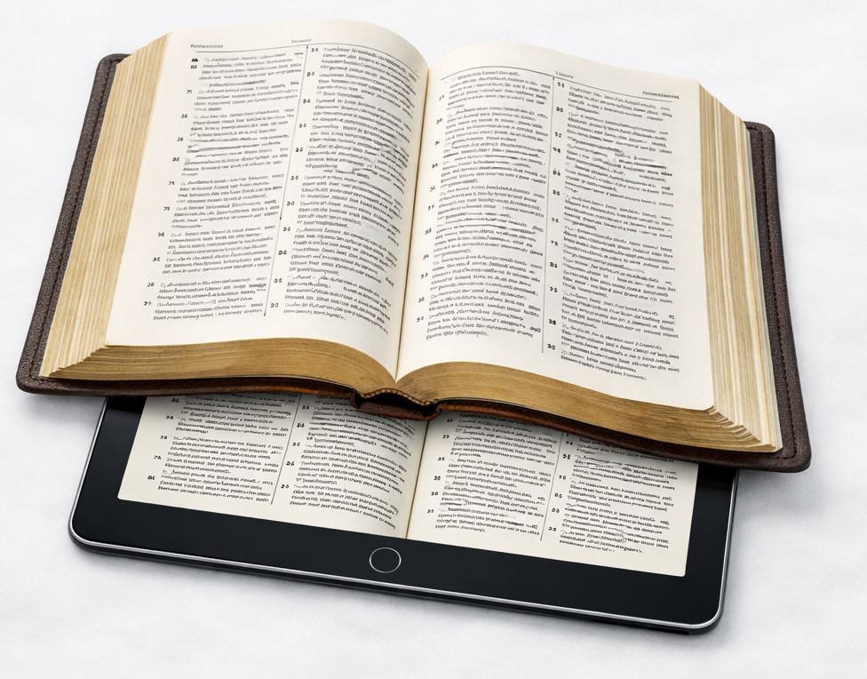
The Lytle Light Page 3

Current Concerns
All Following entries Are By Date Order And Are Alphabetical By Last Name. A Superscripted Number In Brackets, I.E., ^{[1]}, At The End Of An Entry Denotes How Many Weeks The Entry Has Been In The Bulletin.
JUNE 14
- Bailey, Linzi [Ronda Spicer’s niece] – Her liver surgery on Tuesday, June 9th went well, Praise To GOD! ^{[NEW]}
- Brown, Colton, Abby, Phoenix & Atreaus – They now all have a viral infection of the stomach. ^{[NEW]}
- Nicholson, Brad Nicholson [Deborah Newman’s sister’s husband] – He has been diagnosed with frontal lobe dementia – he’s now in a nursing home in Castroville. ^{[NEW]}
- Renninger, Ruane – She’s still exper-iencing much leg discomfort. ^{[NEW]}
- Smoot, Randy [Roger Smoot’s brother] – He fell last Sunday night, admitted to hospital Monday morning, and transferred to Warm Springs Rehab Wednesday afternoon. No broken bones but very weak due to Parkinson’s. ^{[NEW]}
- Sparks, Tim [Tom Woodard’s son-in-law] – He experienced another chest/heart episode. His doctor(s) thinks he may need another stint. ^{[NEW]}
- Spicer, Ronda – Her first cataract surgery on Thursday, June 4 went well, Praise To GOD! She’s scheduled for the second cataract surgery Thursday, June 18. ^{[NEW]}
- Vierling, Gene – As of his last scan, he’s cancer free, Praise To GOD! ^{[NEW]}
- Watkins, Elizabeth & Mitch – Various Health Issues. ^{[NEW]}
- Woodard, Tom & Pat – Praise To GOD! for their safe return from Krum, TX where they attended their grand-daughter’s wedding. ^{[NEW]}
JUNE 7
- Praise To GOD! for Janice & Tim Sparks’ safe return from the 25th wedding anniversary cruise ^{[01]}
Ongoing Concerns
All Ongoing Concern(s) Below Will
Remain For 25 Weeks. Removal Can Be Requested Earlier But Concern(s) Will Automatically Be Removed At The 26TH Week. If Someone Is Moved Off This Ongoing List And You Believe They Should Go Back On The Detailed List Above, Please Let Mitch Know.
Alsup, Dylan ^{[07] •} Anderson, Dale ^{[04] •} Balderrama, Matthew ^{[05]} • Barber, Kathy Family ^{[02]} • Beauchemin, Marvale ^{[04] •} Bippert, Cheryl ^{[07]} • Bradley Family ^{[21] •} Bridgewater, Larry ^{[22]} • Brown, Colton family ^{[16] •} Busse, Duane ^{[05] •} Cashion, Corena ^{[04] •} Cashion, Mark ^{[02] •} Cook, Karen ^{[07] •} Coombs, Derek ^{[15] •} Dolbeare, Robert ^{[08] •} Drake, Paul & Lynn ^{[07] •} Dubose, Belinda Family ^{[02] •} Duncan, Roberta ^{[22] •} Dwyer, Meagan ^{[12] •} Dygert, Harold Family ^{[14] •} Fintel, Rick ^{[23] •} Flatequal Family ^{[22] •} Flatequal, Pam ^{[09] •} Flores, Carlos ^{[22] •} Gonzalez, Joel ^{[25] •} Guzman, Emily Family ^{[13] •} Jackson, April ^{[06] •} Keese, Bob & Katheryn ^{[07] •} Last-Name-Unknown, Irene ^{[10] •} Lester, Bob ^{[25] •} McMeans, Melanie ^{[11] •} McMeans, Wendell ^{[18] •} Melendy Family ^{[05] •} Moore, Jennifer ^{[17] •} Moore, Michael & Michelle ^{[09] •} Moore, Perry ^{[15] •} Moore, Sherry ^{[05] •} Morgan, Mitzy Family ^{[10] •} Morris, Barry ^{[07]} • Mr. Lowe ^{[20] •} Ott, Ronnie ^{[05] •} Persat, Diana ^{[25] •} Pillows, Darlene ^{[07] •} Potter, Edna Family ^{[03]} • Price, Jennifer ^{[19] •} Ranne, Ruth Family ^{[04] •} Renninger, Ruane’s grand-daughter-in-law ^{[19] •} Roeder, Gary ^{[04] •} Schilling, Ina ^{[20] •} Sims, Linda ^{[17] •} Smith, Betty ^{[06] •} Smith, Jimmie (JD) ^{[24] •} Smoot, Bailey ^{[17] •} Smoot, Beth ^{[11] •} Smoot, Cody & Emily ^{[21] •} Smoot, Deborah ^{[02]} • Smoot, Max ^{[14] •} Smoot, Tiffany ^{[23] •} Sparks, Lane & Ashley ^{[16] •} Stepanovich Family ^{[09] •} Street, Cris ^{[22] •} Strickland, Greg ^{[03]} • Vierling, Gene ^{[12] •} Vierling, Scott ^{[24] •} Villereal, Douglas Family ^{[12] •} Walker, Tony Family ^{[24] •} Weisel, Michelle ^{[20] •} White, Linda ^{[15] •} Woodard, June ^{[05]}

Sunny Glen Pantry Requests
See Bulletin Board In Front Hallway For Items Being Requested.
Truck Comes This Tuesday, June 16.

There is a way that seems right to a man, but its end is the way of death.
– Proverbs 14:12
Local, State, National & Global Concerns
- May The Will Of GOD, The FATHER Of LOVE, HOPE, COMPASSION, GRACE, MERCY, And RIGHTEOUSNESS Be Done On Earth As It Is In Heaven!
- People In The U.S.A. And Around The World Who’ve Been Affected By Natural Disasters
- Our Local, State & Federal Government Officials, Military, First Responders & Teachers, Nourishing & Life-giving Rain
- Coronaviruses, Flues & Other Deadly Sicknesses
- Civil Unrest, Racial Strife & Mass Shootings
- War, Unrest & Lack Of Peace In Other Countries

Father, Please Hear Our Prayer

The Lytle Light Page 4
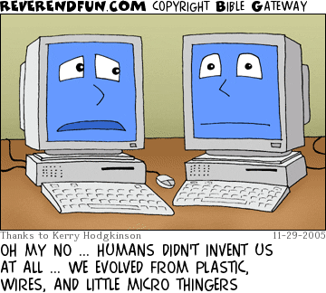

The Lytle Light Page 5
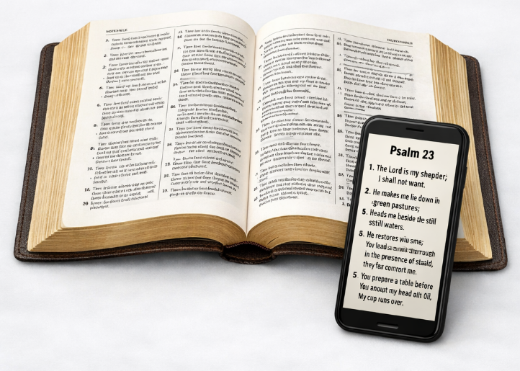
The Lytle Light Page 6
Anniversaries & Birthdays
Tom & Pat Woodard Jun 10 Anniversary

Gaylia Dzielzanowski Jun 20 Birthday
Colton & Abby Brown Jun 21 Anniversary


Viola Dzielzanowski Jun 26 Birthday
Colton Brown Jul 6 Birthday
If Your Special Day Is July 6th Or Before And You Do Not
See Your Name(s) Above Or If Something Is Incorrect, Please Let Mitch Know
Events & Other Stuff

----- Church Stuff ----- Church Stuff ----- Church Stuff ----- Church Stuff ----- Church Stuff -----
4th Or 5th ~Every Table Fellowship Potluck Lunch

Other Sunday Approximately 12PM – 2PM
Every Thursday Sewing Sisters Approximately 12PM – 2PM
Every Tuesday Lytle Friendship Art Club 9:30AM
Every 3RD Mon VFW Auxiliary – Fellowship Room At 6:30PM
Sun – Jun 14 In Search Of The Lord’s Way – Presumption
Tue – Jun 16 Sunny Glen Pickup – See Front Hall Bulletin Board For Items Needed
Sun – Jun 21 In Search Of The Lord’s Way – Thy Will Be Done
--- Non-Church Stuff --- Non-Church Stuff --- Non-Church Stuff --- Non-Church Stuff ---
Sun – Jun 14 Army’s 251st Birthday & Flag Day & Strawberry Shortcake Day
Mon – Jun 15 World Senior Abuse Awareness Day & National Prune Day
Tue – Jun 16 Fresh Veggies Day & National Fudge Day
Wed – Jun 17 National Apple Strudel Day

Thu – Jun 18 International Picnic And Sushi Days & National Cherry Tart Day
Fri – Jun 19 Juneteenth
Sat – Jun 20 American Eagle Day & National ¹Vanilla Milkshake And ²Ice Cream Soda Days
Sun – Jun 21 National ¹Cookie Dough Day And ²Peaches & Cream And ³Smoothie And ⁴Turkey Lovers Days
The Lytle Light Page 7

. . . they received the word with all readiness, and searched the Scriptures daily to find out whether these things were so. – Acts 17:11b


Want To Be
Part Of This Local Family Of Christ Jesus?
To be identified with our Congregation (aka “place membership”): Please fill out a Visitor’s Card, making sure to check the box on front that says, “Wish To Serve In This Congregation.” Please place the completed card in the collection plate on the table in the back of the auditorium.
Read Along W/Tom
Sunday 6/14/2026 Hosea 14
Monday 6/15/2026 Jonah 1
Tuesday 6/16/2026 Jonah 2
Wednesday 6/17/2026 Jonah 3
Thursday 6/18/2026 Jonah 4
Friday 6/19/2026 Amos 1
Saturday 6/20/2026 Amos 2
Memorize Scripture —
2 Timothy 3:16-17 – ¹⁶ All Scripture is given by inspiration of God, and is profitable for doctrine, for reproof, for correction, for instruction in righteousness, ¹⁷ that the man of God may be complete, thoroughly equipped for every good work.
Matthew 24:35 – ³⁵ Heaven and earth will pass away, but My words will by no means pass away.
1 John 4:1 – ¹ Beloved, do not believe every spirit, but test the spirits, whether they are of God; because many false prophets have gone out into the world.

Interactive
Daily Bible Reading Plan —
To open and/or download the interactive PDF file go to: video.wvbs.org/spotlight
Daily Bible Reading For Edification —

Old & New In 365 —
Daily Readings From Both The Old And New Testaments
SUN – Day 169 - Neh 7-8; Act 3
MON – Day 170 - Neh 9-11; Act 4:1-22
TUE – Day 171 - Neh 12-13; Act 4:23-37
WED – Day 172 - Est 1-3; Act 5:1-16
THU – Day 173 - Est 4-6; Act 5:17-42
FRI – Day 174 - Est 7-10; Act 6
SAT – Day 175 - Job 1-3; Act 7:1-19
Neh = Nehemiah | Act = Acts
Est = Esther | Job = Job

[Days Listed Are NOT Days Of The Year
But Days Of The Plan]

The Lytle Light Page 8

