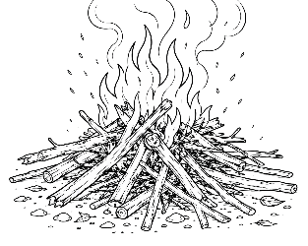
7-12 Year-Olds
9/13/2026
KINDLING
for KIDS!

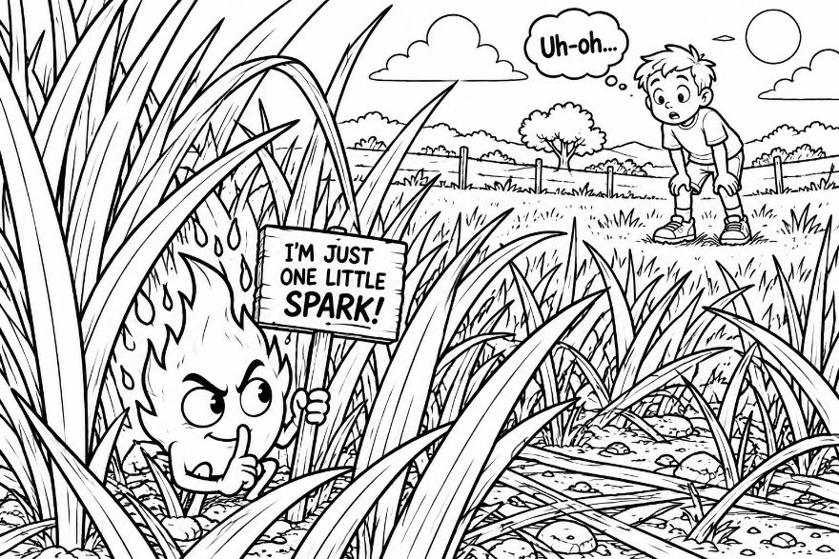
🔥ONE SPARK – Little Things Can Become BIG Things!

ONE LITTLE SPARK...

Imagine a huge field filled with dry grass.

Now imagine one tiny spark landing in it.

It's so small you might hardly notice it.

But that little spark can become a much bigger problem. That's why we're careful around fire. Texas A&M Forest Service teaches that dry grass can catch fire from a small spark.

The Bible tells us something surprising: “See how great a forest a little fire kindles!” (James 3:5).

But James wasn't really teaching a lesson about wildfires. He was talking about... 👅 OUR WORDS!

One little mean comment. One rumor. One angry reply. One secret that wasn't ours to tell. And… SPARK! ⚡

Before long, somebody tells somebody else. Feelings get hurt. People become angry. Friends take sides.
Something that started very small becomes VERY BIG!

🔥THIS WEEK'S BIG QUESTION: AM I STARTING FIRES?

OR PUTTING THEM OUT?**

🔥 MEET THE SPARK STARTERS!

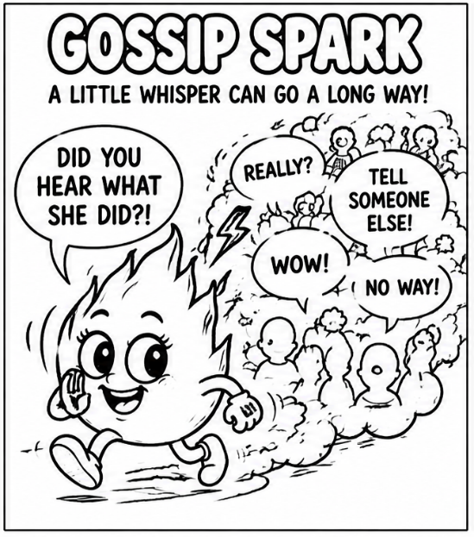
💬 Gossip Spark –

“DID YOU HEAR WHAT SHE DID?!”

You hear something juicy about somebody.

Do you really need to tell someone else?

SPARK!⚡

“A talebearer reveals secrets, but he who is of a faithful spirit conceals a matter” (Proverbs 11:13).

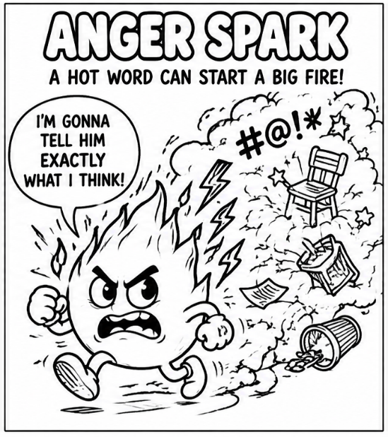
😡 Anger Spark –

“I'M GONNA TELL HIM EXACTLY WHAT I THINK!”

You're angry. Your mouth is loaded and ready.

That's when you need to stop!

“A soft answer turns away wrath, but a harsh word stirs up anger” (Proverbs 15:1).

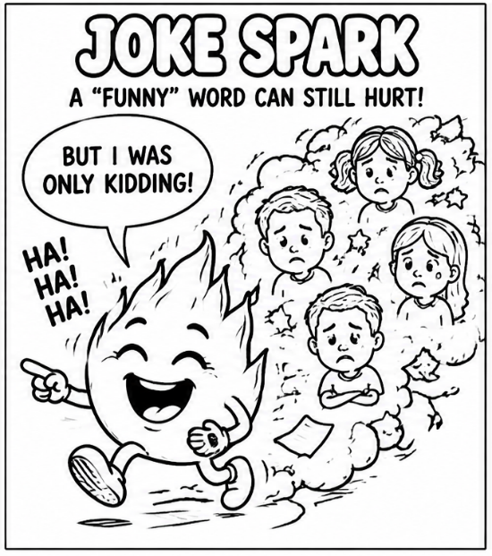
🤡 Joke Spark

“BUT I WAS ONLY KIDDING!”

Sometimes a joke is funny to everybody except the person it's about.

If our joke embarrasses or hurts somebody, saying “just kidding” doesn't magically make the hurt disappear.

“Let no corrupt word proceed out of your mouth, but what is good for necessary edification...” (Ephesians 4:29).

🎮 SPARK STOPPER CHALLENGE

Before you say it, ask:

☐ IS IT TRUE? ☐ IS IT KIND? ☐ DOES IT NEED TO BE SAID?

If not... 🧯 DON'T FEED THE FIRE!

💧 Be A Fire Exinguisher!

Anybody can toss another log onto an argument. Jesus wants us to become people who stop the fire from spreading.

Someone insults you? 🔥 Don't insult them back! • Someone tells you gossip? 🔥 Don't pass it along! • Your friend is angry at somebody? 🔥 Don't make them angrier! • Someone makes a mistake? 🔥 Don't announce it to everyone!

Instead... 💧 DROP A KIND WORD!

“Pleasant words are like a honeycomb, sweetness to the soul and health to the bones” (Proverbs 16:24).
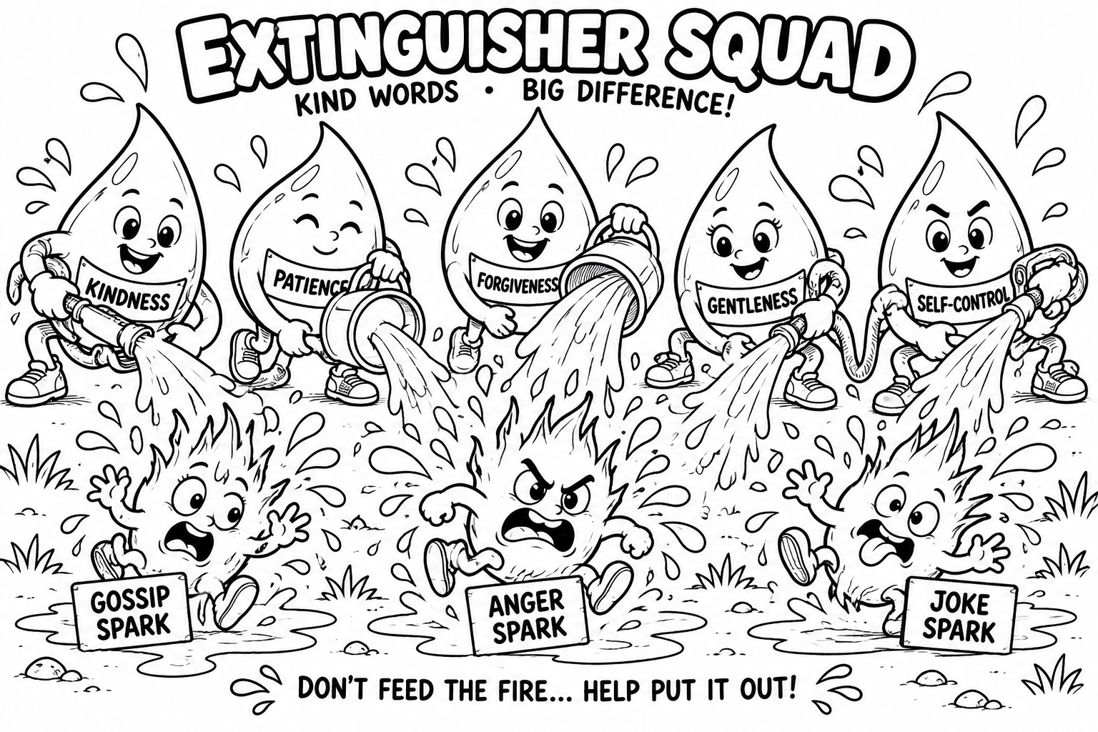
And here's the really neat part: Little things spread both ways! One mean word can spread. But so can...

❤️ ONE KIND WORD 😊 ONE COMPLIMENT 🤝 ONE ACT OF FRIENDSHIP 🙏 ONE PRAYER 🫶 ONE “I FORGIVE YOU”

Maybe instead of starting one spark, you can start... ❤️ ONE SPARK OF KINDNESS!

⭐ KINDNESS CHALLENGE

This week I will start a GOOD spark by:

_________________________________________________________

