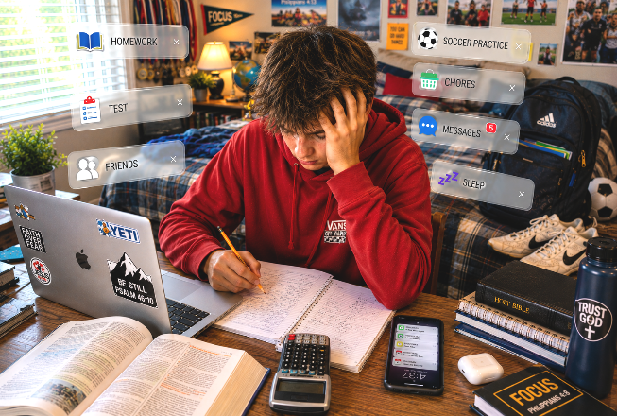

YOUR BRAIN HAS 47 TABS OPEN 🤯🤯🤯🤯🤯🤯🤯🤯🤯🤯🤯🤯🤯
TORCHLIGHT for TEENS
13-16+Year-Olds 8/30/2026

“Come to Me, all you who labor and are heavy laden, and I will give you rest” (Matthew 11:28).

School • Homework • Practice • Friends • Family • Notifications • Tests • Drama • Church • That thing you said yesterday that you're still replaying in
your head... And somehow you're supposed to keep everything running.

Sometimes your brain feels like a browser with 47 tabs open, three videos playing somewhere, and absolutely no idea which tab the music is coming from.

😂 Welcome to being human.

But there's a dangerous idea hiding underneath all that busyness – I should be able to handle this. But Jesus never said that. Instead He said: “Come to Me.”

Christianity isn't about becoming so strong that you eventually don't need God very much. It's exactly the opposite. The more we grow, the more we understand where our strength actually comes from.

THE COMMENT SECTION 💬

Which response sounds most like YOU when you're overwhelmed?

□ “I'm fine.” (Definitely not fine.)
□ “I'll deal with it later.”
□ “Nobody understands.”
□ “I'll just try harder.”
□ “God, I need Your help.”

Then: Which response does Jesus actually invite you to make?

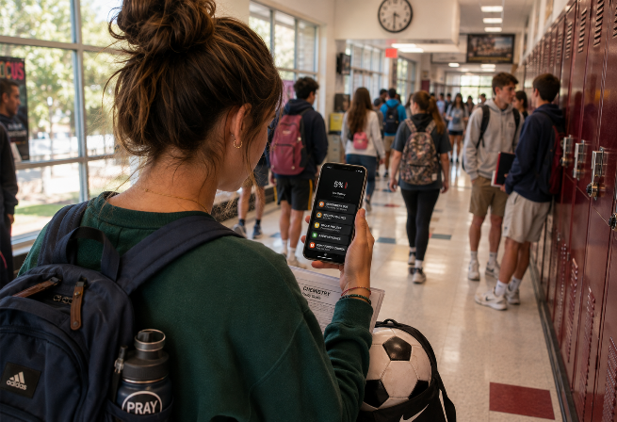
5% BATTERY. 100% DEMAND. 🪫

“He gives power to the weak, and to those who have no might He increases strength” (Isaiah 40:29).

You know the moment. BATTERY: 5% Suddenly you're making decisions. Battery saver goes on. Brightness goes down. Apps get closed. Videos stop.

Why?

Because you know something important: THE POWER IS LIMITED. Here's something harder to admit: So is yours.

You cannot endlessly spend physical energy, emotional energy, attention, patience, and mental energy without eventually running low. But sometimes we act as though being exhausted means we've failed. But Isaiah says otherwise. God “gives power to the weak.”

Weakness isn't proof that God has abandoned you. Sometimes recognizing your weakness is what finally makes you stop pretending you're the power source.

BATTERY CHECK 🔋

What drains YOUR battery?

📚 School pressure
📱 Social media
🏃 Activities
👥 Friend drama
😟 Worry
😴 Not enough sleep
🎮 Staying online too long
🏠 Family responsibilities

Circle your biggest three.

Then:

What have you been trying to handle yourself without asking God for help?
________________________________________________________________________________________________________________________________________________


PLUG INTO THE SOURCE ⚡

“But those who wait on the LORD shall renew their strength” (Isaiah 40:31).

Imagine your phone battery hits 1%.

So you sit beside the charger. You look at the charger. You admire the charger. You tell everyone: “That's an awesome charger.” Then you walk
away without plugging in you phone. 😂Your phone is still dying.

Sometimes Christians do something strangely similar. We own a Bible. We believe prayer matters. We attend worship. We know God is there. But when life gets crazy, those are sometimes the first things that get squeezed out.

Jesus once told His exhausted disciples: “Come aside by yourselves to a deserted place and rest a while” (Mark 6:31).

Notice something important. They weren't exhausted from doing bad things. They were exhausted from doing good things. You can fill your life with good activities and still become spiritually empty. The answer isn't necessarily: DO LESS.

Well, sometimes you can't. Instead, the answer is: STOP TRYING TO BE YOUR OWN POWER SOURCE.

Prayer isn't another item on your schedule. God's Word isn't another homework assignment. Worship isn't another obligation. They're ways we turn toward the God whose strength doesn't run out.

CHARGING STATION

Draw a line between each problem and the proper Scripture:

WORRY |  | Matthew 11:28
EXHAUSTION |  | Psalm 46:10
WEAKNESS |  | 1 Peter 5:7
CHAOS |  | Proverbs 3:5–6
NEEDING DIRECTION |  | Isaiah 40:29

“BE STILL” DOES NOT EQUAL “DO NOTHING”

“Be still, and know that I am God” (Psalm 46:10).

“Be still” can sound like: Stop doing stuff. But there's something much bigger happening in that verse. God says: “Be still, and KNOW that I am GOD.” In other words: Stop for a mo-
ment. Remember who God is. And remember something else: YOU'RE NOT HIM.

You don't have to control everything • You don't have to know everything • You don't have to fix everyone • You don't have to have your entire future figured out • You don't have to pretend you're okay when you need help.

Peter says: “Casting all your care upon Him, for He cares for you” (1 Peter 5:7).

Why give God your worries? Not because they don't matter. Because YOU matter to HIM.

So this week, when everything hits at once and your internal battery starts flashing red, remember:

🔋WHEN LOW POWER MODE HITS –

STOP • ✋I don't have unlimited strength • PRAY 🙏 God, I need You • UNLOAD🎒Give Him what you're carrying • CONNECT🔌Spend time with God and His Word • GO 👟Do the next thing God has given you to do.

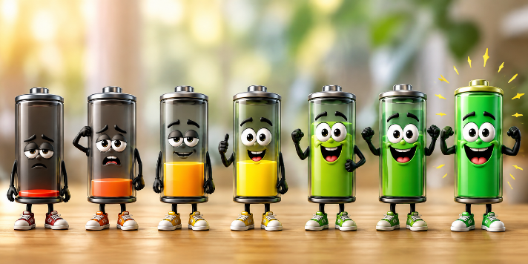
And remember – you weren't designed to generate unlimited power – you were designed to depend upon God.

And fortunately – HIS BATTERY NEVER DIPS BELOW 100%.

