

🕰️WHEN IT FINALLY CLICKS
TORCHLIGHT for TEENS
13-16+Year-Olds 8/30/2026
That moment when your brain finally goes… Ohhhhhhhh. 😳

Ever have something suddenly make sense WAY later than it should? Your parents warned you • Your teacher explained it • Your friend tried to tell you • You ignored everybody. Then three weeks, six months, or two years later... WAIT. WHAT? THAT'S WHAT THEY MEANT?!

Sometimes God's Word works a little like that. You can read the same verse ten times and think, Yeah,
yeah, I know this one. Then one day something happens – and suddenly that verse isn't just words on a page anymore. IT CLICKS. James says: “But be doers of the word, and not hearers only, deceiving yourselves” (James 1:22).

Knowing what God says isn't the same thing as living what God says.

- Maybe you've heard “forgive” a hundred times. Then somebody actually hurts you.
- You've heard “do not worry.” Then something happens that scares you.
- You've heard “love your enemies.” Then you meet somebody who's really hard to love.

Suddenly Christianity isn't a vocabulary test. It's real life.

Put a ✔ beside any you've discovered:

☐ Mom or Dad actually knew what they were talking about.
☐ That “friend” wasn't really acting like a friend.
☐ Gossip really DOES cause problems.
☐ One stupid decision can have consequences.
☐ Being popular isn't the same as being liked.
☐ God's rules aren't there to ruin my fun.
☐ Forgiving someone doesn't mean what they did was okay.
☐ Reading the Bible is different from actually DOING what it says.

💡 YOUR TURN

What's something about following Jesus that's beginning to make more sense as you get older?
________________________________________________________________________________________________________________________________________________

DON'T JUST GET IT. LIVE IT.

😎 THE AURA METER – How much aura did that cost you?

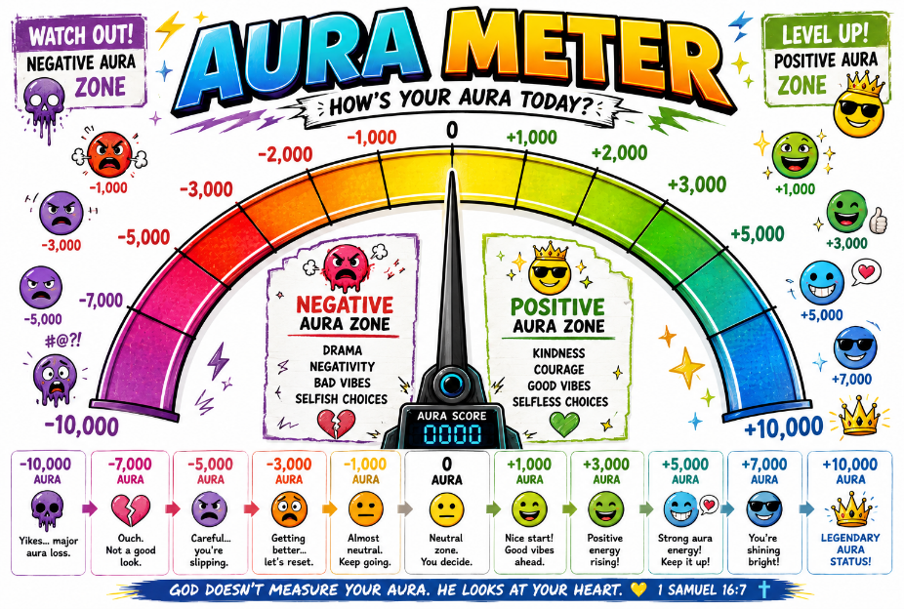
You walk confidently into class • Backpack over one shoulder • Perfect entrance • You sit down • Wrong classroom. 💀 -8,000 AURA

As you probably know, “Aura” is internet slang for that imposs-ible-to-measure cool-ness, confidence, pr-esence, or respect somebody seems to
have.

So, let's calculate your completely scientific, definitely legitimate...

📊 AURA SCORE – Write + or - and give each one an Aura Score from 1 to 10,000.

You trip in the cafeteria, get up, and pretend nothing happened.
AURA Score: __________
You stand up for somebody who's being picked on.
AURA Score: __________
You tell a joke. Nobody laughs.
AURA Score: __________
You help someone without posting about it.
AURA Score: __________
You wave back at somebody...then realize they were waving at the person behind you.
AURA Score: __________
Your friends start gossiping and you refuse to join in.
AURA Score: __________
You answer the teacher confidently. You're completely wrong.
AURA Score: __________
You apologize first even though it's embarrassing.
AURA Score: __________
Your phone rings during something VERY quiet.
AURA Score: __________
You sit beside the kid everybody else ignores.
AURA Score: __________


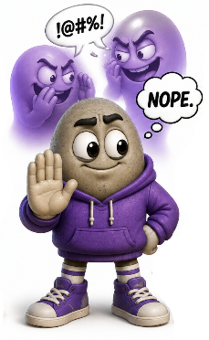
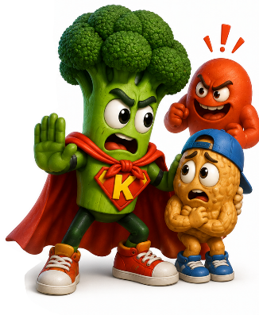

⚠️ PLOT TWIST

God doesn't care about your Aura Score. Samuel once looked at a man who LOOKED like God's obvious choice. God told him: “For the LORD does not see as man sees; for man looks at the outward appearance, but the LORD looks at the heart” (1 Samuel 16:7).

We spend enormous amounts of energy worrying about what other people see.
Do I look cool? Did that sound stupid? What will they think?
God looks deeper – He sees your motives – Your kindness – Your honesty – Your courage – Your character. So maybe the important question isn't: 😎 “HOW'S MY AURA?” Maybe it's: ❤️ “HOW'S MY HEART?”

⏰ SCHOOL MORNING BOSS BATTLE

⚠️ BOSS APPROACHING...

ALARM: 6:30 AM

😴 Five more minutes.

ALARM: 6:35 AM

😴 Five more minutes.

ALARM: 6:40 AM

😴 I'm getting up.

TIME: 7:14 AM

😳

🚨 BOSS BATTLE INITIATED
OBJECTIVE: LEAVE HOUSE
TIME REMAINING: 11 MINUTES
DIFFICULTY: 💀💀💀💀💀

🎮 COMPLETE THE MISSION
☐ Find clothes
☐ Brush teeth
☐ Find OTHER shoe
☐ Backpack
☐ Homework
☐ Phone
☐ Charger
☐ Breakfast???
☐ Where are my keys???
☐ WHY IS EVERYBODY YELLING?!


🥔 PROCRASTINATION POTATO HAS ENTERED THE CHAT

“Relax. You can do it later.”

That's funny when we're talking about getting out of bed.

It's not so funny when “later” becomes how we live.

I'll apologize later • I'll forgive them later •
I'll start praying later • I'll read my Bible
later • I'll help them later • I'll get serious
about following Jesus later.

There's always another tomorrow...
until there isn't.

The Bible says: “Therefore, to him who knows to do good and does not do it, to him it is sin” (James 4:17).
Notice what it doesn't say: Knowing what's right is enough.

God calls us to DO what we know is right.

⏰ WHAT HAVE YOU BEEN PUTTING OFF?

Think of ONE thing you already know God wants you to do.

Now finish this sentence: INSTEAD OF “LATER,” THIS WEEK I WILL...
________________________________________________________________________________________________________________________________________________

🏆 FINAL BOSS STRATEGY

You don't have to fix your entire life today. Just stop using tomorrow as an excuse for something you can do today.

🥔 PROCRASTINATION POTATO: “You can always start tomorrow...”

✝️ JESUS: FOLLOW ME TODAY.

⏰ STOP SNOOZING ON WHAT MATTERS.

🗣️ TRANSLATE THE TEENAGER – CAN YOU SPEAK 2026?

Did you know that teen slang changes approximately every seventeen minutes.*

*Not scientifically verified.

See whether you can translate.

TEEN → ADULT

1. “Bro lost 10,000 aura in front of the whole class.”
Translation: ____________________________________________________________

2. “That's actually a W.”
Translation: ____________________________________________________________

3. “Unc is NOT surviving this.”
Translation: ____________________________________________________________

4. “Bro is aura farming.”
Translation: ____________________________________________________________

5. “My brain is cooked.”
Translation: ____________________________________________________________

📖 NOW TRANSLATE THE BIBLE

Rewrite these Bible moments in completely ridiculous modern teen-speak.

🦁 DANIEL
Daniel refused to stop praying even though it meant being thrown into a den of lions.
TEEN TRANSLATION: _________________________________________________
________________________________________________________________________
Example: “Daniel walked into the lion situation with +∞ aura.”

🪨 DAVID
Everybody was afraid of Goliath. David walked onto the battlefield with a sling and trusted God.
TEEN TRANSLATION: _________________________________________________
________________________________________________________________________

🔥 SHADRACH, MESHACH & ABED-NEGO
The king threatened them with a fiery furnace. They still refused to worship his idol.
TEEN TRANSLATION: _________________________________________________
________________________________________________________________________

🐋 JONAH
God told Jonah to go to Nineveh. Jonah went approximately... THE COMPLETE OPPOSITE DIRECTION.
TEEN TRANSLATION: _________________________________________________
________________________________________________________________________

🐓 PETER
Peter confidently told Jesus he would NEVER deny Him. A few hours later... He denied Him three times.
TEEN TRANSLATION: _________________________________________________
________________________________________________________________________

🤔 LANGUAGE CHANGES. TRUTH DOESN'T.

People don't speak exactly the way they did 2,000 years ago.

Words change • Slang changes • Memes change • Cultures change.

But God's truth doesn't expire when the internet finds a new vocabulary.

“The grass withers, the flower fades, but the word of our God stands forever” (Isaiah 40:8).

Today's slang will eventually sound ancient. God's Word won't.
NO TRANSLATION REQUIRED.

🎉 THINGS WE SHOULD BE WEIRDLY EXCITED ABOUT – WHY IS NOBODY FREAKING OUT ABOUT THIS?!

We know how to get excited. Your team wins. Your favorite game finally updates. The food arrives. School gets canceled. Somebody texts: “NO HOMEWORK TONIGHT.” And suddenly: 🎉🙌🔥 LET'S GOOOOOOO!!!

But sometimes the things that deserve our BIGGEST reaction get almost none. Think about it...

🚨 This actually happened! SOME-BODY KEPT THEIR PROMISE!
🎉👏🥳 WOW! WE HAVE A PERSON WHO ACTUALLY DID WHAT THEY SAID THEY WOULD DO!

Your friend stood up for you when you weren’t there!
🔥🙌🏆 FRIENDSHIP LEVEL: LEGENDARY.

Somebody admitted they were wrong!
😳🎉👏 WAIT...PEOPLE CAN DO THAT?!

You got eight hours of sleep!
😴🏆🎊 ABSOLUTE VICTORY.

Somebody included the person everybody else ignored!
❤️🔥🙌 THIS DESERVES MORE ATTENTION.

But here's an even bigger one:

✝️ GOD WANTS YOU.

The Creator of the universe knows your name • He hears you when you pray • He forgives • He gives second chances • He gave His Son for you.

And sometimes our response is basically: “Oh. Cool.”

Meanwhile, a notification appears on our phone: 😱😱😱 Something might be backward. David wrote: “I was glad when they said to me, ‘Let us go into the house of the LORD’” (Psalm 122:1).

David didn't say: “Fine. I guess I'll go.” He was GLAD.

🤩 YOUR HYPE METER

Rate these from 😐 MEH to 🤯 THIS IS AMAZING!

Someone forgives you:
😐 1 — 2 — 3 — 4 — 5 🤯
An answered prayer:
😐 1 — 2 — 3 — 4 — 5 🤯
A friend tells you the truth:
😐 1 — 2 — 3 — 4 — 5 🤯
Getting to worship with other Christians:
😐 1 — 2 — 3 — 4 — 5 🤯
Realizing God gave you another day:
😐 1 — 2 — 3 — 4 — 5 🤯
Knowing God hears you when you pray:
😐 1 — 2 — 3 — 4 — 5 🤯

MAYBE WE NEED TO GET EXCITED ABOUT BETTER THINGS.
🎉 SOME THINGS REALLY ARE WORTH THE HYPE🎉

