
TORCHLIGHT for TEENS
13-16+Year-Olds 9/13/2026

🔥 ONE SPARK – IT WAS JUST ONE COMMENT...

“See how great a forest a little fire kindles!” (James 3:5).

Nobody planned for it to become a big deal • Somebody made one comment • Somebody else repeated it • Someone added a detail • A screenshot appeared • Then another person sent it to another group • By lunch... 🔥🔥🔥...every-body knew. Except half of what everybody “knew” wasn't even true.

James compares our words to something surprisingly small: A spark.

One tiny spark doesn't look dangerous • Neither does one sarcastic comment • One rumor • One angry text • One embarrassing photo • One joke at somebody else's expense.

But sparks don't always stay small. Neither do words.

📱 WATCH THE FIRE SPREAD
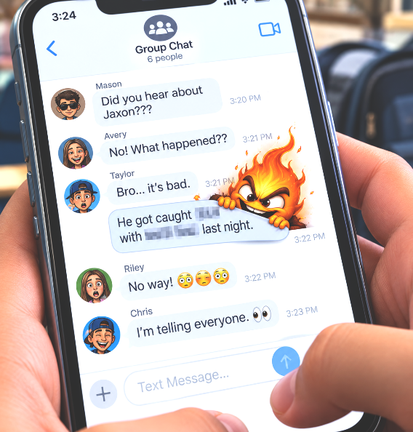

8:03 AM
Someone texts:
“Did you hear what happened?”
⬇️
8:07 AM
Three people know.
⬇️
8:19 AM
Somebody screenshots it.
⬇️
9:02 AM
Someone adds something that might have happened.
⬇️
10:26 AM
People who don't even know the person are talking about it.
⬇️
12:14 PM
🔥 THE WHOLE SCHOOL “KNOWS.”

And it started with... one spark.

🧯 BEFORE YOU PASS IT ON... Ask:

🔎 Do I KNOW it's true? 💚 Is repeating it kind? 🎯 Does anyone actually need to know? ✝️ Would sharing it honor Jesus? If not...

LET THE FIRE DIE WITH YOU.

THE SPARK TEST – HOW FAST CAN ONE LITTLE THING SPREAD?

Imagine someone posts: “I heard Alex got kicked off the team.” You don't know whether it's true. But... YOU SEND IT TO 3 PEOPLE. Each of those people sends it to 3 more. Then each of those send it to 3.

Complete the chain:

YOU: 1
ROUND 1: 3
ROUND 2: ______ (Hint: It’s 3x3x3 or 3³)
ROUND 3: ______ (Hint: It’s 3x3x3x3 or 3⁴)
ROUND 4: ______
ROUND 5: ______
ROUND 6: ______

ANSWER: By Round 6, your one message could have reached 729 people in this simplified example! All because somebody pressed: SEND.
Of course, real life doesn't spread in a perfect mathematical pattern. Sometimes something dies immediately. Sometimes it spreads even faster. That's the point. Once you release something, you don't control where it goes.
James writes: “And the tongue is a fire, a world of iniquity” (James 3:6).

🧠 BUT THERE'S ANOTHER SIDE... What if the spark is GOOD?

One encouragement • One invitation • One person standing up for somebody • One apology • One act of kindness • One person willing to say: “Guys, that's not funny.”

GOOD CAN SPREAD TOO!

⚡ START A DIFFERENT FIRE

Check or Write ONE thing you could deliberately spread this week:

☐ Encouragement
☐ Kindness
☐ Truth
☐ Forgiveness
☐ Courage
☐ Invitation
☐ Other: ______________________

Then name one person you can start with:
________________________________________________________________________

YOUR SPARK WILL SPREAD SOMETHING.
CHOOSE WHAT YOU LIGHT.

🧯 BE THE EXTINGUISHER – BECAUSE EVERY GROUP HAS SOMEBODY HOLDING THE MATCH.

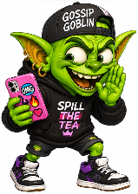
You've already met:

🗑️ GOSSIP GOBLIN – “DUDE...did you hear?!”
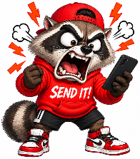
Special ability: Can turn “I'm not sure” into “EVERY-
BODY KNOWS.”
🔥 RAGE RACCOON – “SEND IT!”

Special ability: Types immediately. Regrets eventually.
🦙DRAMA LLAMA – “I'M NOT GETTING INVOLV-ED...”
...and proceeds to become extremely involved.
Special ability: Adds approximately 73% more drama
to every situation.

But then there's somebody else.

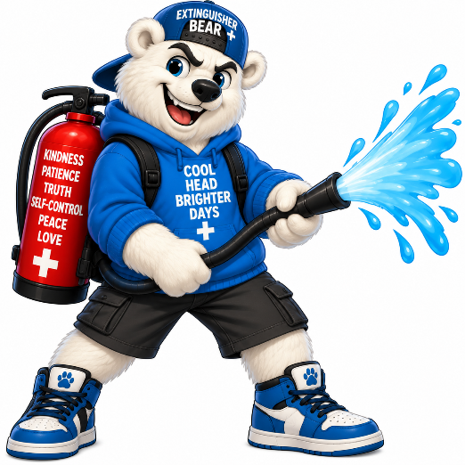
🧯 THE EXTINGUISHER – Who refuses to keep feeding the fire!

Jesus said: “Blessed are the peacemakers, for they shall be called sons of God” (Matthew 5:9).

Notice Jesus didn't say: Blessed are the people who WATCH peace happen. He used the word PEACEMAKERS. Those who MAKE peace. That sometimes requires courage.

🎮 CHOOSE YOUR MOVE

Someone starts gossiping.
🔥 MOVE A: “WAIT – tell me everything.”
🧯 MOVE B: “Maybe we shouldn't talk about them when they're not here.”

A friend is furious and wants to send an angry text.
🔥 MOVE A: “DO IT!”
🧯 MOVE B: “Give it ten minutes before you send anything.”

Everyone is laughing at somebody.
🔥 MOVE A: Join in so nobody turns on you.
🧯 MOVE B: Don't laugh – and if you can, change what's happening.

YOU said something that started trouble.
🔥 MOVE A: Blame somebody else.
🧯 MOVE B: “That was me. I shouldn't have said it. I'm sorry.”

🧯 THIS WEEK'S CHALLENGE

You don't have to control everybody else's words. Start with yours. Before you speak... Before you post... Before you forward... Before you hit SEND... Remember: ONE SPARK CAN START THE FIRE. ONE PERSON CAN STOP IT. And sometimes... THAT PERSON NEEDS TO BE YOU.

