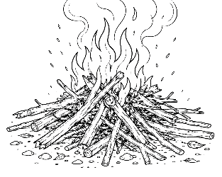
7-12 Year-Olds
7/12/2026

KINDLING
for KIDS!

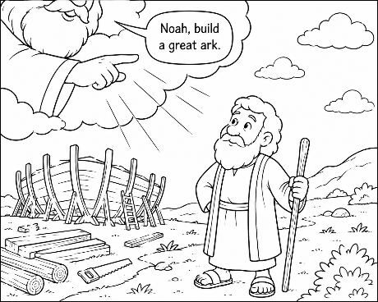
Living for God Like Noah Did!
"Choosing to Follow God Every Day"

Key Verse – "But Noah
found grace in the eyes of the LORD" (Genesis 6:8).

Noah Chose to Follow God

Devotional

Long ago, people forgot about God. Many people chose to do wrong every day. But one man was different. His name was Noah. Noah loved God. He listened to God and obeyed Him, even when everyone else laughed at him.

Sometimes it can feel like everyone around us is making bad choices. Maybe kids make fun of someone, tell lies, or leave others out. But God wants us to be like Noah – we don't have to follow the crowd – like Noah, we can choose to follow Jesus every day.

Memory Verse – "Trust in the LORD with all your heart" (Proverbs 3:5).

Word Search

Words: Noah • Ark • God • Faith • Trust • Love
Animals • Family • Obey • Grace • Rainbow • Flood

R N V G W F A I T H M C G A K R A L P M
H T V X I L A E G V V D O C D D M J C O
I Q B S C K K K U W F J D U R U V N B B
L C Z Q O Q J U E L Y Y O G K H I F O E
F V N G F S L X O X S L M M S S R R O Y
O O Z V S M M O P T P I G T S U R T D U
E G J L A H D I G G L M J F O Y M F R B
M X E D V V V F S E F A B S F L U F C F
L R C G M R D W M R U F R N O A L C W S
R S B T J Y L H L O B J O E H N A K P L
G K Q F A L C R F Y G R A C E I A H Y T
C I V B M X N H Q V F K X E A M Z W E B
R B O R R Z T A A Z V B T L B A J R A P
V S L B Z K G O Y E A Z U C D L A W K T
J V O F G H K N Y V R K S G O S B K T C
P J S Q K C G D K O B Y V C T D O O H E
D R A I N B O W E L R Y L M F C R G B Y
S I H Q H Y Q J R Q E C U U R R W B A F
L C E E C O A S M R G P M O P F W A M U
T V A Z V U Y U D H O I R T N P I B F M
Did You Know?

The Bible says Noah brought animals onto the ark two by two, and for some animals God instructed
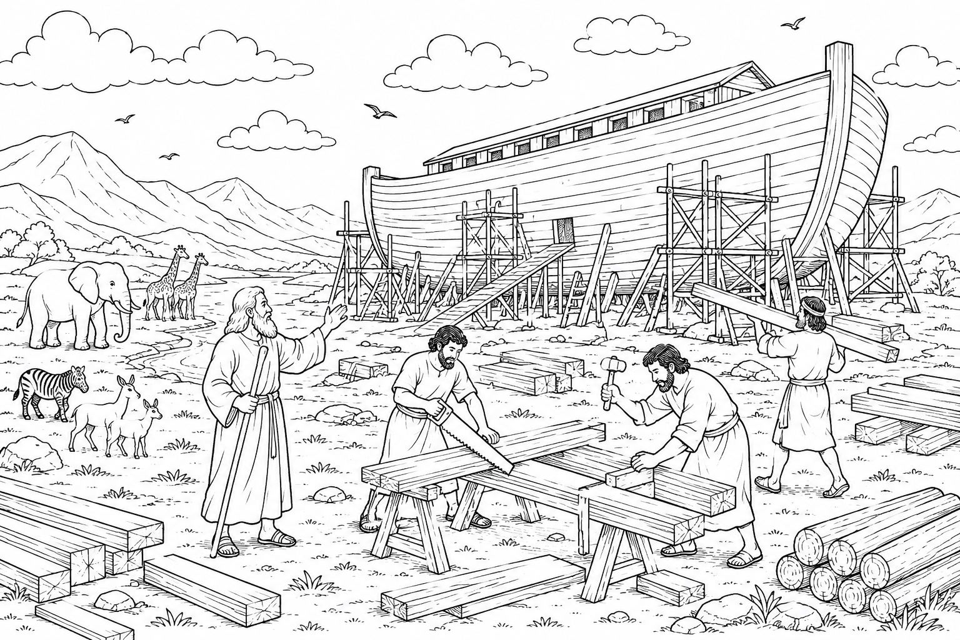
Noah to bring seven pairs. God planned everything perfectly! (Genesis 7).

God Always Keeps His Promises

Devotional

After the Flood, God placed a beautiful rainbow in the sky. The rainbow reminds us that God always keeps His promises. People sometimes forget promises. God never forgets.

Every promise in the Bible shows us that God is faithful.
When God says He loves you... He really does. When God says He will never leave His children... He means it.

Memory Verse – "I will never leave you nor forsake you" (Hebrews 13:5).

Maze – Help The Animals Find Noah’s Ark

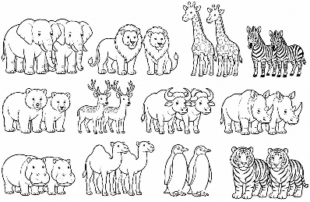
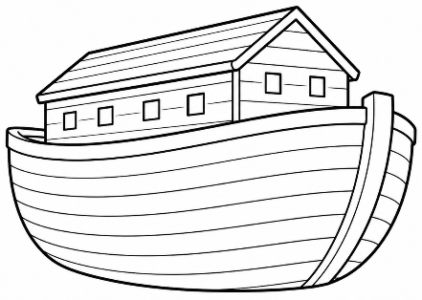
Did You Know?

The ark was enormous!

It was was about
450 feet long –
about the
length of
one and
a half

foot-
ball fi-
elds! That
gave plenty of
room for the an-
imals God Brought
to Noah!

