
TORCHLIGHT for TEENS
13-16+Year-Olds 7/26/2026

Noah Then . . . Us Now (Part Three)


THE DOOR WAS SHUT

Main Verse – “I have set My rainbow in the cloud, and it shall be for the sign of the covenant between Me and the earth” (Genesis 9:13)

When God Keeps His Promises – Have you ever waited for something that felt like it would never happen? Maybe it was summer vacation. A big game.
Graduation. A family trip. Waiting can be difficult. Noah knew what it meant to wait.

For years he built the ark while people ignored God's warning. Day after day he trusted God's promise, even though nothing around him seemed to change. Then one day... Everything changed. The animals entered the ark. Noah's family stepped inside.

And then the Bible records one of the shortest – but most powerful – sentences in all of Scripture: “...and the LORD shut him in” (Genesis 7:16). Noah didn't close the door. God did.

That moment marked the end of God's invitation and the beginning of His judgment. For many years, God's patience had given people time to repent. But they chose not to listen. The door that had stood open was now closed.

A Picture of God's Mercy – It's easy to focus on the Flood itself, but don't miss what came before it.

Before the rain... There was a warning. Before judgment... There was an invitation. Before destruction... There was an ark. The ark reminds us that God delights in rescuing people who trust Him. Throughout the Bible, we see the same pattern.
Word Search

INVITATION • LOVES • CARES JUDGMENT • LIFE • PEOPLE DESTRUCTION • EXPERIENCED DELIGHTS • FAITH • RESCUING SAFETY • WARNS • PATTERN TRUSTED • REMOVES • CALLS STORM • DIFFICULTY

W X B Z O D L L X W J S Z
S Y Q G R U Y S S Q T J S
E W Z A N G T Y F O T P J
R L Y R S I L D R W W X T
A K P W E X U M U V Z C A
C Z Z N D C C C S V Y F R
G A T B E A I N S Q S S U
U J U X C L F O Z E E J V
N U P O N L F X P V R O L
O D P S E S I F O L I S N
I G A E I X D M F Q I P R
T M K V R B E U W N Z D K
C E S O E R P Q H L T E F
U N A L P X E T I M R T F
R T F O X X O V H N I S J
T L E H E S P Y I N F U D
S K T W R V L V V A P R E
E G Y A L N E I I A T T L
D K G R A W T T T G W G I
P I S Y A A H T H Q Z H G
Q C B R T V E A S N P Q H
P R N I I R L I F E M D T
M S O S N S Z V D Z X R S
F N S S A D Z E H X M J R

God warns because He loves. God calls because He cares. God rescues those who place their faith in Him. That doesn't mean following God removes every difficulty from life. Noah still experienced the storm. But he experienced it from a place of safety because he trusted God before the storm arrived.

Then... and Now – Noah trusted God's promise even when he couldn't yet see the rain. Today, Christians trust God's promises even when we cannot see everything He is doing. And remember, faith isn't pretending problems don't exist. Faith is believing God is faithful even when life is uncertain.

Think About It – Why do you think so many people ignored Noah's warning? Why is it sometimes difficult to trust God before we see the outcome? Can you think of a time when trusting God helped you through a difficult situation? How
does God's promise to Noah encourage your faith today?

Did You Know? – The rainbow wasn't simply a beautiful part of nature. God chose it as a reminder of His covenant – a promise that He would never again destroy all the earth with a flood (Genesis 9:11–17). Every rainbow points us back to God's faithfulness.

Memory Verse Challenge – “I have set My rainbow in the cloud, and it shall
be for the sign of the covenant between Me and the earth” (Genesis 9:13).

Can you memorize this verse before next Sunday?

This Week's Challenge – The next time you see a rainbow – or even a picture of one – pause for a moment and thank God for keeping His promises. Then ask yourself: “Am I trusting His promises in my own life today?

HOPE AFTER THE STORM

Main Verse – “Then Noah built an altar to the LORD...” (Genesis 8:20)

What's the First Thing You Would Do? Imagine spending more than a year inside the ark (it was day 150 when the ark came to rest on Mount Ararat and another 220 days for the earth to become dry enough for Noah and his family to disembark from the ark).

You've heard the rain. You've felt the waves. You've waited... and waited... and waited. Finally, the ark comes to rest. The door opens. Fresh air fills your lungs. Solid ground is beneath your feet.

What do you think you would do first?

• Would you run? • Explore? • Build a home? • Celebrate? •

Well, the Bible tells us what Noah did – He worshiped. Genesis 8:20 says, “Then Noah built an altar to the LORD...” Before building a house... Before planting crops... Before beginning a new life... Noah stopped to thank God.

That simple act teaches us an important truth: A grateful heart remembers the One who brought it safely through the storm.

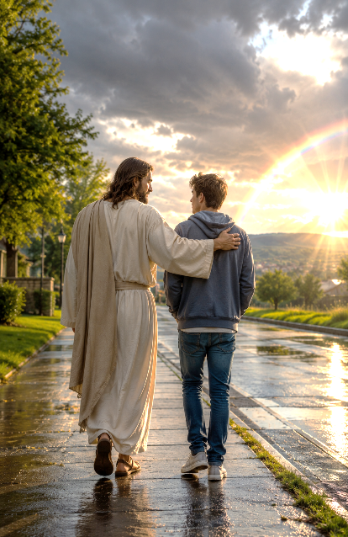
Fortunately, Storms Don't Last Forever – Every teenager faces storms. Sometimes they're easy for others to see. Sometimes they're hidden deep inside. You may struggle with:

Feeling Left Out • Family Problems • Anxiety About The Future • School Pressure • Fear Disappointment • Loneliness • Temptation

The good news is NOT that Christians never experience storms. The good news is that God walks with His people through them. Noah still experienced the flood. But God never abandoned him. The same God who remembered Noah (Genesis 8:1) remembers His children today.

The Rainbow Was More Than Beautiful – When God placed the rainbow in the sky, He wasn't creating something magical. He was giving people a reminder. Every rainbow points back to God's covenant – His promise. And God always keeps His promises.

Sometimes He answers immediately. Sometimes we wait. Sometimes His answer looks different than we expected (This may be the hardest). But His faithfulness never changes. That's why biblical hope isn't based on our circumstances. It's based on God's unchanging character.

Faith Under Pressure – A Scenario

You've prayed about something important for a long time. Nothing seems to be happening. How do you respond?

□ Give up praying.
□ Decide God doesn't care.
□ Keep trusting that God hears and knows what's best.
□ Ask mature Christians to pray with you and encourage you.

Remember: Waiting on God isn't wasted time. He is still working – even when we can't yet see it.

Bible Detective – Read these verses and write what each one teaches about hope. Use a separate sheet of paper if you need more room to write.

Isaiah 40:31 _____________________________________________________
Romans 15:13 _____________________________________________________
Hebrews 10:23 _____________________________________________________
Psalm 62:5 _____________________________________________________
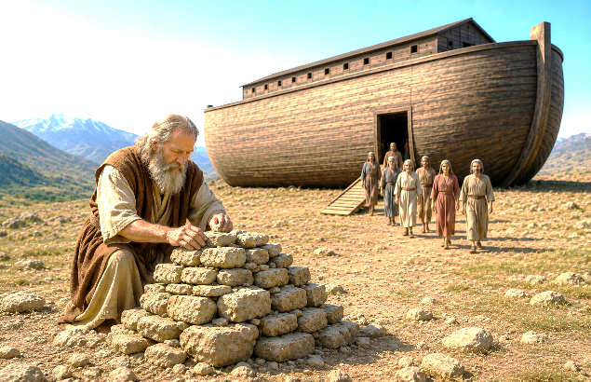
Did You Notice? – Genesis 8:1 begins with these powerful words: “Then God remembered Noah...” I don’t believe that this meant that God had forgotten him. In the Bible, when God “remembers,” it often means He is about to act according to His promises. No, Noah wasn't forgotten. Neither are you.

Think About It – Why do you think Noah worshiped before doing anything else? What “storms” do teenagers often face today? How can gratitude help us during difficult times? Is there something God has brought you through that you can thank Him for today?

Prayer – Heavenly Father, Thank You for being faithful in every season of life. Help me to trust You when life is difficult and to thank You when You bring me through the storm. Teach me to remember Your goodness, to worship You with a grateful heart, and to place my hope in Your promises rather than my circumstances. In Jesus' name, Amen.

Faith Builders – Hope Is Built on God's Promises

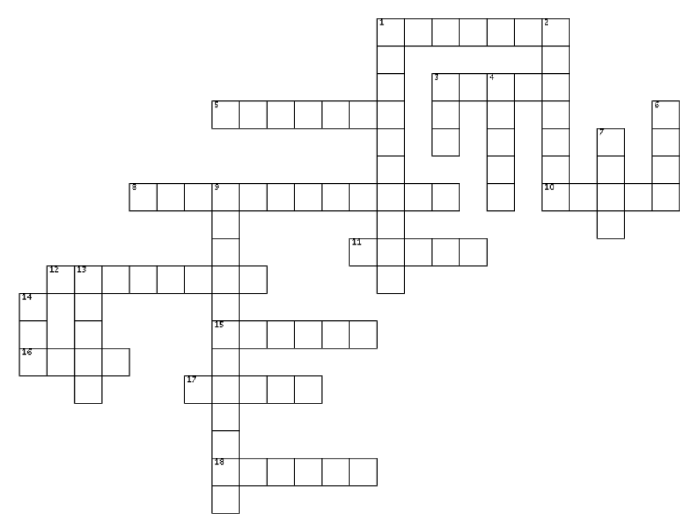
Hope Crossword
Down
1. What God did for
Noah after the
flood.
2. Honoring and
praising God.
3. The huge boat
that protected
Noah's family.
4. Depending on
God even when
you can't see the
future.
6. Confident
expectation be-
cause God keeps
His promises.
7. The man who
trusted God and
built the ark.
9. Showing
gratitude for
God's blessings.
13. The leaf that
showed dry land
was near.
14. The Creator who
saved Noah.
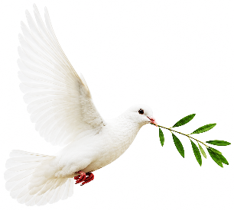

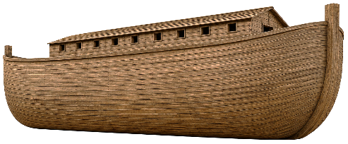

Across
1. God's colorful sign of His promise.
3. A place built to honor God.
5. A commitment that should be kept.
8. Always doing what is right and true.
10. The calm God gives His people.
11. Kindness shown when punishment is
deserved.
12. A special promise God made.
15. The eight people saved on the ark.
16. The bird that returned with an olive leaf.
17. The worldwide judgment in Noah's day.
18. Protection found by obeying God.


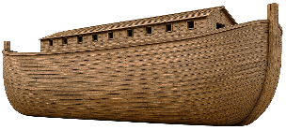


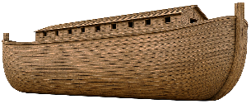

Would You Trust God? – Circle the response you think best reflects biblical hope.

- You prayed about something for months, but nothing has changed.

A. God has forgotten me.
B. I'll keep trusting Him while I wait.

- Things at school become difficult.

A. I'll face it alone.
B. I'll pray, seek wise counsel, and trust God.

- You make a mistake.

A. Give up.
B. Confess it, learn from it, and keep following Christ.

- Life doesn't go according to your plans.

A. God must not care.
B. God's plans are wiser than mine.

Bible Detective – Read Genesis chapters 8 & 9 and answer.

Which bird never returned? ___________________________________________
Which bird came back carrying an olive leaf? ____________________________
What was God's covenant sign? _______________________________________
What did Noah build after leaving the ark? ______________________________
Who shut the ark's door? ______________________________________________

THE BUILDER'S TOOLBOX

This Week's Tool: GRATITUDE

Gratitude changes the way we see life. Instead of asking, “Why is this happening?” we begin asking, “God, what are You teaching me?”

Gratitude reminds us that God has been faithful in the past, is faithful today, and will remain faithful tomorrow. Noah remembered God's goodness. We can too.
THE BIG PICTURE

Complete the chart below.

Week | Key Word | What I Learned
Week 1 | Grace
Week 2 | Obedience
Week 3 | Hope

Final Prayer

Dear Father, Thank You for teaching me through Noah's life. Help me to remember that Your grace saves me, Your truth guides me, and Your promises give me hope. Give me courage to obey You, even when it's difficult. Help me become the person You created me to be. May my life point others to Jesus. In Jesus Name, Amen.

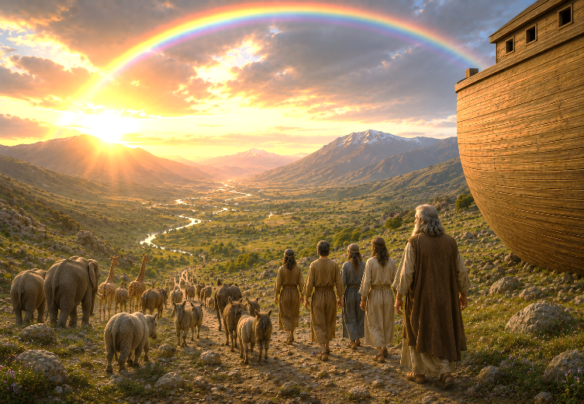
One Last Thought – People remember Noah because he built an ark. But God remembered Noah because Noah walked with Him. One day, people may forget our accomplishments. But nothing done for Christ is ever forgotten by God. So wherever life takes you... choose grace… choose obedience… choose hope. And above all – choose Jesus.

“But as for me and my house, we will serve the Lord” (Joshua 24:15)

