

1
KIDS ZONE! 7-12 Years 5/31/2026

The Joy Of Serving!

Big Idea:

Serving others makes God smile – and it fills your heart too!

Bible Verse:

“Serve one another in love.” — Galatians 5:13

Think On It:

Today we’re learning about something amazing: serving others! Serving means helping some-one, even when you don’t have to. Jesus loved serving people — and when we serve, we’re following Him!

Bible Spotlight – Jesus Washes Feet:

Jesus did something surprising: He washed His disciples’ feet! Feet were dusty, dirty, and… well… kinda stinky. But Jesus showed that no job is too small when it’s done with love.
Something Else To Think On:

What’s one small thing YOU can do to help someone today?
_______________________________

How does it feel when someone helps you?

Bad Okay Meh Nice Really Good

Drawing Time:

Draw a picture of yourself helping someone! (Helping a friend, feeding a pet, cleaning up, sharing a snack — anything!)

Serving Can Be Fun!

Why Does Serving Brings Joy? Because when you serve others it makes people feel loved, makes YOU feel good inside, helps you grow to be more like Jesus, spreads kindness everywhere you go! It’s like tossing kindness confetti — it lands on everyone!
2
Mini Devotional

You don’t have to be a grown‑up to serve God. Kids can serve in HUGE ways:
- Holding the door for someone
- Picking up trash without being asked
- Sitting with someone who feels lonely
- Helping at home
- Praying for a friend
Every act of service is like a little light shining for Jesus.
Serve It Word Search

Find the following words to do with joyfully serving others: SERVE • HELP • LOVE • SHARE SMILE • JESUS • KIND OTHERS • KINDNESS GOOD • WASH • FEET

E B O O J Y L E G F
R Y L O V E J M T L
A H N T S F F B V B
H O K E R M K E P Q
S T R B X O H L E C
S V Y K U U E D S T
E K I I E H W G I O
E S O N S L L T Q U
I U W D A W I D P F
H S H T S M R M W Z
V E W M Z D K B S A
S J K I N D N E S S

X K L X O O E U T T
W A S H N O D T C A
I R Z A J G J O F D
A B I S R E H T O C
3
Let’s Serve This Week!
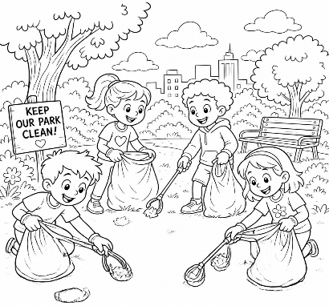
Serving Scramble!

Unscramble the words:

EVRSE __ __ __ __ __
PLEH __ __ __ __
VLEO __ __ __ __
SESUJ __ __ __ __ __
Secret Mission

Pick ONE Mission To Accomplish This Week:

Mission Kindness:
Do something helpful without telling anyone.
Mission Smile:
Make 3 people smile today.
Mission Surprise:
Leave a kind note for someone.
Mission Cleanup:
Clean a room without being asked.
NIKD __ __ __ __

Closing Prayer:

“Dear Father God, thank You for showing us how to serve. Help me to look for ways to help others with joy. Make my heart kind and ready to serve. Amen.”
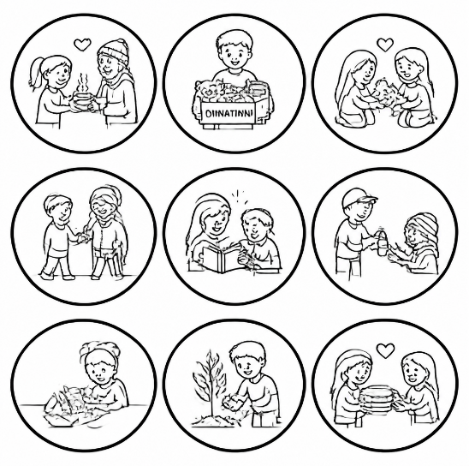

4

