

Bulletin of the CHURCH of CHRIST in Lytle, Texas
Sunday Schedule: 9:45AM – Bible Study | 10:45AM – Worship
12:00PM Fellowship Meal (4th or 5th Sundays)
Wednesday Schedule: 4PM – Bible Study
May 31, 2026
Volume MMXXVI Number 22

1948 2026
The Joy Of Serving – And Other Miracles
I was thinking about service and what it means, after all Paul – and therefore God – wrote “Serve on another humbly in love” (Galatians 5:15). So, I’d like to “talk” to you about serving others without losing your mind – to do so with joy and occasionally with snacks! Serving others is a sacred art, a spiritual discipline that proves God has a sense of humor. I also proves that God can use anyone, even the person who can’t seem to figure out how to make a pot of coffee when the carafe is empty. God is also asking us to love our neighbors, even the ones who borrow our tools and return them “slightly improved.”
Serving others is the clearest ways in which we are able to imitate Jesus. It’s also one of the clearest ways we discover how much patience we thought had and discover how much sanctification we still need.
John 13 reminds us that service isn’t glamorous but if Jesus could wash His disciples’ feet – dusty, sweaty, sandal-seasoned feet – if the Son of God could kneel down and scrub 10 toes per apostle – we, I think, should be able to help stack chairs or tables, listen to someone’s 17-minute story about their cat (a
[continued on page 3]
[continued from front]
story by-the-way could have been told in less then two minutes), or volunteer for nursery “duty”– the spiritual Olympics – (I’m still hopeful we’ll one day have some babies, toddlers, and young children), and do it all while smiling. So, no. Serving isn’t glamorous. But it’s holy. And it’s how we become more like Christ.
Here are some signs that you might be a servant at heart: if you can’t walk past a crooked Hymn book without fixing it, or if you’ve ever said, “I’ll help,” before knowing what the job is, or you know where every single extension cord in the building is stored, or you can carry three folding tables at once – one handed – and feel oddly proud of it.
But you may ask, “Why does serving feel so difficult?” To set things straight, I want to say that I believe serving others is beautiful but boy-o-boy it’s oh so messy, and though it may be difficult, it matters more than we think.
Serving others often interrupts our plans because God loves using us at the least convenient moment – He enjoys tapping us on the shoulder so that we can show how much we’re growing to resemble His Son. Just sat down? Someone needs help. Just poured yourself a cup of coffee? Someone needs prayer. Just opened a box of donuts? Someone needs a donut. Every time you sit down to relax a moment

someone says, “Hey, quick question...”
Serving others exposes our hearts. Nothing reveals spiritual maturity like helping someone move. Especially when they live on the third floor. And there’s no elevator. And they own a piano.
Serving others reminds us that we’re not the center of the universe – I know, a shocking revelation every time. Jesus said, “Whoever wants to become great among you must be your servant” (Matthew 20:26). Galatians 6:2 reminds us, “Carry each other’s burdens.” And 1 Peter 4:10 tells us, “Use whatever gift you have received to serve others.” Brethren, serving isn’t a punishment – it’s participation in God’s work.
There are myriad ways we can find to serve: send a text of encouragement to someone who’s struggling, do a chore at home without announcing it like a press release, sit with someone new at church, let someone go ahead of you in line (even if they have 47-and-a-half items, pray for someone by name, offer help before someone has to ask. This is a short list, and you may say, “Hey, those are just small acts, how can they matter?” But small acts do matter. Jesus multiplied loaves and fish – He can multiply your kindness too.
Let me share a short story about the day I tried to serve and accidently started a ministry. I once offered to set up the fellowship [continued on page 6]

[continued from page 3]
fellowship hall for an upcoming meal. Simple, right? Three minutes later, someone said, “Oh great! You’re in charge of the whole fellowship hall now.” Ten minutes later someone asked me if I knew how to run the coffee machine. Twenty minutes later I got, “Could you unlock the storage closet?” And thirty minutes after that, “Could you maybe fix the thermostat?” So, by the end of the morning I had organized a closet, brewed three gallons of coffee, found a missing table and somehow became the official unofficial “Fellowship Room Coordinator.” Is there a moral? Yes. When you serve, God uses you – sometimes a bit more than you’d planned.
I’m going to close this article with a “Church Service Bingo” (feel free to actually use these to print your own version of bingo for your next game).
- Someone says, “We’ve always done it this way.”
- A volunteer shows up with a tool belt that could fix the International Space Station or at least the space shuttle.
- Someone brings donuts “for the group” but hides the good ones.
- A child hands you something sticky and you don’t ask questions.
- You pretend you understand how the sound system works.
- You get volunteered (volun-told?) for

something.
- Someone says, “It’ll only take five minutes.” (Believe me, it won’t – you best just schedule the rest of the day and part of tomorrow to complete that five-minute project).
- You can stack tables and chairs like a world champion Tetris gamer.
So, this week, pray this simple prayer: “Father, open my eyes to someone I can serve today – and please give me the courage to do it with joy.” Then watch what [continued on page 7]
[continued from page 6]
what God does. I suppose there’s one more prayer you could also pray: “Father, make me a servant ... but maybe not during nap time.” IENDI
Lytle Light
You Are The Light Of The World.
– Matthew 5:14a
15340 Main Street,
Lytle, TX 78052
PO Box 668,
Lytle, TX 78058
(726) 241-5234
Tom Woodard
(210) 562-0136
Mitch Watkins
(210) 213-8392

lytlechurchofchrist.org
lytlechurchofchrist@yahoo.com
facebook.com/Lytle-Church-Of-Christ-101136328215158
Searching for faith rather than simply religion; virtue rather than simply values; relationship rather than rule-keeping; divine help rather than self-help? We may be the place for you.


Sermon
Sermon Scriptures: Matthew 13:11-14; Luke 17:21; Matthew 6:10; 1 Corinth-ians 15:24; Matthew 13:43; John 3:3-5; Acts 2:38; Titus 3:5
Series: “The Parables Of Jesus” – Defining

The Kingdom Of Heaven
INTRODUCTION - (1) The General “Theme” Of Parables (2) “The Kingdom Of Heaven” Was The Theme (3) It Is A Prominent Subject In The Parables
I. The Kingdom Of Heaven Vs. The Kingdom Of God
A. Is There A Difference?
B. Why The Different Expressions?
II. Four Inter-Related Concepts
A. The Reign Of God
B. Spiritual In Nature
C. Visibly Manifested Today
D. Both Present And Future
III. Definition: Kingdom Of Heaven
A. In The “Present” Sense...
B. In The “Future” Sense...
CONCLUSION - (1) Many References To The “Kingdom Of Heaven” (2) Appreciation For “The Kingdom Of Heaven” (3) Help Appreciate “The Mysteries Of The Kingdom Of Heaven”! (4) The Principle Of The New Birth
Invitation
Wednesday @ 5PM
Series On Prayer – Part 5
The Lytle Light Page 2
Order Of Worship
- Enter To Worship
- Announcements
- Scripture Reading
- Opening Prayer
484 – In The Morning Of Joy
498 – Wonderful City Of God
- Minister’s Prayer
513 – Never Grow Old
514 – In That Beautiful Land
159 – I Gave My Life For Thee
Lord’s Supper
- Sermon — Outline Starts Below
485 – In The Land Of Fadeless Day
- Final Announcements
521 – Just Over In The Glory Land
- Closing Prayer
- Depart To Serve In Peace & Love
Welcome Visitor!
Welcome Our Worship Service! • Please Stay A Bit After Services So We May Become Better Acquainted! • Also, Please Join Us For Our Bi-Monthly Fellowship Meal After Worship Services, See Events & Stuff Page • Please Be Sure To Pick Up A Visitor Pamphlet From The Table Under The Mirror In The Front Hall. • And Please Fill Out A Visitor Card From The Back Of The Pew In Front Of You And Place It In The Collection Plate Located On The Table In The Back Of The Audi-torium So That We May Have A Record Of Your Visit With Us Today. • Thanks!

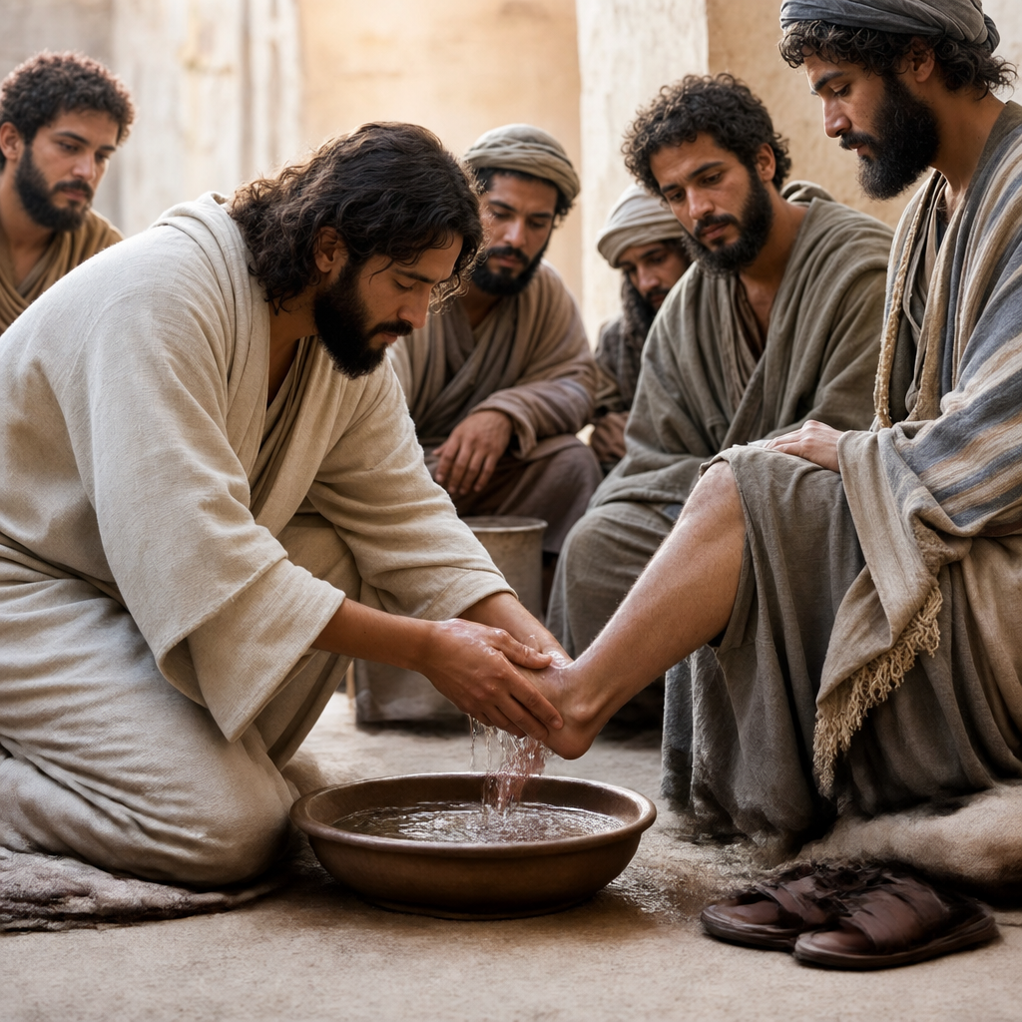
The Lytle Light Page 3

Current Concerns
All Following entries Are By Date Order And Are Alphabetical By Last Name. A Superscripted Number In Brackets, I.E., ^{[1]}, At The End Of An Entry Denotes How Many Weeks The Entry Has Been In The Bulletin.
MAY 31
- Bailey, Linzi [Ronda Spicer’s niece] – She’s scheduled for surgery to have her tumor removed on Tuesday, June 9th ^{[NEW]}
- Barber, Kathy [Devine Congregation Member] – She recently passed into eternity. ^{[NEW]}
- Cashion, Mark [Dana Cashion’s brother] – He’s had a miserable 2026 thus far – He broke his ankle and had hardware implanted, he was bitten by a brown recluse spider which got infected and traveled to the ankle hardware, he had the recently installed hardware removed and new implanted. Doctors have been trying to get the infection under control. In the meantime, he fell off his scooter and hurt his shoulder but can’t have that fixed until that infection is controlled. ^{[NEW]}
- Dubose, Belinda [Lytle Art Club Member] – She recently passed into eternity. ^{[NEW]}
- Spicer, Ronda – She’s scheduled for cataract surgery Thursday, June 4 and again Thursday, June 18. ^{[NEW]}
- Strunk, Billy – He’s been diagnosed with prostate cancer and is on new medication(s) but they’re making him “loopy.” ^{[NEW]}
- Watkins, Elizabeth & Mitch – Health Issues.
MAY 24
- Potter, Edna Family [Friend of the Watkins’] – Edna passed into eternity, Tuesday, May 19. She would have been 98 on June 2. ^{[01]}
- Smoot, Deborah – Praise To GOD! She saw her gastroenterologist and received a good report. She also had a very thorough consultation with cardio-therapy before she begins therapy Wednesday, May 27. Earlier, she had
stints implanted in her heart. Also, still be in prayer about her severe osteo-porosis. ^{[01]}
- Strickland, Greg [Janice Sparks’ friend] – He’s been diagnosed with frontal lobe dementia. His wife Holly is retiring from school so they can have more time together. ^{[01]}
Ongoing Concerns
All Ongoing Concern(s) Below Will
Remain For 20 Weeks. Removal Can Be Requested Earlier But Concern(s) Will Automatically Be Removed At The 26TH Week. If Someone Is Moved Off This Ongoing List And You Believe They Should Go Back On The Detailed List Above, Please Let Mitch Know.
Alderman, Roy ^{[22]}; Alsup, Dylan ^{[04]}; Anderson, Dale ^{[02]}; Balderrama, Matthew ^{[03]}; Beauchemin, Marvale ^{[02]}; Bippert, Cheryl ^{[05]}; Bradley Family ^{[19]}; Bridgewater, Larry ^{[20]}; Brown, Colton family ^{[14]}; Brown, Diane Family ^{[23]}; Busse, Duane ^{[03]}; Cashion, Corena ^{[02]}; Cook, Karen ^{[05]}; Coombs, Derek ^{[13]}; Dolbeare, Robert ^{[06]}; Drake, Paul & Lynn ^{[05]}; Duncan, Roberta ^{[20]}; Dwyer, Meagan ^{[10]}; Dygert, Harold Family ^{[12]}; Fintel, Rick ^{[21]}; Flatequal Family ^{[20]}; Flatequal, Pam ^{[07]}; Flores, Carlos ^{[20]}; Gonzalez, Joel ^{[23]}; Guzman, Emily Family ^{[11]}; Jackson, April ^{[04]}; Keese, Bob & Katheryn ^{[07]}; Last-Name-Unknown, Irene ^{[08]}; Lester, Bob ^{[23]}; McMeans, Melanie ^{[09]}; McMeans, Wendell ^{[16]}; Melendy Family ^{[03]}; Moore, Jennifer ^{[15]}; Moore, Michael & Michelle ^{[07]}; Moore, Perry ^{[13]}; Moore, Sherry ^{[03]}; Morgan, Mitzy Family ^{[08]}; Morris, Barry ^{[05]}; Mr. Lowe ^{[18]}; Ott, Ronnie ^{[03]}; Persat, Diana ^{[23]}; Pillows, Darlene ^{[05]}; Price, Jennifer ^{[17]}; Ranne, Ruth Family ^{[02]}; Renninger, Ruane’s grand-daughter-in-law ^{[17]}; Roeder, Gary ^{[02]}; Schilling, Ina ^{[18]}; Sims, Linda ^{[15]}; Smith, Betty ^{[04]}; Smith, Jimmie (JD) ^{[22]}; Smoot, Bailey ^{[15]}; Smoot, Beth ^{[09]}; Smoot, Cody & Emily ^{[19]}; Smoot, Max ^{[12]}; Smoot, Tiffany ^{[21]}; Sparks, Lane & Ashley ^{[14]}; Stepanovich Family ^{[07]}; Street, Cris ^{[20]}; Vierling, Gene ^{[10]}; Vierling, Scott ^{[22]}; Villereal, Douglas Family ^{[10]}; Walker, Tony Family ^{[22]}; Weisel, Michelle ^{[18]}; White, Linda ^{[13]}; Woodard, June ^{[03]}

Sunny Glen Requests
Fruit Cocktail, Pre-Sweetened Cereal, Granola Bars, Indv. Pkg’s Cookies, Powdered Sports Drinks, Capri-Sun Pouches, Plastic Red Cups, Plastic Cutlery, Toilet Bowl Scrubbers, 2-Ply Toilet Paper, 55 Gallon Contractor Trash Bags, Laundry Detergent, Baby Shampoo, Antiseptic Wipes, Variety Pack Bandages
The Lytle Light Page 4
Local, State, National & Global Concerns
- May The Will Of GOD, The FATHER Of LOVE, HOPE, COMPASSION, GRACE, MERCY, And RIGHTEOUSNESS Be Done On Earth As It Is In Heaven!
- People In The U.S.A. And Around The World Who’ve Been Affected By Natural Disasters
- Our Local, State & Federal Government Officials, Military, First Responders & Teachers, Nourishing & Life-giving Rain
- Coronaviruses, Flues & Other Deadly Sicknesses
- Civil Unrest, Racial Strife & Mass Shootings
- War, Unrest & Lack Of Peace In Other Countries

Father, Please Hear Our Prayer

The Lytle Light Page 5

Scripture Word Search
Galatians 5:13-14
¹³ For you, brethren, have been called to liberty; only do not use liberty as an opportunity for the flesh, but through love serve one another. ¹⁴ For all the law is fulfilled in one word, even in this: “You shall love your neighbor as yourself.

E A P W S P H X B I F F C F J W G U Z
L X U E J Q D Q P N Z U X Z J A S D Q
O V R J K M A X X M T L N Q K H J Q U
V V X I Y T R E B I L F Q S J W F J E
E D Z T J Z B P K N S I K W D E K U C
J H J R H D R B L B L L O C B W D N J
B P L E Q R R O P J V L A Y W Y D L T
D Y X H I K O H R P K E C O O W M E B
C U Z T S A N U Q Y O D O U R A M L H
R F J O W O D Q G A N S A R D L N P S
O W D N L N D N S H H R Q S C U X A J
B G F A T H D D E L L A C E Q F Y M I
H E S U V J M M V O A Q G L B L Z M S
G A G M S U V A H P Y N F F G E I E U
I B L P L S C B R E T H R E N S B S C
E Y Y T I N U T R O P P O J P H A E Y
N H L L A H S P J D Y A V J R C K P M
The Lytle Light Page 6
Anniversaries & Birthdays
Carol Vierling May 22 Birthday

Hunter Kruger (Dzielzanowski) May 29 Birthday
Gene Vierling May 31 Birthday
Rick & Pam Fintel Jun 1 Anniversary
Tom & Pat Woodard Jun 10 Anniversary
Gaylia Dzielzanowski Jun 20 Birthday
If Your Special Day Is Jun 20th Or Before And You Do Not
See Your Name(s) Above Or If Something Is Incorrect, Please Let Mitch Know
Events & Other Stuff

----- Church Stuff ----- Church Stuff ----- Church Stuff ----- Church Stuff ----- Church Stuff -----
4th Or 5th ~Every Table Fellowship Potluck Lunch

Other Sunday Approximately 12PM – 2PM
Every Thursday Sewing Sisters Approximately 12PM – 2PM
Every Tuesday Lytle Friendship Art Club 9:30AM
Every 3RD Mon VFW Auxiliary – Fellowship Room At 6:30PM
T O D A Y ! 5th Sunday Fellowship Meal
Sun – Jun 7 In Search Of The Lord’s Way – Do You Know Jesus?
Sun – Jun 14 In Search Of The Lord’s Way – Presumption
Tue – Jun 16 Sunny Glen Pickup – See Front Hall Bulletin Board For Items Needed
--- Non-Church Stuff --- Non-Church Stuff --- Non-Church Stuff --- Non-Church Stuff ---
Sun – May 31 National ¹Smile And ²Macaroon Days
Mon – Jun 1 World Milk Day & National ¹Olive And ²Hazelnut Cake Days
Tue – Jun 2 National ¹Rocky Road Ice Cream And ²Rotisserie Chicken Days
Wed – Jun 3 Love Conquers All Day & National Egg Day
Thu – Jun 4 National ¹Hug Your Cat And ²Cheese Days
Fri – Jun 5 National ¹Donut And ²Sausage Roll And ³Veggie Burger Days
Sat – Jun 6 D-Day & National Applesauce Cake Day

The Lytle Light Page 7


Want To Be
Part Of This Local Family Of Christ Jesus?
To be identified with our Congregation (aka “place membership”): Please fill out a Visitor’s Card, making sure to check the box on front that says, “Wish To Serve In This Congregation.” Please place the completed card in the collection plate on the table in the back of the auditorium.
Read Along W/Tom
Sunday 5/31/2026 Psalm 9
Monday 6/1/2026 Hosea 1
Tuesday 6/1/2026 Hosea 2
Wednesday 6/3/2026 Hosea 3
Thursday 6/4/2026 Hosea 4
Friday 6/5/2026 Hosea 5
Saturday 6/6/2026 Hosea 6
Memorize Scripture —
Matthew 20:26-28 – ²⁶ Yet it shall not be so among you; but whoever desires to become great among you, let him be your servant. ²⁷ And whoever desires to be first among you, let him be your slave — ²⁸ just as the Son of Man did not come to be served, but to serve, and to give His life a ransom for many.
Acts 20:35 – ³⁵ I have shown you in every way, by laboring like this, that you must support the weak. And remember the words of the Lord Jesus, that He said, “It is more blessed to give than to receive.”
Romans 12:10-11 – ¹⁰ Be kindly affectionate to one another with brotherly love, in honor giving preference to one another; ¹¹ not lagging in diligence, fervent in spirit, serving the Lord.

Interactive
Daily Bible Reading Plan —
To open and/or download the interactive PDF file go to: video.wvbs.org/spotlight
Daily Bible Reading For Edification —

Old & New In 365 —
Daily Readings From Both The Old And New Testaments
SUN – Day 155 - 2 Chr 13-16; Jhn 14
MON – Day 156 - 2 Chr 17-19; Jhn 15
TUE – Day 157 - 2 Chr 20-22; Jhn 16:1-15
WED – Day 158 - 2 Chr 23-25; Jhn 16:16-
33
THU – Day 159 - 2 Chr 26-28; Jhn 17
FRI – Day 160 - 2 Chr 29-31; Jhn 18:1-23
SAT – Day 161 - 2 Chr 32-33; Jhn 18:24-
40

Chr = Chronicles | Jhn = John

[Days Listed Are NOT Days Of The Year
But Days Of The Plan]
The Lytle Light Page 8


