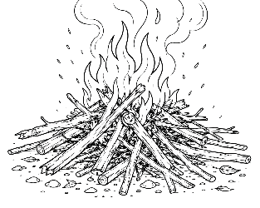
7-12 Year-Olds
7/19/2026
KINDLING
for KIDS!

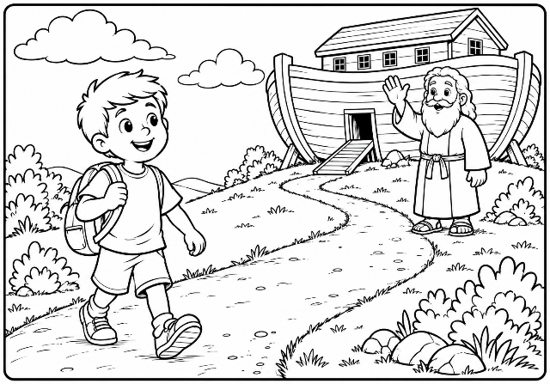
Living For God Like Noah Did!
Noah lived in a world where many people ignored God, but he chose to obey Him anyway. That wasn't always easy. People may have laughed when Noah built a huge
ark, but Noah trusted that God knew what was best.

Living like Noah today doesn't mean building a giant boat. It means choosing to do what is right, even when others don't. It means trusting God, telling the truth, being kind, helping someone who is lonely, and obeying God even when it's hard.

Today we don't build arks like Noah. But God still asks us to trust Him. We obey by being kind • telling the truth • praying • reading the Bible • loving others. Even if everyone else chooses the wrong path, we can still choose God's way. And that's what Noah did. And that's what Jesus wants us to do.

Memory Verse – “Be strong and of good courage... for the LORD your God is with you wherever you go” (Joshua 1:9).
Every day, we have chances to show that we trust God. When you forgive a friend, tell the truth, or include someone who feels left out, you're living with the same kind of faith Noah had. God is pleased when we choose obedience because we love Him.

Just as God took care of Noah and his family, He promises to be with us too. We may not always know what will happen tomorrow, but we can trust God today. One faithful choice at a time helps us grow stronger in our walk with Him.

Word Scramble - Unscramble The Following Words (Hint – They’re All Words From The Devotional Above):

BEIECNEDO ___ ___ ___ ___ ___ ___ ___ ___ ___
HECCANS ___ ___ ___ ___ ___ ___ ___
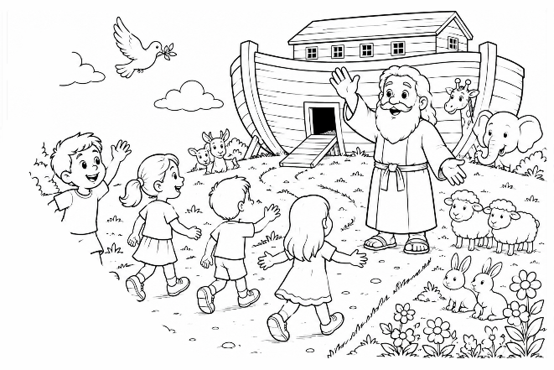
OESOHC ___ ___ ___ ___ ___ ___
OHOS ___ ___ ___ ___
LAKW ___ ___ ___ ___
AHON ___ ___ ___ ___
RSUTT ___ ___ ___ ___ ___
MIAFLY ___ ___ ___ ___ ___ ___
COICCHE ___ ___ ___ ___ ___ ___ ___
THUFFAIL ___ ___ ___ ___ ___ ___ ___ ___
SESOMIRP ___ ___ ___ ___ ___ ___ ___ ___
RONSTGER ___ ___ ___ ___ ___ ___ ___ ___
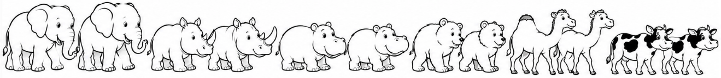

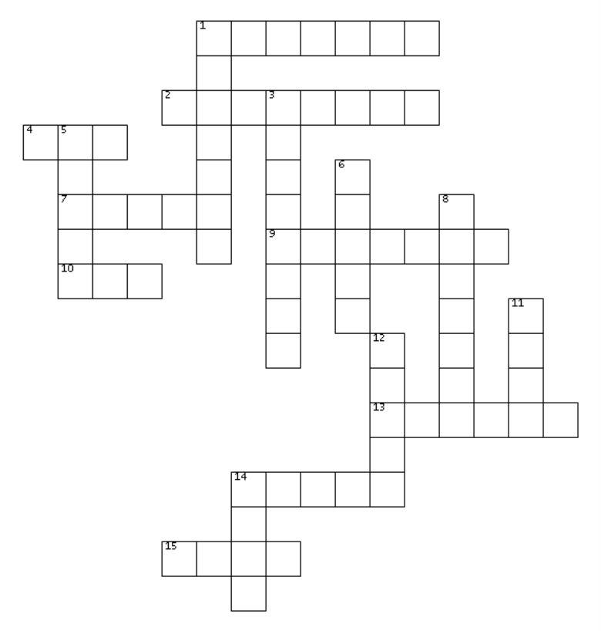
Noah & Obedience Crossword – (Hint – All the words in the crossword appear elsewhere in this bulletin)
Across
1. Being brave enough to do
what is right.
2. Someone who keeps
trusting and obeying
God.
4. The special boat God
told Noah to build.
7. God's wonderful gift
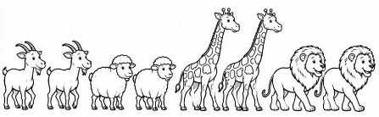
that we cannot earn.
9. God's colorful promise
in the sky.
10. The animals came into
the ark by ______.
13. Noah listened to God
and ______ Him.
14. God told Noah to
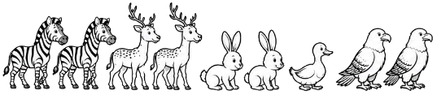
______ the ark.
15. Talking to God.
Down
1. God often gives us second ______ to do what is right.
3. The day after today.
5. Choose what is ______ instead of what is wrong.
6. Believing God even when you cannot see the whole plan.
8. To let go of anger when someone says they're sorry.
11. God showed His great ______ for the world.
12. The great rain that covered the earth.
14. Noah's ark was a very big ______.
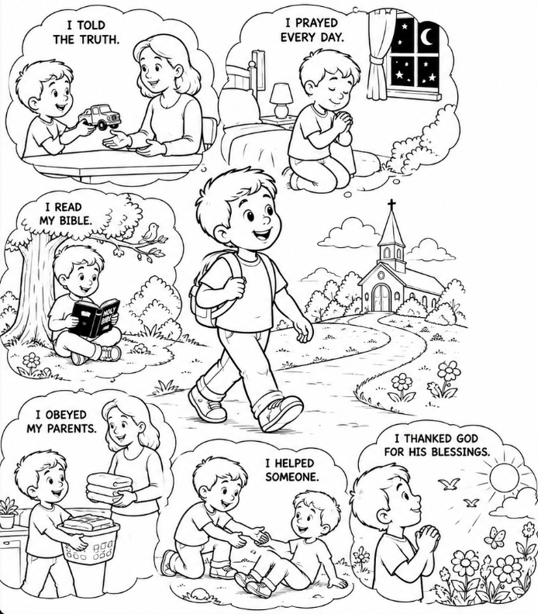
This Week check off any you do:

□ I told the truth.
□ I prayed every day.
□ I read my Bible.
□ I obeyed my parents.
□ I helped someone.
□ I thanked God for His
blessings.

Closing Thought

Just because everyone else is doing something doesn't mean it's right. Like Noah, we can
choose to trust God, obey Him, and shine His light every day. When we make good choices, show kindness, tell the truth, and help others, people can see God's love through us. Every day is a new opportunity to follow Jesus and be a bright light in our homes, schools, and communities.

Scripture – “Let your light so shine before men, that they may see your good works and glorify your Father in heaven.” — Matthew 5:16

Prayer – Dear Father God, thank you for my life, my family, and my friends. Help me to be obedient to you and adults you have put in my life. Help me to help others so that your light shines through me and glorifies you. In Jesus name, Amen.

