
7-12 Year-Olds
10/04/2026
KINDLING
for KIDS!

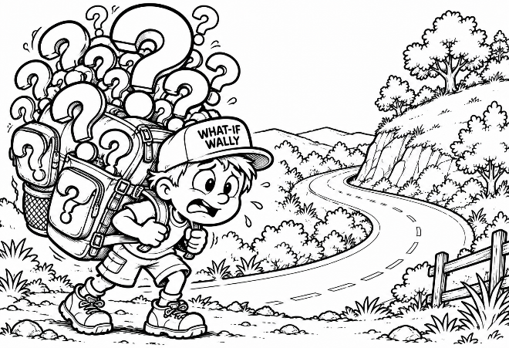
What If?

❓Meet What-If Wally!

Wally has a problem. Actually, Wally has LOTS of problems. At least he thinks he does. Wally is carrying an enormous backpack stuffed with giant question marks.

“What if the test is really hard?” Another question mark goes into the backpack. “What if I make a mistake?” In goes another. “What if somebody doesn’t like me?” Another one! What if something goes wrong tomorrow?

THUD! Pretty soon Wally's backpack is so heavy he can barely move!

Have you ever carried a backpack like Wally's? No, not a real backpack – a worry backpack. Sometimes we worry about things that haven't even happened. We imagine everything that might go wrong tomorrow and start carrying all those worries today.

The Bible gives us something better to do: “Whenever I am afraid, I will trust in You.” (Psalm 56:3). That means trusting God doesn't mean difficult things will never happen. It means that whatever happens, God will still be with us.

❓ Quick Check – Something I've been saying “What If?” about:
_________________________________________________________

Today’s Big Idea: Don’t Carry Tomorrow’s Worries Today!
You Can’t See Around The Bend!

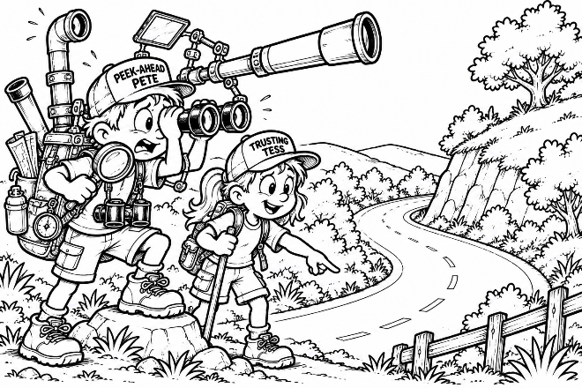
Meet... 🔭 PEEK-AHEAD PETE!
Pete has binoculars. And a telescope. And a magnifying glass. And a peri-scope. He may even have a ladder! Why? Pete is desperately trying to see around the bend in the road.
“I need to know what happens tomorrow!” There's just one prob-lem. He can't. Standing nearby is...
👣 TRUSTING TESS.
Tess can't see around the bend either. But Tess notices something Pete doesn't: She can see enough road to take TODAY'S next step.

Jesus said: “Therefore do not worry about tomorrow, for tomorrow will worry about its own things” (Matthew 6:34). Jesus wasn't saying we should never plan ahead. Doing your homework, packing your school bag or preparing for tomorrow can be wise. But planning isn't the same thing as worrying.

Worry says: “I have to figure out everything that might happen!”
Trust says: “I'll do what I can today and trust God with tomorrow.”

✅ Today Or Tomorrow? Put a ✔ beside the things you can do Today.

☐ Pray about something that's
worrying me.
☐ Do the work I have today.
☐ Know everything that will happen
tomorrow.
☐ Trust God with something I
cannot control.
☐ Be kind to someone today.
☐ Obey my parents today.
☐ Be patient when aggravated.

👣 One Step At A Time! You don't need to see the whole road. Take the next right step.
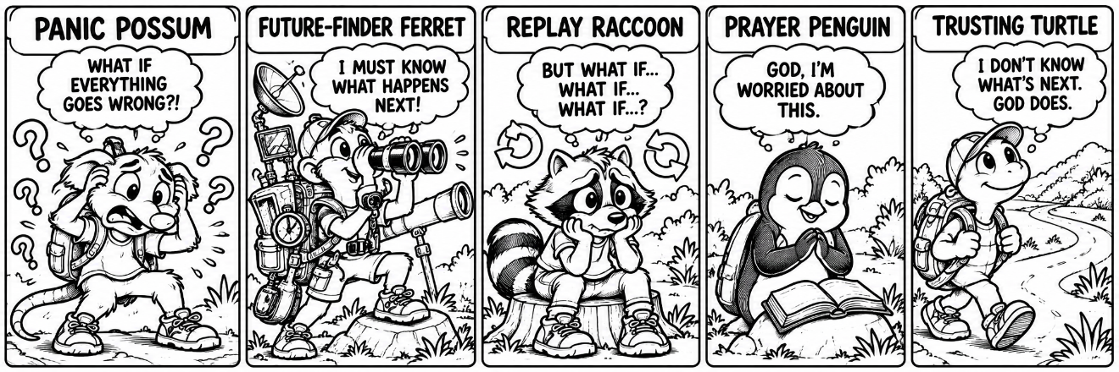
Meet The “What-If” Crew!

Everybody handles worry differently. Which one looks most like you some-times?

😱 Panic Possum – “What if everything goes wrong?!”
Panic Possum expects trouble before trouble even arrives.

🔮 Future-Finder Ferret – “I must know what happens next!”
If there's a gadget for predicting tomorrow, Ferret owns three of them.

🔁 Replay Raccoon – “But what if…? What if…? What if…?”
One worry goes around and around and around in his head.

🙏 Prayer Penguin – “God, I’m worried about this.”
Instead of carrying the worry alone, Penguin talks to God about it.

🐢 Trusting Turtle – “I don’t know what’s next, but God does.”
Turtle doesn't know everything about tomorrow. He just keeps trusting God and taking the next step.

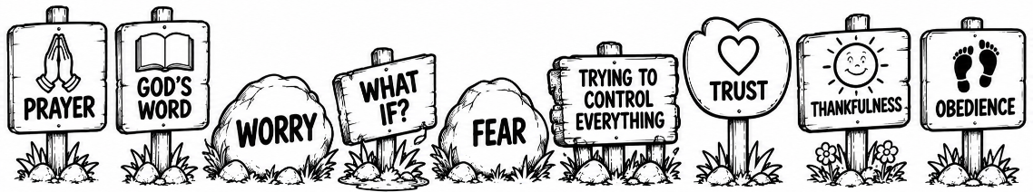
The Bible tells us: “Be anxious for nothing, but in everything by prayer and supplication, with thanksgiving, let your requests be made known to God” (Philippians 4:6).

God invites us to bring our worries to Him. 🔄Turn your “What If?” into a prayer! What if… ____________________________________________
_________________________________________________________

❓ → 🙏 Instead, I can pray: __________________________________
_________________________________________________________

So, when “What If?” shows up, let prayer show up too!

Take The Next Step!
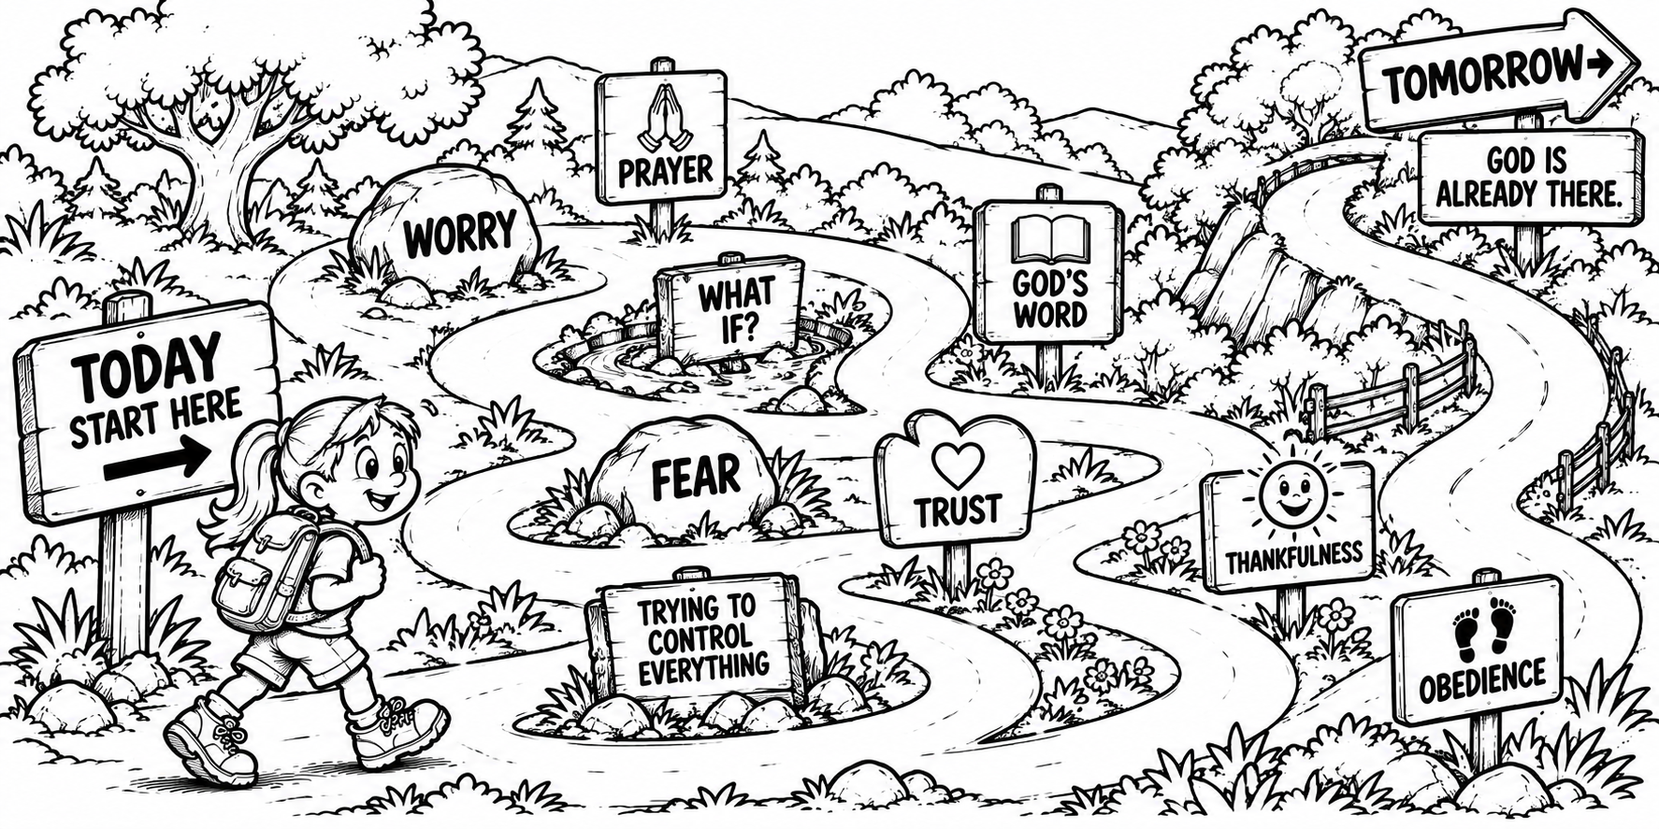
Imagine you're walking down a road. You can see where you're standing. You can see the next few steps. But farther ahead... The road disappears around the bend. You can’t see tomorrow. But God can. And God says: “Fear not, for I am with you; be not dismayed, for I am your God” (Isaiah 41:10).

🙏 My Prayer – Dear God, sometimes I worry about things that haven't happened yet. When I start asking “What if?”, help me remember that You already know tomorrow. Help me pray, trust You and do what is right today. Thank You for being with me wherever the road leads. In Jesus’ Name, Amen.

