
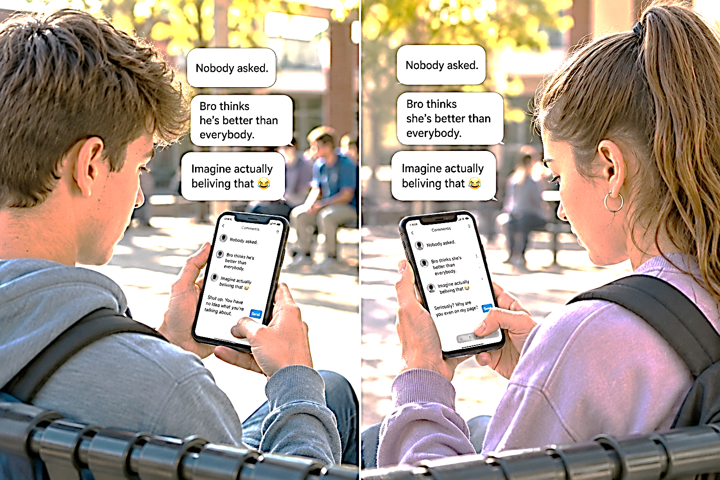
TORCHLIGHT for TEENS
13-16+Year-Olds 8/23/2026
The Comment Section
You Get One Reply, What Do You Type?

“A soft answer turns away wrath, but a harsh word stirs up anger” (Proverbs 15:1).

Someone posts something rude about you…

Your phone buzzes…

You read the incoming text…
😳 Wait...WHAT?

You type a reply.

Delete it.

Type another.

Delete THAT one.

Now you've written something so devastating that your friends would probably
give you a standing ovation. 🧍‍♂️👏 🧍‍♀️👏 🧍👏

Your thumb is hovering over SEND.

HOLD UP.

Following Jesus doesn't stop when you open the comment section.
It's easy to be kind when people are kind to us. Jesus calls us to something harder: choosing how we respond when someone embarrasses us, insults us, annoys us, or tries to make us angry.
That doesn't mean pretending cruel words don't hurt. It doesn't mean you can't calmly correct something that's untrue. And if someone is threatening, harassing, or bullying you, tell a trusted adult and use the platform's safety tools rather than fighting it out online.
But sometimes the most powerful response isn't the cleverest comeback. Sometimes it's refusing to become the person who's attacking you.

📱 YOUR COMMENT SECTION

You get ONE reply. What do you type?

COMMENT #1: “Nobody asked 🙄”

YOUR REPLY:

COMMENT #2: “Imagine actually believing that 😂”

YOUR REPLY:

COMMENT #3: “Bro thinks he's better than everybody 🤨👑”

YOUR REPLY:

COMMENT #4: “Why are you even here? 👉🚪”

YOUR REPLY:

COMMENT #5: “That might be the dumbest thing you've ever posted 💀💀💀”

YOUR REPLY:

⚠️ PLOT TWIST

There's another option… You don't actually have to reply. Sometimes the wisest Christian response to an argument on the internet is:

[DELETE DRAFT] [CLOSE COMMENTS] [PUT PHONE DOWN] [WALK AWAY]

Winning an argument isn't always the same thing as representing Jesus well.

BEFORE YOU HIT SEND...

Ask:

Is it TRUE? Check it, investigate it, verify it. 🧐✅🔎

Is it KIND? Is it nice, gentle, thoughtful, compassionate? ❤️🤝💬

Is it NECESSARY? Does it need to be said, is there a purpose? ❓🤔🎯💬
Would I say it if JESUS were standing beside me?

Because He is.

DON'T LET SOMEONE ELSE'S COMMENT CHOOSE YOUR CHARACTER.



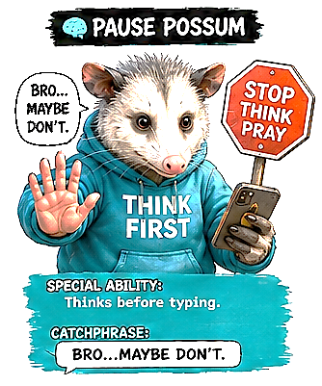
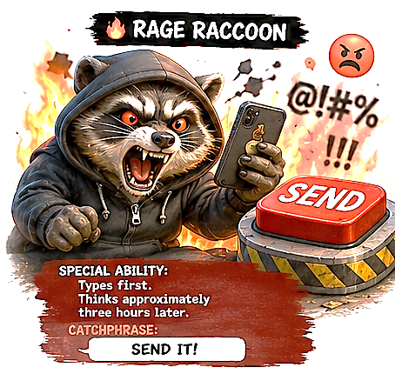

Meet 🔥Rage Raccoon🔥 – Someone posts a rude comment. His fingers are already moving – TYPE. TYPE. TYPE. He has created the perfect comeback. It's funny. It's brutal. His friends will love it. SEND IT!
Then there's 🧠Pause Possum🧠 – He gets the same comment. He's angry too. He even starts typing a response. But then he stops… Bro... maybe don't. 🧠Pause Possum🧠 understands something 🔥Rage Raccoon🔥 hasn't figured out: just because you CAN say something doesn't mean you SHOULD.
That's not only good internet advice. It's BIBLICAL. James tells us to be “swift to hear, slow to speak, slow to wrath” (James 1:19). That's difficult when somebody embarrasses you, insults you, or says something untrue. So, when that happens, maybe just don’t reply. Before you hit SEND, become a 🧠Pause Possum🧠 for a minimum of ten seconds… maybe more.
Ask, does it represent ✝️Jesus✝️ well? The internet may tell you that you need the perfect comeback. Jesus teaches something better. You don't have to win the comment section. You do have to guard your character.

