
TORCHLIGHT for TEENS
13-16+Year-Olds 8/16/2026


ARE YOU LIVING IT OR LARPING IT?

“Take heed that you do not do your charitable deeds before men, to be seen by them.” — Matthew 6:1 (NKJV)

WAIT...WHAT'S “LARPING”? Orig-inally, LARP meant Live Action Role-Playing – people dressing up and acting
as characters in a game or story. But online, teens sometimes use “larping” differently. It can mean acting like you're something you're really not. And that raises an uncomfortable question: CAN YOU LARP AS A CHRISTIAN?

- You know the right words.
- You know when to stand up.
- You know when to pray.
- You know the Bible answers.
- You might even post a Bible verse.

But Jesus isn't interested in a character you play. He wants the real you. Jesus warned His followers about doing good things simply “to be seen” by other people. The problem wasn't praying, giving, serving, or doing good. Those things were right. The problem was who they were doing it for. It's easy to look faithful when people are watching. The real test happens when nobody is.

- Do you tell the truth when lying would be easier?
- Do you treat the unpopular kid kindly when your friends aren't around?
- Do you pray when there's no audience?
- Do you refuse to join the gossip when everybody else is doing it?
- Do you follow Jesus when doing so might cost you likes, laughs, popularity – or friends?

That's not role-playing. That's living it.

🎭 LIVING IT OR LARPING IT?

Put LIVE or LARP beside each one.

___ I help someone – and immediately make sure everybody knows about it.
___ I refuse to forward some embarrassing gossip even though nobody would
know it came from me.
___ I post a Bible verse because I want people to think I'm spiritual.
___ I apologize when I know I'm wrong – even though I could probably get away
with it.
___ I'm kind to someone at church but ignore that same person at school.
___ I pray for a friend without ever telling anyone I did it.
___ I act completely different depending on which group of friends I'm around.
___ I choose what Jesus says is right even when nobody else agrees.

THE REAL QUESTION

Don't just ask: “Do people think I'm a Christian?”
Ask: “Would Jesus recognize the person I am when nobody's watching?”

DON'T JUST PLAY THE PART. LIVE THE FAITH.

🎮 QUEST UPDATED – NEW MISSION AVAILABLE

“Let your light so shine before men, that they may see your good works and glorify your Father in heaven.” — Matthew 5:16 (NKJV)

You have entered a new level.

LOCATION: School
DIFFICULTY: Unpredictable
PLAYERS: Everybody
MISSION LENGTH: 7 Days

Your objective isn't simply to survive the week. Jesus has given you something to do while you're here: Every hallway, classroom, lunch table, practice, group chat, bus ride, and trip home gives you opportunities to live differently. And nobody is keeping an XP score. Nor is there an achievement badge floating above your head. And it is unlikely you will hear dramatic victory music when you do the right thing. But your choices matter. So...

🕹️ THIS WEEK'S QUESTS
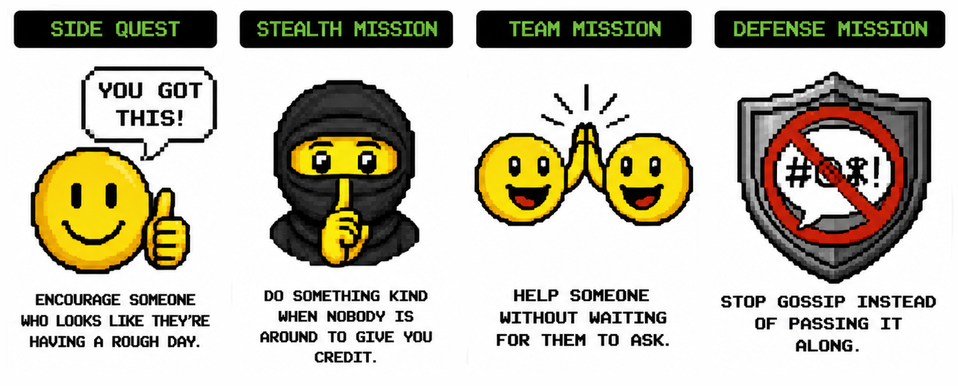
- SIDE QUEST: Encourage someone who looks like they're having a rough day.
- STEALTH MISSION: Do something kind when nobody is around to give you credit.
- TEAM MISSION: Help someone without waiting for them to ask.
- DEFENSE MISSION: Stop gossip instead of passing it along.
- COURAGE MISSION: Tell the truth when lying would make things easier.
- SECRET MISSION: Pray for someone who doesn't know you're praying for them.
- BONUS QUEST: Sit with, talk to, or include somebody who seems left out.
- LEGENDARY QUEST: Forgive someone even though they haven't earned it.

⚠️ BOSS BATTLE

Someone annoys you • They say something rude • Your irritation meter immediately hits: ██████████ 100%

OBJECTIVE: Don't lose your self-control.

Choose your move:

🎮 A – ATTACK: Say something worse back.
🎮 B – RAGE QUIT: Storm away and make sure everybody knows you're angry.
🎮 C – REVENGE MODE: Start planning how to get even.
🎮 D – SELF-CONTROL: Stop. Think. Pray. Choose a response that honors Christ.

BEST MOVE: D
“He who is slow to anger is better than the mighty, and he who rules his spirit than he who takes a city.” — Proverbs 16:32 (NKJV)

🏆 ACHIEVEMENT UNLOCKED?

At the end of the week, come back and count your completed quests.

0–2: KEEP GOING
3–5: LEVELING UP
6–7: STRONG WEEK
8: QUEST COMPLETE!

But remember: Following Jesus isn't about collecting points. It's about becoming more like Him. So when you mess up – and you will – don't stare at the giant GAME OVER!

God's grace gives you another opportunity to get back up and keep going.

✝️ KEEP GOING.

NEW DAY • NEW CHOICES • SAME MISSION • FOLLOW JESUS
