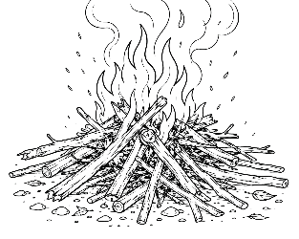
7-12 Year-Olds
9/27/2026
KINDLING
for KIDS!

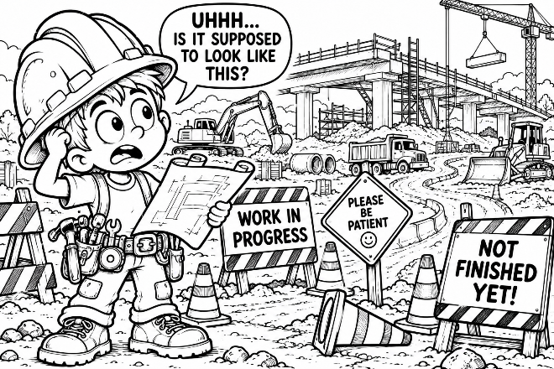
UNDER CONSTRUCTION
God’s Not Finished With Me Yet - Meet Construction Connor. He’s got a problem. He's standing in the middle of a construction project – and it is a MESS!

There are orange cones everywhere. There's a giant hole in the ground. A
bridge isn't finished. Dirt is piled up. Trucks are rumbling around. Connor scratches his head. “UHHH... IS IT SUPPOSED TO LOOK LIKE THIS?” Yep! Because it's... 🚧 UNDER CONSTRUCTION! 🚧

A construction zone doesn't look like the finished road because the workers aren't finished yet. Guess what? YOU'RE UNDER CONSTRUCTION TOO! God is still working in your life. Maybe you're learning to be more patient. Maybe you're learning to control your temper. Maybe you're learning to obey your parents without complaining. Maybe you're learning to tell the truth – even when it's hard.

Sometimes you'll do really well. Sometimes you'll mess up. But listen to this: “He who has begun a good work in you will complete it...”
(Philippians 1:6). God isn't finished with you yet!

🛠️ QUICK CHECK – Something God is helping me get better at:
__________________________________________________________________________________________________________________
Meet The Construction Crew! –

God uses His Word to teach us how to live. As we listen to Him and obey Him, He helps us grow. And every construction project needs a good crew!

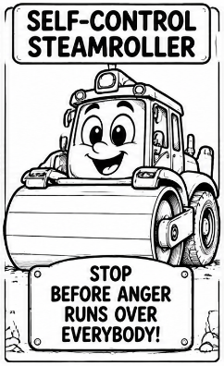
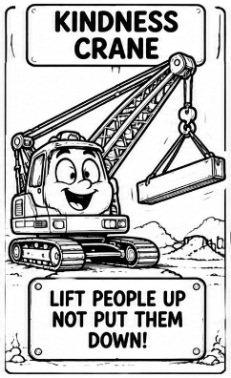
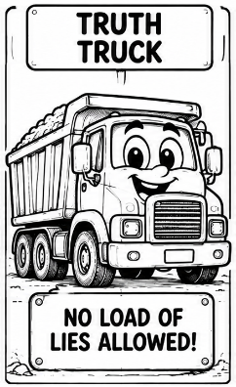
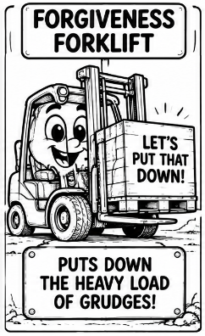
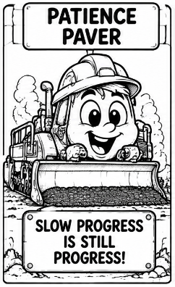

🚜 Patience Paver
“Slow Progress Is Still Progress!”
Patience Paver keeps moving – even when things take longer than expected.
I need patience when: __________________________

🏗️ Kindness Crane
This crane has only one job: Lift People Up! Encourage somebody. Include somebody. Say something kind.
“Therefore comfort each other and edify one another...” (1 Thessalonians 5:11).
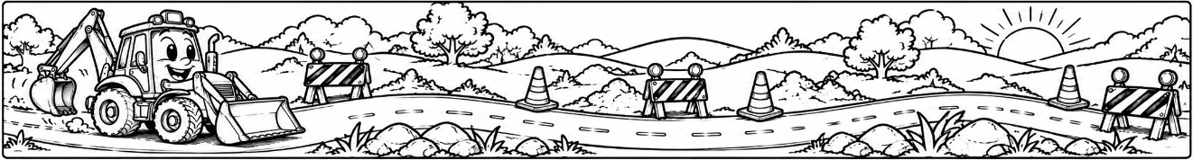
🚧Self-Control Steamroller
He's angry. He's annoyed. He's about to say something REALLY BIG... SCREEEEEECH! Self-Control Steamroller knows when to STOP!

🚚 Truth Truck
NO LOAD OF LIES ALLOWED! Truth Truck carries only the truth – even when telling the truth is difficult.

🏋️ Forgiveness Forklift
Holding a grudge can become a very heavy load. Forgiveness Forklift says: “LET'S PUT THAT DOWN!”

🚧 What Is God Building In You? –

Put a ✔ beside one you'd especially like God's help with:

☐ Patience ☐ Kindness ☐ Honesty ☐ Self-Control ☐ Forgiveness ☐ Courage

Watch Out For Potholes! –

Even a good road can develop... 🕳️ Potholes! And sometimes our choices have potholes too… Like:

😤 The Complaining Pothole – “But I Don’t Wanna!” 😤

😡 The Anger Pothole – Kaboooooom!” 😡

👑 The Me-First Pothole – “What About Meeeeee? 👑

🤫 The Gossip Pothole – “Did You Hear What Happened?” 🤫

🥱 The Lazy Pothole – I’ll Do It… Eventually.” 🥱

Those are some rough roads! But God doesn't simply point at our potholes and say, “Fix yourself!” He teaches us through His Word. We can pray for His help, obey what He teaches us, and keep growing.

🔧 Road Repair! 🔧
Draw a line between each POTHOLE and the right REPAIR.

🕳️ POTHOLE | 🔧 REPAIR
Anger | Thankfulness
Gossip | Diligence
Me First | Self-Control
Complaining | Kind Words
Laziness | Serving Others

🔧😤🔧🕳️😡🔧🕳️👑🔧🕳️🤫🔧🕳️🥱🔧🕳️🔧
⭐ Construction Challenge
Choose one pothole you need God's help repairing this week:
My pothole: ________________________________________________
The better choice: __________________________________________

Detour! –

Uh-oh. You're headed down the road and suddenly see: 🚧 WRONG WAY! DETOUR! ➡️ Sometimes we head the wrong direction too. LYING → WRONG WAY or MEAN WORDS → WRONG WAY or DISOBEYING → WRONG WAY or SELFISHNESS → WRONG WAY What should we do? Keep going? NOPE!

When we realize we're going the wrong way, God wants us to turn around and go His way. That's part of what repentance means. Proverbs 3:5-6 tells us: “Trust in the LORD with all your heart... In all your ways acknowledge Him, and He shall direct your paths.”

🚧 Construction-Zone Maze –
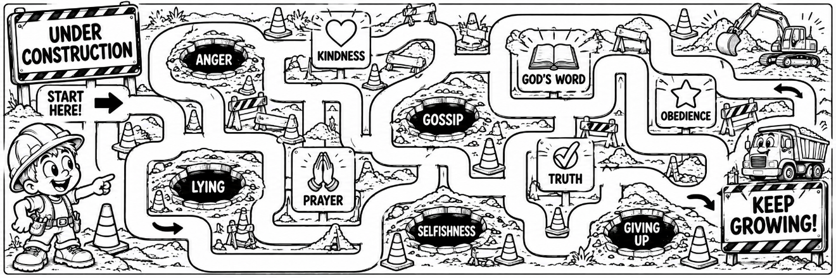

🙏 Construction Prayer
Dear God, Thank You for not giving up on me. I know I'm still growing. Help me learn Your Word, obey You and become more like Jesus. When I make a wrong turn, help me turn back to You. Thank You for continuing the good work You started in me. In Jesus' name, Amen.

