
TORCHLIGHT for TEENS
13-16+Year-Olds 8/9/2026

THE FARE HAS BEEN PAID!
Now Where Will You Go?

Memory Verse – “For the wages of sin is death, but the gift of God is eternal life in Christ Jesus our Lord” (Romans 6:23).

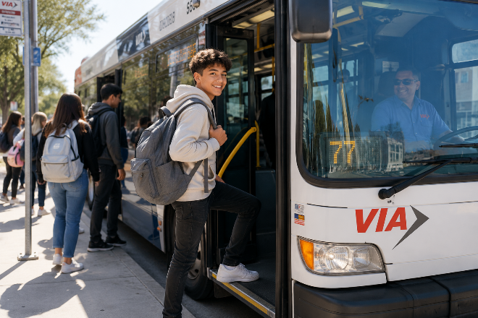
Devotional – Imagine boarding a bus without reaching for your wallet because someone else already paid the fare. That's exactly what many San Antonio students can now do through VIA's student transportation pro-gram.

The Bible tells us of an even greater gift. Jesus paid a price we could never pay ourselves. His sacrifice opened
the way to forgiveness and eternal life. But receiving God's grace isn't the end of the journey – it's the beginning of a life spent following Him.

The fare has already been paid. The question is: Where will your journey take you?


Hidden Message – Replace each number with its letter (you may have to shift the alphabet up 2 or down 2 to solve the puzzle).

_____ _____ _____ _____ _____ _____ _____ _____ _____ _____ _____
21 7 20 24 7 13 18 6 7 16 21
Choose Your Steps Carefully

Verse – “I am the way, the truth, and the life” (John 14:6).


Devotional – Every bus has many stops and life has many choices.

Every day you decide what to watch, who to spend time with, what kind of language to use, and what sort of person you are becoming.

Jesus doesn't simply point us toward the right destination. He is the Way.

Following Him means choosing the
path that leads toward kindness, honesty, courage, purity, and faith – even when the crowd gets off at a different stop.
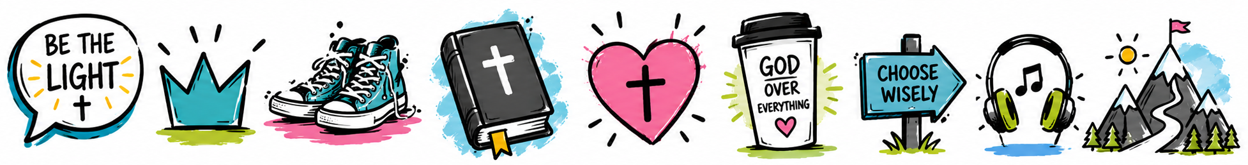


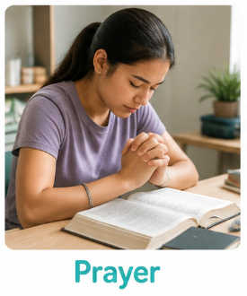
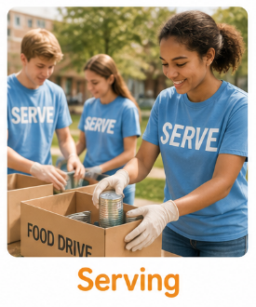
Circle the one that does NOT belong.



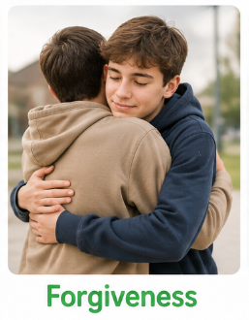


Grace Changes What We Do

Verses – “For by grace you have been saved through faith, and that not of yourselves; it is the gift of God, not of works, lest anyone should boast. For we are His workmanship, created in Christ Jesus for good works, which God prepared beforehand that we should walk in them” (Ephesians 2:8–10).


Devotional – Grace isn't something we earn. It's something we receive.

But God's grace changes us.

When Jesus paid our fare, He didn't invite us to sit still. He invites us to become people who encourage friends, forgive quickly, help quietly, stand for truth, and love others because He first loved us.

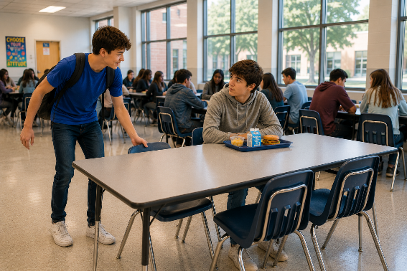
Challenge – Choose ONE this week.
□ Sit with someone who's alone.
□ Encourage someone having a bad day.
□ Read one chapter of the Bible each day.
□ Pray for a classmate.
□ Help at home without being asked.

Prayer – Father, thank You for having your Son pay the price I never could. Help me live each day with gratitude, making choices that honor You and showing Your love to the people around me. Amen.


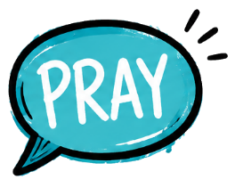
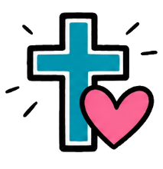
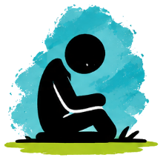

Ride It Forward

Verse – “Let your light so shine before men...” (Matthew 5:16)


Devotional – Imagine if someone paid your bus fare every single day. Wouldn't you be thankful?

Jesus has given you something far greater.

The best way to thank Him isn't simply saying "thank You." It's living like someone whose life has been changed.

That means every hallway • every classroom • every practice • every friendship every day.

Word Search

LIGHT • SHINE • WAGES • SIN • DEATH • ETERNAL • WAY • TRUTH • LIFE GRACE • SAVED • FAITH • GIFT • BOAT • WORKMANSHIP • CREATED CHRIST • JESUS • GOOD • WORKS • WALK

L D S B K M O Y G C Z S H A B D R C K C D A M S D Q O E Q J
D A P B L P Y S D X K G T Y C O E V F M A G U O O N J D Q U
R I W I H T U R T V G O I J H U Y V J F J L L I G H T W W A
J I U C J X S P G R C Q A Z R E Q T A U A J S G P S H Y K C
I Y B E R B M O V G K I F I I Q F W Z S T H E S L B O A S T
V T Z X T E G C C Q M X E S S O O I I A F T G Z B K C A L X
M R N K D E A A J I A A F I T B O Y L V Z Y A G B Q Q W Q V
Y I M E W N R T I W G E D N E D T Z N N S W W D S Z O O U H
O J K F N R T N E J T L X P C O W Z P Y G O C O E T M L L C
D V L A U I P Z A D S F G O O D O W A L K F H H W A E C E U
Y G R A C E H G W L U Z I P I H S N A M K R O W Z S T G D F
V J W A Y C Q S M K S J N G W K R W T L V Y H F Q T R H S C
H P Y L Y O Q Y X U E O B D M R F L S K R O W I L I A A I S
X Q I Q F H C U D B J X G U Q N P R G H D A A N E Y V V U W
J L S D L I U E R N N X G U Y Y T P B O Y T O D D Q Z L M V

