
7-12 Year-Olds
8/23/2026
KINDLING
for KIDS!

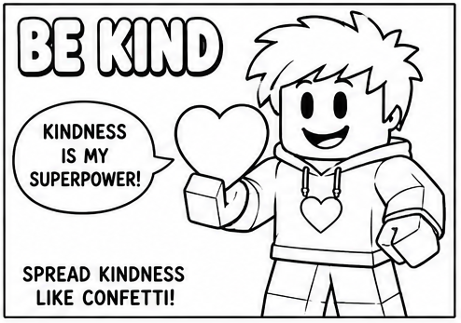
Kindness Is A Super Power!

“And be kind to one another, tenderhearted, forgiving one another...” – Ephesians 4:32

Being kind doesn't require super strength! You can be kind by sharing, encouraging someone, including a lonely kid, or speaking gently when you're upset. Jesus wants
His kindness to be seen in the way we treat people—even people who aren't always kind to us.
🎮 Today’s Quest: Do one kind thing for someone who isn't expecting it.
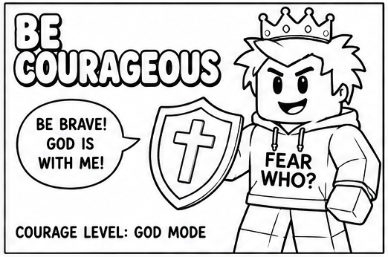
Fear Who?

“Be strong and of good courage, do not fear nor be afraid...” – Deuteronomy 31:6

Courage doesn't mean you never feel afraid. It means choosing what is right even when you're nervous, worried, or standing alone.
When doing the right thing
seems hard, remember that God hasn't left you to face it by yourself. He is with you!

🎮 Today’s Quest: When you have to choose between what's popular and what's right, choose what's right.
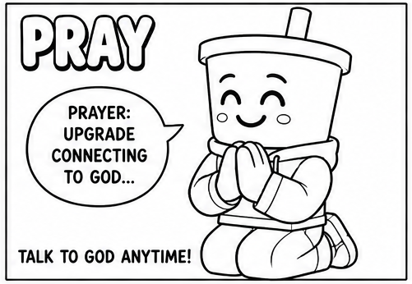
Connection To God!

“Pray without ceasing.” – 1 Thessalonians 5:17

You don't need special words, a special place, or even a special time to pray. You can talk to God in the morning, before a test, while riding in the car, when you're worried, or when something wonderful
happens. God wants you to make prayer a regular part of your day.

🎮 Today’s Quest: Stop three times today and talk to God.

Word Search – Find The Following Words:
M T S E T H T X M P E K R W Y Y L F B
G W O R R I E D T O N I J O F A Z O D
N J C S E R G W V C G A D N E R C F T
I D S S R V E I Z H K Z F D A P J A U
V B X E E T N U T L Z C U E R O J L D
I Q N N G T T A D K M M S R N F S P T
G S O D U J L B K V J S V F D U P O K
R J S N L E E C H O O S E U L A E P I
O C D I A W N R Q U J X W L A F C U G
F E D K R K E N H Q G L D T E T I L K
C N N P Y U S S U O V R E N X C A A P
L V K R X Q S P K U J V H X J R L R F
GENTLENESS • PRAY TEST • WORRIED WONDERFUL • RIGHT REGULAR • CHOOSE POPULAR • NERVOUS SPECIAL • KINDNESS FEAR • FORGIVING

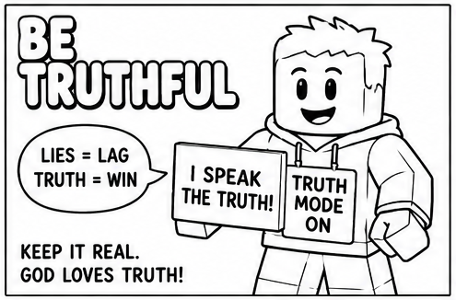
Truth Mode: On!

“Therefore, putting away lying, ‘Let each one of you speak truth with his neighbor.’” — Ephesians 4:25

Sometimes telling the truth can be difficult – especially when we think the truth might get us in trouble. But a lie usually creates an even
bigger problem. God loves truth, and He wants His children to be people others can trust. No cheats. No fake stories. Truth mode ON!

🎮 Today’s Quest: Tell the truth even when telling it isn't easy.

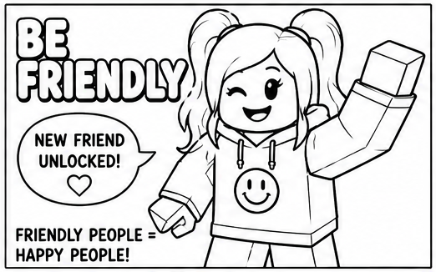
New Friend Unlocked!

“A man who has friends must himself be friendly...” — Proverbs 18:24

Want to find a friend? Start by being one! Smile. Say hello. Invite someone to join you. Listen when someone talks. Look around for the kid
who might be feeling left out. A little friendliness from you could completely change someone else's day.

🎮 Today’s Quest: Talk to someone you don't normally talk to and make them feel welcome.

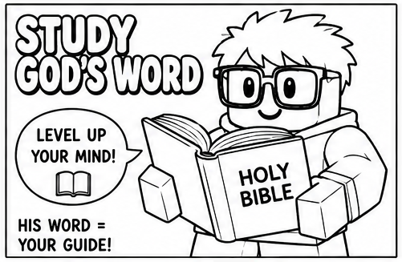
Level Up Your Mind!

“Your word I have hidden in my heart, that I might not sin against You.” – Psalm 119:11

A game gives you instructions for figuring out where to go and what to do. God has given us something much more important – His Word! The
Bible teaches us who God is, what is right, and how He wants us to live. Don't just own a Bible. Open it. Read it. Learn it. Live it!

🎮 Today’s Quest: Read at least five verses from your Bible today and choose one to remember.
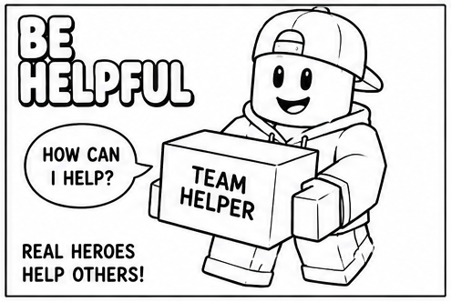
Team Helper!

“Through love serve one another.” – Galatians 5:13

You don't have to be a grown-up to serve others. Hold a door. Pick something up. Help someone carry something. Share your supplies. Notice what needs doing instead of waiting for somebody to tell
you. Jesus showed His love by serving people, and we can follow His example.

🎮 TODAY'S QUEST: Find one person who needs help – and volunteer before you're asked.

