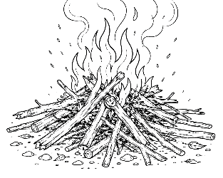
7-12 Year-Olds
9/20/2026
KINDLING
for KIDS!

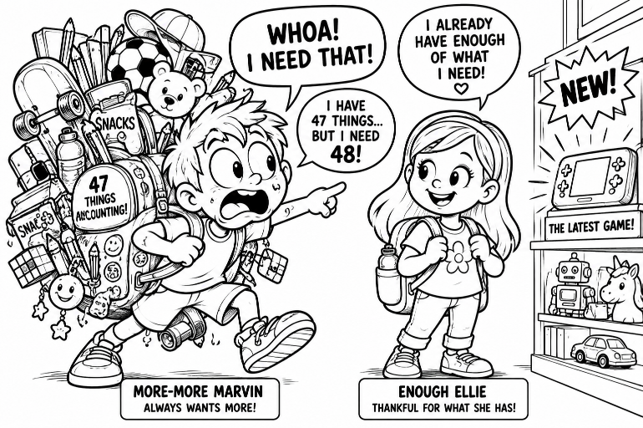
But I Need More!

MEET MORE-MORE MARVIN! Marvin has a backpack. Actually, Marvin VERY FULL backpack. Inside are snacks, toys, pencils, games, gadgets, a water bottle, three squishies, seventeen stickers and several things Marvin has completely
forgotten he owns.

But Marvin sees something new. His eyes get HUGE. “WHOA! I NEED THAT!” Really, Marvin? “YES! I HAVE 47 THINGS... BUT I NEED 48!”

Sometimes we're a little like Marvin. We see what someone else has and suddenly what we have doesn't seem like enough: A newer game • Cooler shoes • Another toy • A bigger dessert • More screen time.

There's nothing wrong with enjoying good things. But there's a difference between saying: “I'd LIKE that.” and “I HAVE TO HAVE THAT TO BE HAPPY!”

Jesus taught us something much more important than getting more stuff: “Is not life more than food and the body more than clothing?”
(Matthew 6:25).

God has already given you something that no toy store can sell: people who care about you • abilities you can use • a world to enjoy – and most important-
antly, the opportunity to know Him!

🤔 THE BIG QUESTION: HOW MUCH IS ENOUGH?

Maybe the better question is: HAVE I NOTICED WHAT GOD HAS ALREADY GIVEN ME?

✏️ QUICK CHALLENGE: Write three things God has given you that you're thankful for:

1.________________________________________________________

2.________________________________________________________

3.________________________________________________________

Look Up!
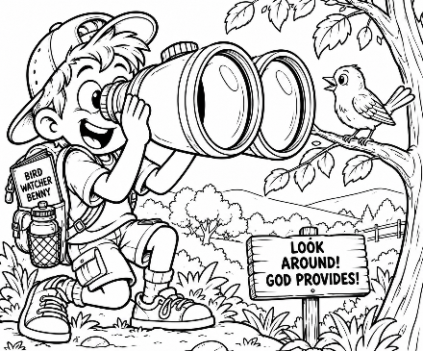
JESUS SAID TO LOOK AT THE BIRDS!
Imagine Bird-Watcher Benny with the world's most ridiculously enormous binoculars. He spots a bird. “WAIT A MINUTE...” The bird doesn't have a refrigerator. It doesn't have a grocery cart. It doesn't even have pockets! Yet Jesus said: “Look at the birds of the air, for they neither sow nor reap
nor gather into barns; yet your heavenly Father feeds them” (Matthew 6:26).

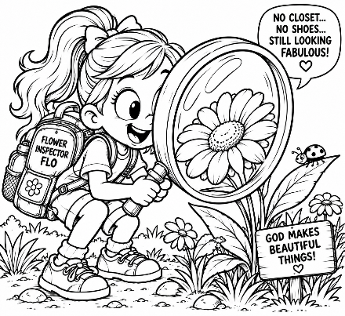
THEN JESUS TELLS US TO LOOK AT SOMETHING ELSE – THE FLOWERS!
Here comes Flower-Inspector Flo with a gigantic magnifying glass. She examines a beautiful flower.
“No closet... no shoes… still looks fabulous!”

Jesus pointed to the flowers to remind us that God cares even about the beautiful things growing in a field.
Then He said: “Therefore do not worry...” (Matthew 6:31). Why? Because...
❤️ YOUR HEAVENLY FATHER KNOWS WHAT YOU NEED!❤️

That doesn't mean we'll always get everything we want. It means we don't have to spend today worrying about tomorrow. When you're worried, you can talk to God about it. 🙏 WORRY → PRAYER

I'm worried about:

_________________________________________________________
I can ask God to help me:

_________________________________________________________

🎮 TODAY'S MISSION
The next time you see a bird or a flower, remember:
GOD KNOWS • GOD CARES • I CAN TRUST HIM.

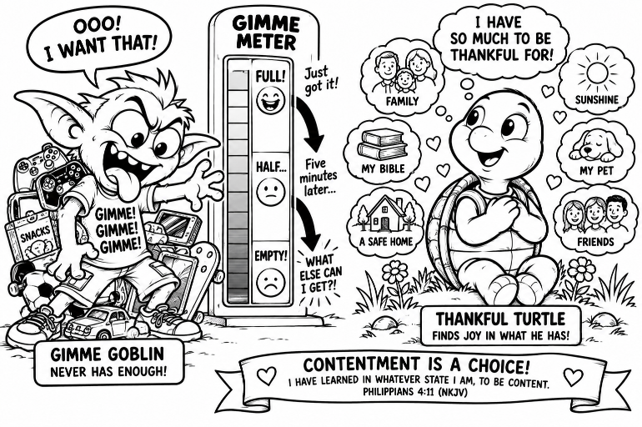
NEED IT OR WANT IT?

Sometimes we say, “BUT I NEEEEEEED IT!” But do we? Meet 👹 THE GIMME GOBLIN whose favorite words are: “GIMME!” and “WHAT ELSE CAN I GET?!” Uh-oh.

Across town lives... 🐢 THANKFUL TURTLE. Thankful Turtle doesn't have everything. But he has discovered something the Gimme Goblin hasn't: YOU CAN ENJOY WHAT YOU HAVE WHILE YOU HAVE IT!

Paul wrote: “I have learned in whatever state I am, to be content” (Philippians 4:11).

Notice that word: LEARNED. Contentment is something we can learn. It means being thankful for what we have instead of always thinking about what we don't have.

🎯 NEED IT OR WANT IT? Write N for NEED or W for WANT.

_____ Clean water
_____ The newest video game
_____ Food
_____ Another stuffed animal
_____ Clothing
_____ A giant bag of candy
_____ A safe place to live
_____ Love and people who care about me
_____ Three more hours of screen time
_____ A 14-FOOT INFLATABLE TACO FOR MY BEDROOM 🌮😳

⚠️ IMPORTANT! WANTS aren't automatically bad. It's okay to want a toy, game or treat. The question is: “Can I still be thankful if I don’t get it?

🐢 THANKFUL TURTLE CHALLENGE – Finish this sentence:

I don't have everything I want, but today I'm thankful for...

_________________________________________________________

_________________________________________________________

What Comes First?

Jesus didn’t finish His lesson by saying: “So never want anything.” He gave us something much better to put first. “But seek first the kingdom of God and His righteousness, and all these things shall be added to you” (Matthew 6:33).

God First! Imagine your life as a video game. Lots of things pop onto the screen demanding your attention: Games • Screens • What Everybody Else Has • More Stuff • Worry • Gimme! Some of these things aren’t bad. They just should NOT become Number One – Jesus says, SEEK GOD FIRST!

